



User Manual -

**Reservation**

**ICMS**

Document History

|  |  |  |  |  |  |  |  |
| --- | --- | --- | --- | --- | --- | --- | --- |
| **Description** | **Author** | **Date** | **Reviewed By & Date** | **Review Remarks** | **Version** | **Change Summary** | **Approved By (with Date)** |
| **Reservation –User Manual** | Pradip | 31/05/2017 |  |  | 1.0 |  |  |
| **Reservation –User Manual** | Pradip | 12/12/2017 |  |  | 1.1 |  |  |
|  |  |  |  |  |  |  |  |
|  |  |  |  |  |  |  |  |

**Table of Contents**

1 Introduction: 9

1.1 Cargo Reservation 9

1.1.1 Cargo Booking Search panel 12

1.1.2 Create New Booking 18

1.1.3 Update Booking 24

1.1.4 Execution of Shipment (Issue of AWB) 26

1.1.5 Copy Booking 37

1.1.6 Interline Booking 38

1.1.7 Interline Booking –GA to OAL 38

1.1.8 Interline Booking –OAL to GA 41

1.1.9 Update Interline Booking 44

1.1.10 Execute Interline Booking 44

1.1.11 House Airway Bill Capture (HAWB) 44

1.2 Cross Border function 49

1.2.1 Cross Border Booking –Agent Log in 50

1.2.2 Cross Border Booking –Other Log in 51

1.2.3 Cross border booking will displayed on Log in station (Change process) 53

1.3 Booking List 53

1.3.1 Search Booking List 54

1.4 Loading instruction 55

1.4.1 Create Loading Instruction 55

1.5 AWB Penalty 58

1.5.1 Cancel Shipment 59

1.5.2 Void Shipment 61

1.5.3 No show shipment 64

1.6 Group Booking 68

1.6.1 Transfer Flight (Group Booking) 68

1.6.2 Amend Flight status 71

1.7 Master Booking List (MBL) 72

1.8 Allotment 78

1.8.1 Create New Allotment 83

1.8.2 Edit/Update Allotment 87

1.8.3 Release Allotment 89

1.9 Capacity Management 92

1.9.1 Search/view the Capacity 92

1.9.2 Edit/Modify Capacity 97

1.9.3 Cancel Flight (Manual Option) 99

1.9.4 Change of Aircraft (Manual option) 100

1.10 Mail Reservation 103

1.10.1 Search Panel (Mail Booking ) 103

1.10.2 New Air Mail Booking 106

1.10.3 Update Mail Booking 110

1.10.4 Mail under Cargo 111

1.11 AWB Tracking 112

1.12 Search schedule 114

1.13 Rate 116

1.13.1 Spot rate 116

1.13.2 Campaign Rate 124

1.13.3 Rate search 125

1.13.4 Rate search by Reference Number 127

1.13.5 Rate priority (precedence) 128

1.14 Stock Management 129

1.14.1 Distribute the stock (Manual) 129

1.14.2 Return from Forwarder (Agent) 134

1.14.3 AWB Blacklisting 136

1.14.4 AWB stock Report 138

1.14.5 Blacklist AWB Report 140

1.15 Space control 141

1.15.1 Space control Action 146

1.15.2 Space control status –action 151

1.15.3 Re plan –By space control 153

1.16 Embargo 156

1.16.1 Create New Embargo 160

**Table of figures**

Figure 1 Log in 9

Figure 2 Reservation Grid 10

Figure 3 Search panel 12

Figure 4 Main Grid 12

Figure 5 New Booking 18

Figure 6 Search flight Route 22

Figure 7 Flight select 22

Figure 8 save Reservation 23

Figure 9 Save successfully 23

Figure 10 AWB Grid 23

Figure 11 View Route 24

Figure 12 Search route 24

Figure 13 Clear Itinerary 24

Figure 14 U Tab 25

Figure 15 Update Booking 25

Figure 16 E Tab 26

Figure 17 Execution of AWB 27

Figure 18 Execute Button 29

Figure 19 Shipment Executed –appeared in Grid 30

Figure 20 Rate Tab 30

Figure 21 Rate Tab 31

Figure 22 Apply spot code 32

Figure 23 spot code apply 33

Figure 24 AWB 34

Figure 25 AWB Copy Normal 35

Figure 26 Preprinted format 35

Figure 27 AWB Label 36

Figure 28 IATA 606 label 37

Figure 29 Copy Booking 37

Figure 30 New Copy Screen 38

Figure 31 Main Cargo Reservation page 39

Figure 32 New Cargo Booking 39

Figure 33 OAL Itinerary selection 40

Figure 34 GA and OAL flight selection 40

Figure 35 HAWB Capture 45

Figure 36 HAWB information 46

Figure 37 HAWB Details 46

Figure 1 Process Flow -Cross Border 49

Figure 2 Agent Log in 50

Figure 3 Airline Log in 51

Figure 4 Airline Log in -Cross border Booking 52

Figure 5 User SKK with Airport Access 53

Figure 38 Booking List 53

Figure 39 Search Booking List 54

Figure 40 Print Booking list 54

Figure 41 Loading Instruction 55

Figure 42 Create LI 56

Figure 43 LI print preview 57

Figure 44 LI Version 58

Figure 45 AWB Penalty 59

Figure 46 Shipment Cancelation 59

Figure 47 Cancel Mark 60

Figure 48 Date wise cancel 60

Figure 49 Penalty Report –Cancellation 61

Figure 50 Void Shipment 62

Figure 51 Void Report 63

Figure 52 Date wise Void 64

Figure 53 Date Wise Void Report 64

Figure 54 No Show 65

Figure 55 No show Penalty Report 66

Figure 56 No Show Date wise 66

Figure 57 Create No show Date wise 66

Figure 58 Group Booking 68

Figure 59 Group Booking Flight search 69

Figure 60 Transfer shipments 69

Figure 61 Amend Flight status 71

Figure 62 MBL 73

Figure 63 MBL Search 73

Figure 64 Allotment 79

Figure 65 Create Allotment 83

Figure 66 Edit Allotment 87

Figure 67 Edit Allotment Record 88

Figure 68 Modify Allotment 88

Figure 69 Allotment Release 89

Figure 70 Release Allotment 90

Figure 71 Auto Allotment Release 91

Figure 72 View & Edit flight 92

Figure 73 Search Details 93

Figure 74 Edit Capacity 97

Figure 75 Cancel Flight 99

Figure 76 Change of aircraft 100

Figure 77 Mail Reservation 103

Figure 78 New airmail Booking 106

Figure 79 Search Flight 109

Figure 80 save Mail Booking 109

Figure 81 Update CN 110

Figure 82 Reservation cargo 111

Figure 83 Mail under cargo 112

Figure 84 AWB Tracking 112

Figure 86 Search schedule 114

Figure 87 Schedule search with No leg 115

Figure 88 Search schedule with 1 leg 115

Figure 89 Spot Rate 116

Figure 90 Create Spot rate 119

Figure 91 Approve Spot Rate 122

Figure 92 Approve screen 123

Figure 93 Create Campaign rate 124

Figure 94 Search Rate 125

Figure 95 Rate Information 126

Figure 96 Search by Reference 127

Figure 97 Rate priority 128

Figure 98 Issue AWB Stock 129

Figure 99 Issue to Forwarder 132

Figure 100 Issue process 132

Figure 101 Return from Agent 134

Figure 102 Return Process 135

Figure 103 Return process 135

Figure 104 Returned to Office 136

Figure 105 Office Stock 136

Figure 106 Blacklist AWB 136

Figure 107 AWB stock Report 138

Figure 108 Detail report 139

Figure 109 Backlist Report 140

Figure 110 Space control Search 141

Figure 111 Space control Flight Search Details 147

Figure 112 Re plan 153

Figure 113 Embargo 156

Figure 114 New Embargo 161

# Introduction:

The purpose of this document is to provide the complete Process of Reservation workflow to the user of ICMS application.

## Cargo Reservation

This module used to Book the shipment considering various criteria and the execution of the shipment, shipment could be cargo, courier or mail , User first need to log into the system with authorized user ID and password

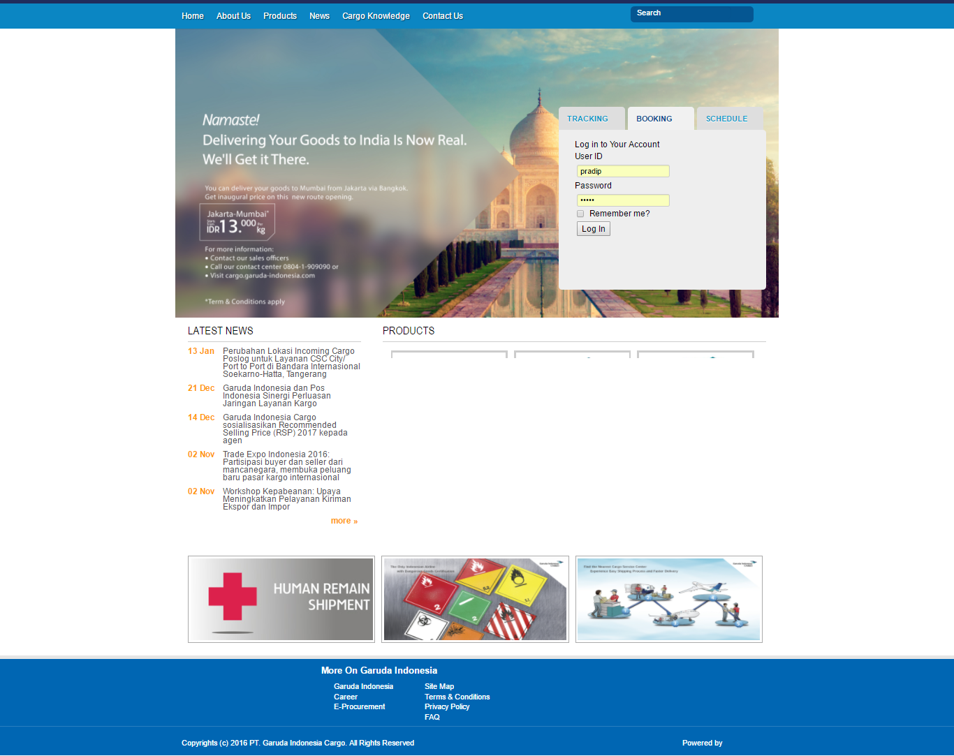

Figure Log in

User need to type the User ID and password and need to click the Log in Tab to open the main reservation page

To Process the Reservation and Booking, User need to navigate as bellow

Navigation-Click Reservation>Cargo Booking

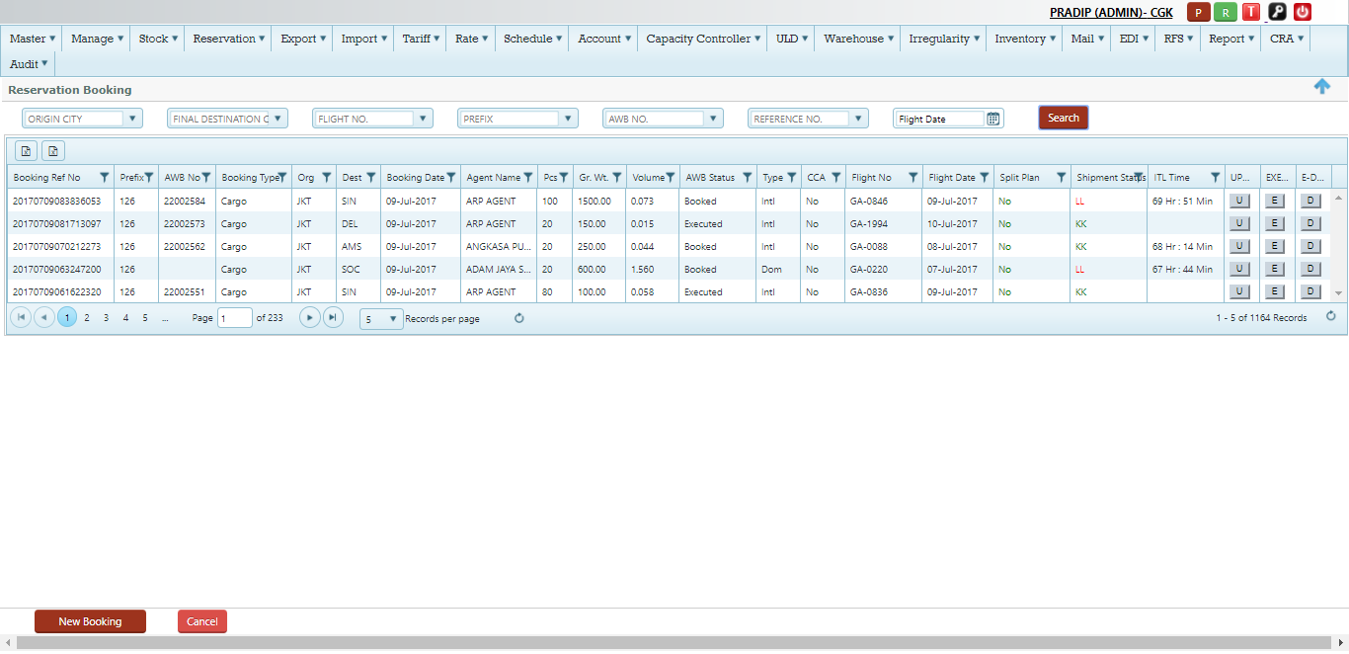

Figure Reservation Grid

Screen details (Fig 2)

|  |  |
| --- | --- |
| C:\Users\Pradip\Desktop\screen\screenshot-gauat.bookmycargo.net-2017-07-09-17-53-19.png | This is the master Module , will manage by the system admin |
| C:\Users\Pradip\Desktop\screen\screenshot-gauat.bookmycargo.net-2017-07-09-18-03-04.png | This is the user ID/permission module |
| C:\Users\Pradip\Desktop\screen\screenshot-gauat.bookmycargo.net-2017-07-09-17-54-04.png | This is the stock control Module |
| C:\Users\Pradip\Desktop\screen\screenshot-gauat.bookmycargo.net-2017-06-27-16-49-54.png | This is the reservation Module Tab , user will able to make booking under this tab |
| C:\Users\Pradip\Desktop\screen\screenshot-gauat.bookmycargo.net-2017-06-27-16-50-51.png | This is the Export Module , user able to accept the cargo and create the charges for the shipment |
| C:\Users\Pradip\Desktop\screen\screenshot-gauat.bookmycargo.net-2017-07-09-17-54-55.png | This is the Import operation module |
| C:\Users\Pradip\Desktop\screen\screenshot-gauat.bookmycargo.net-2017-07-09-17-55-47.png | This is the Tariff module , user need to manage and maintain all tariff here |
| C:\Users\Pradip\Desktop\screen\screenshot-gauat.bookmycargo.net-2017-06-27-16-51-28.png | Rate tab – user will able to view various rates under this tab |
| C:\Users\Pradip\Desktop\screen\screenshot-gauat.bookmycargo.net-2017-06-27-16-51-51.png | Schedule Tab – user able to view the flight schedule for specific date |
| C:\Users\Pradip\Desktop\screen\screenshot-gauat.bookmycargo.net-2017-06-27-16-52-12.png | Account Tab – user able to create and issue the Invoice for the POS cash transaction under this tab |
| C:\Users\Pradip\Desktop\screen\screenshot-gauat.bookmycargo.net-2017-07-09-17-56-59.png | This is the Capacity control module , it contain some of the sub module like –space control, Booking list ,Embargo , group Booking |
| C:\Users\Pradip\Desktop\screen\screenshot-gauat.bookmycargo.net-2017-07-09-17-57-35.png | This is the complete ULD management module |
| C:\Users\Pradip\Desktop\screen\screenshot-gauat.bookmycargo.net-2017-07-09-17-58-31.png | This is the warehouse module , |
| C:\Users\Pradip\Desktop\screen\screenshot-gauat.bookmycargo.net-2017-07-09-17-59-11.png | This is the Irregularity module , it contains sub module Complaint and Claim management als0 |
| C:\Users\Pradip\Desktop\screen\screenshot-gauat.bookmycargo.net-2017-07-09-18-00-22.png | This is the inventory Module |
| C:\Users\Pradip\Desktop\screen\screenshot-gauat.bookmycargo.net-2017-07-09-18-01-03.png | This is the PO mail Reservation and operation module |
| C:\Users\Pradip\Desktop\screen\screenshot-gauat.bookmycargo.net-2017-07-09-18-01-44.png | This is the EDI – Messaging module |
| C:\Users\Pradip\Desktop\screen\screenshot-gauat.bookmycargo.net-2017-07-09-18-02-24.png | This is the Report module |
| C:\Users\Pradip\Desktop\screen\screenshot-gauat.bookmycargo.net-2017-06-27-16-52-39.png | Audit Tab-User able to Track and check the History of the shipment under this module |
| C:\Users\Pradip\Desktop\screen\screenshot-gauat.bookmycargo.net-2017-07-09-17-52-24.png | This indicate the user log in details -user Id (Group )and Airport |
| C:\Users\Pradip\Desktop\screen\screenshot-gauat.bookmycargo.net-2017-06-27-16-45-42.png | P-Button /This used to print the AWB |
| C:\Users\Pradip\Desktop\screen\screenshot-gauat.bookmycargo.net-2017-06-27-16-46-20.png | R-Button /This is used to Refresh the page |
| C:\Users\Pradip\Desktop\screen\screenshot-gauat.bookmycargo.net-2017-06-27-16-46-53.png | T-Button /This is used to Track the AWB/Ref Number |
| C:\Users\Pradip\Desktop\screen\screenshot-gauat.bookmycargo.net-2017-06-27-16-47-55.png | Change of Password/This is used to change the password of the user |
| C:\Users\Pradip\Desktop\screen\screenshot-gauat.bookmycargo.net-2017-06-27-16-48-44.png | Log Out /This is used to log out from the window |

### Cargo Booking Search panel

Search panel used to search the booking and executed shipments made by the user .user can search the bookings by various criteria as given bellow



Figure Search panel

Details-(Refer fig 3)

|  |  |
| --- | --- |
| Origin city | User can select the Origin city from the drop down by typing the three letter code of the City , example-JKT , for Jakarta |
| Final Destination | User can select the City from the drop down list to search based on final destination ,Example- SIN for Singapore |
| Flight No | User can search based on flight No , can select from the drop down list , Example- GA2346 |
| Prefix | User can search by AWB prefix , Example-126 |
| AWB number | User can search by AWB Number , can select from the drop down list , Example-00001234 |
| Reference number | User can also search by reference number , can select from drop down , |
| Flight Date | User can search based on date , cam be select from date calendar given |
| Search | To click the search button , based on above parameter user able to display the bellow grid |

Once User search by the above criteria, the bellow window opens for view (It’s the list of Bookings has done by the user

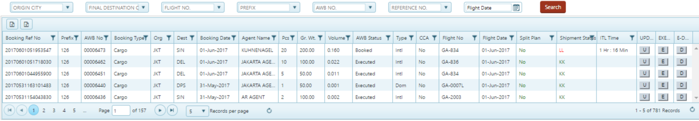

Figure Main Grid

Note-User can also filter the reservation information from the above screen(Fig 4) based on various criteria given bellow

Filter Details

|  |  |
| --- | --- |
| Reference Number | User can filter the reference number by clicking the filter sign(located just next to Ref no)  C:\Users\Pradip\Desktop\screen\filter.png  Type the reference number and just click filter tab , system will automatically filter the data and will get display in the Grid |
| Prefix | User can filter the reservation data based on AWB prefix clicking the filter sign just next to Prefix  C:\Users\Pradip\Desktop\screen\prefix.png  Type the prefix and click to the filter button , system will automatically filter the data and will get display in the Grid |
| AWB No | User can filter the reservation data based on AWB No clicking the filter sign just next to AWB number  C:\Users\Pradip\Desktop\screen\awb.png  Type the AWB number and click to the filter button , system will automatically filter the data and will get display in the Grid |
| Booking Type | Booking Type indicates , Type of Booking like Cargo , Courier or Mail,  User can filter the reservation data based on Booking Type clicking the filter sign just next to Booking Type  C:\Users\Pradip\Desktop\screen\type.png  Type the Booking type and click to the filter button , system will automatically filter the data and will get display in the Grid |
| Origin | User can filter the reservation data based on Origin City clicking the filter sign just next to Origin City  C:\Users\Pradip\Desktop\screen\org.png  Type the three letter code of Origin city and click to the filter button , system will automatically filter the data and will get display in the Grid |
| Destination | User can filter the reservation data based on Destination City clicking the filter sign just next to Destination City  C:\Users\Pradip\Desktop\screen\dest.png  Type the three letter code of Destination city and click to the filter button , system will automatically filter the data and will get display in the Grid |
| Booking Date | User can filter the reservation data based on Booking date clicking the filter sign just next to Booking date  C:\Users\Pradip\Desktop\screen\booking date.png  Select the date from the calendar and click to the filter button , system will automatically filter the data and will get display in the Grid |
| Agent Name | User can filter the reservation data based on Agent name clicking the filter sign just next to Agent name  C:\Users\Pradip\Desktop\screen\panalpina.png  Type the Agent name and click to the filter button , system will automatically filter the data and will get display in the Grid |
| Pieces | User can filter the reservation data based on No of pieces clicking the filter sign just next to Piece Tab  C:\Users\Pradip\Desktop\screen\pc.png  Type the number of pieces and click to the filter button , system will automatically filter the data and will get display in the Grid |
| Gross weight | User can filter the reservation data based on Gross weight clicking the filter sign just next to Gross weight Tab  C:\Users\Pradip\Desktop\screen\gros weight.png  Type the gross weight and click to the filter button , system will automatically filter the data and will get display in the Grid |
| Volume | User can filter the reservation data based on Volume(CBM) clicking the filter sign just next to Volume Tab  C:\Users\Pradip\Desktop\screen\vol.png  Type the Volume and click to the filter button , system will automatically filter the data and will get display in the Grid |
| AWB Status | It indicates the current status of the AWB, Like Booked, Executed, Accepted, Departed etc.  User can filter the reservation data based on AWB status clicking the filter sign just next to AWB status Tab  C:\Users\Pradip\Desktop\screen\awb.png  Type the AWB status and click to the filter button , system will automatically filter the data and will get display in the Grid |
| Type | Type indicates the Type of Transaction, Example –Domestic or International etc.  User can filter the reservation data based on Type(Dom or Intl) clicking the filter sign just next to Type Tab  C:\Users\Pradip\Desktop\screen\type.png  Type the (Dom/intl) and click to the filter button , system will automatically filter the data and will get display in the Grid |
| CCA | It Indicates if any of the AWB has raised CCA against it and it will display as Yes or No ,  User can filter the reservation data based on CCA(as Yes or No) clicking the filter sign just next to CCA Tab  C:\Users\Pradip\Desktop\screen\cca.png  Type the Yes or No and click to the filter button , system will automatically filter the data and will get display in the Grid |
| Flight No | User can filter the reservation data based on Flight Number clicking the filter sign just next to Flight No Tab  C:\Users\Pradip\Desktop\screen\flight.png  Type the flight number and click to the filter button , system will automatically filter the data and will get display in the Grid |
| Flight Date | User can filter the reservation data based on Flight date clicking the filter sign just next to Flight date Tab  C:\Users\Pradip\Desktop\screen\flight date.png  Select the date from calendar and click to the filter button , system will automatically filter the data and will get display in the Grid |
| Split plan | It Indicate the part shipment planned in different flight ,  User can filter the reservation data based on Split plan(Yes/No) clicking the filter sign just next to Split plan Tab  C:\Users\Pradip\Desktop\screen\spli.png  Type Yes/No and click to the filter button , system will automatically filter the data and will get display in the Grid |
| Shipment status | It indicates the status of shipment –Example- confirms (KK) or waits listed (LL) etc.  User can filter the reservation data based on shipment status(KK/LL) clicking the filter sign just next to Shipment status Tab  C:\Users\Pradip\Desktop\screen\ST.png  Type KK/LL and click to the filter button , system will automatically filter the data and will get display in the Grid |
| ITL Time | It indicate the Issue Time limit (defined in Hour/minute),  User can filter the reservation data based on ITL time(hour/minute) clicking the filter sign just next to ITL time Tab  C:\Users\Pradip\Desktop\screen\itl.png  Type time in Hour/min and click to the filter button , system will automatically filter the data and will get display in the Grid |

### Create New Booking

New Booking function used to make a Booking by the user (user be Airline/agent GSA or POS)

Navigation-Reservation>Cargo Booking>click New Booking

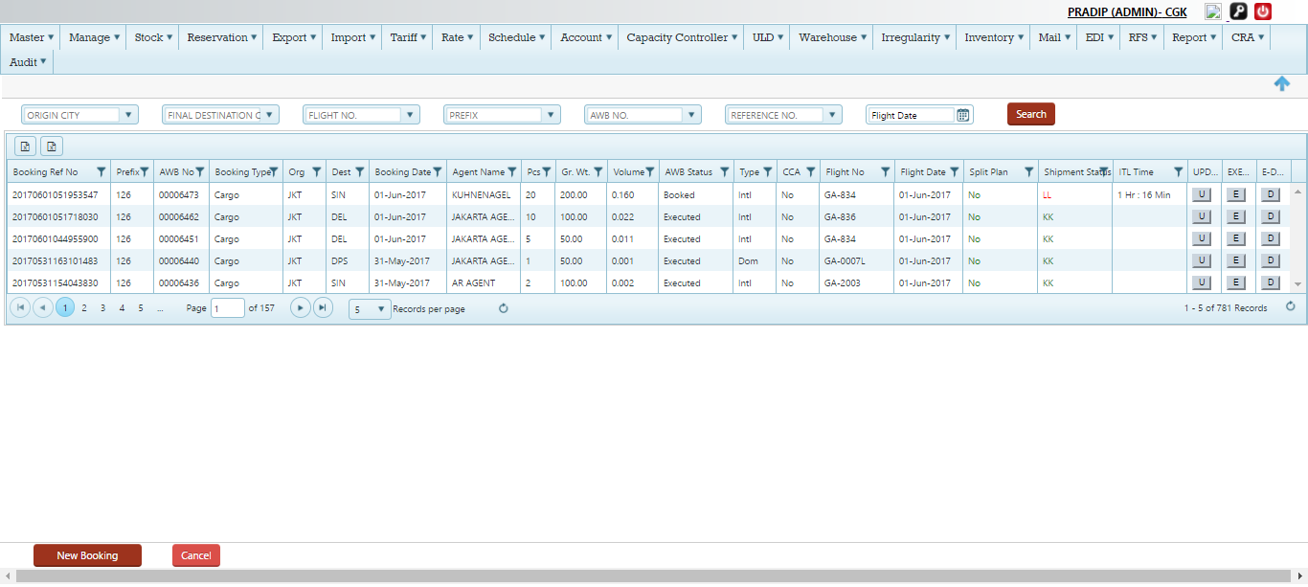

Figure New Booking

Once user click to the New Booking, system will open the new Reservation Window for Booking

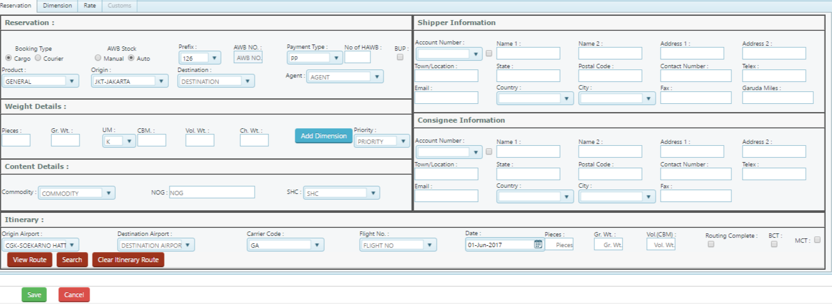

Process Details

|  |  |
| --- | --- |
| Booking Type | Select the Booking type , Example –Cargo, Courier  Note-MAIL under cargo can be booked using product type as MAIL |
| AWB Stock | It indicates the stock type ,  Manual –In case GA has issued the stock to any specific Office/agent , In this case user to type the AWB number that issued  Automatic-If user has no stock then user can select the automatic as stock option to process for Booking  Select the stock type |
| Prefix | Select the prefix, example -126, If user looking for interlines booking need to select appropriate airline prefix like -618,176 etc.  By default system will display as 126 as Host airline prefix  Note-In case of POS booking it is always 126 |
| AWB No | If user selected stock Type as Manual-user need to type the 8 digit AWB serial number or else if it is selected as automatic then this will be disable and system will generate the AWB number while on Booking/execution depend on domestic and international Booking |
| Payment Type | Select as PP or CC , By default system will show as PP |
| No Of HAWB | Type the no of HAWB if user making booking for Consol shipment |
| BUP | Select BUP , if agent is making ULD booking , Once user select the BUP button system will ask for to type the no of BUP , user need to type the no here  C:\Users\Pradip\Desktop\screen\bup.png  Type the No of BUP like 1, 2 or 3 etc. |
| Product | It indicates the product type, Example –General, Airport to airport, Go express, Mail etc.  C:\Users\Pradip\Desktop\screen\product.png  Select the appropriate product , By default system will display as General |
| Origin | Select the origin city from the drop down |
| Destination | Select the Destination city from the drop down |
| Agent | Select the agent name from the drop down list |
|  | Weight Details |
| Pieces | Type the total no of AWB pieces |
| Gross weight | Type the Gross weight of the shipment |
| UM | Select the UM(Unit of measurement ) from the drop down list , Example- K or L |
| CBM | Type the volume if known for Booking purpose , if Dimensions is there user can click to the Dimension tab and update , system will calculate volume and weight based on that |
| Volume weight | Type the Volume weight, If user has put the volume then system calculates the volume weight and chargeable weight. |
| Chargeable weight | Type the chargeable weight , system also calculate the chargeable weight based on dimensions |
| Add Dimension | Add Dimension Tab Used to update the dimension of the individual or total pieces  Click to Add dimension Tab -  C:\Users\Pradip\Desktop\screen\d.png  Once user click to the Add dimension tab , it will open into the New Dimension Tab for updating  C:\Users\Pradip\Desktop\screen\tab.png  Type the Lenth,width,Height and click update , so it will save automatically , user can go back to reservation page by clicking the Back to reservation tab  If shipment Type as BUP , It will open as bellow screen  C:\Users\Pradip\Desktop\screen\bp.png  Select the ULD Type from the drop down list-AKE,PMC and click update all |
| Priority | It indicate the priority of the shipment that will transport from origin to destination  Select the priority from the drop down if any |
|  | Content Details |
| Commodity | Select the commodity from the drop down list |
| NOG | NOG-(Nature of Goods )  Type the Nature of goods as free text field |
| SHC | Select the SHC from the drop down list , Note –if any of the SHC has associated with commodity will display automatically here |
|  | Flight Itinerary |
| Origin Airport | Select the origin airport ,System will display the airport based on origin city |
| Destination Airport | Select the Destination airport from the drop down list , it will auto populated based on Destination city |
| Carrier Code | System will auto populate the carrier code based on AWB prefix choose by user |
| Flight No | Select the flight number from the drop down |
| Flight Date | Select the flight date from the date calendar |
| Pieces | It indicate the part shipment to be planned by the user , Once user type the piece here will automatically split the shipment |
| Gross weight | It indicated the weight of the split pieces |
| Volume (CBM | It indicate the volume of the split pieces |
| Route complete | It indicate that if user need to override the route with compare with the final destination  Example-If shipment Origin city as JKT to SYD via DPS , user can complete the route as JKT -DPS if user tick the route complete radio button |
| BCT | BCT-Booking closer time , If user tick the BCT it will override the BCT |
| MCT | MCT-Minimum connection time ,If user tick the MCT it will override the MCT |

#### Search Button

It used to search the flights based on above criteria, click to search Button

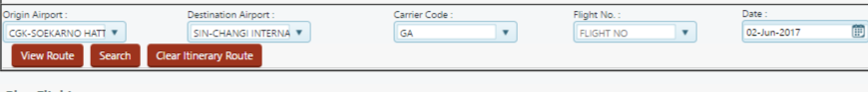

Figure Search flight Route

It will display the flights as bellow sub window

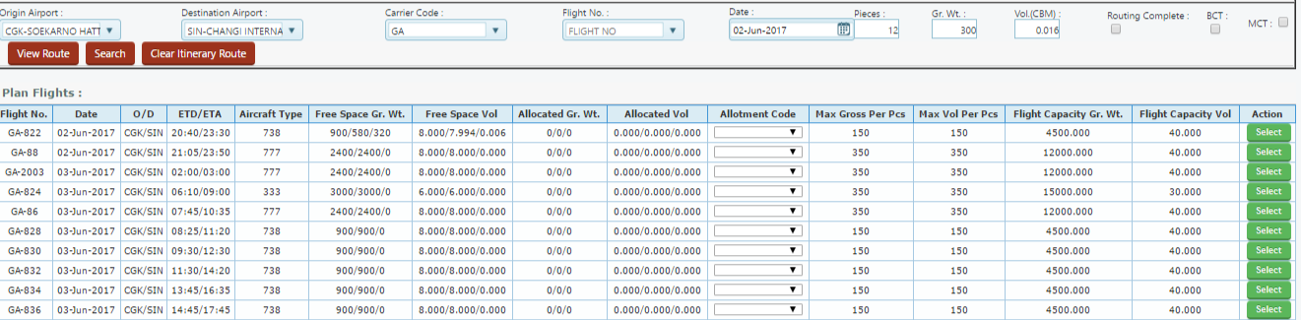

Figure Flight select

User need to select the flight by clicking the select Button, once it is selected it will display into the Route grid as bellow

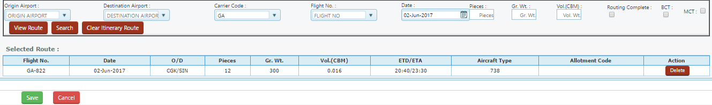

Figure save Reservation

Save Button –Click into the Save button to save the reservation, Once Reservation is saved it will reflect into the main grid

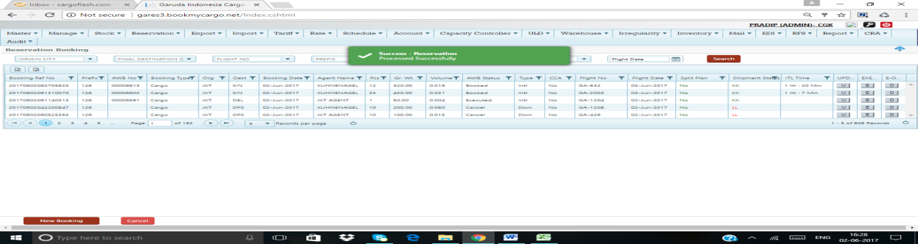

Figure Save successfully

And it will reflect as bellow

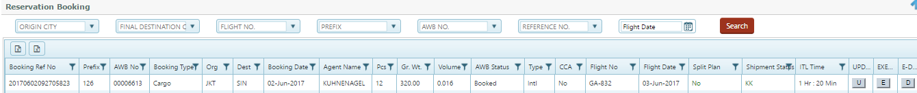

Figure AWB Grid

Cancel Button-Click cancel to exit from the reservation page

Delete Button – click Delete button if user need to search another flight

#### View Route Button

User can select the route using this tab , Let’s say if user has choose as Origin as SIN and destination as AMS , system will show the route like SIN-JKT-AMS or SIN-DPS-AMS or SIN-AMS , user need to select the route



Figure View Route

It will open new sub window as bellow –

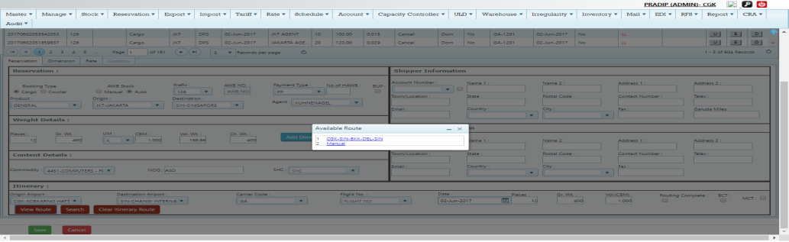

Figure Search route

Select the route and then select the flight

#### Clear Itinerary Button

If user need to choose another route can user by clicking the Clear route Button



Figure Clear Itinerary

### Update Booking

Update Booking used to modify the any existing Booking by the user, to update any existing Booking user need to click into the U tab on the main reservation grid

Navigation-Click Reservation>Cargo Booking>Click into the U tab

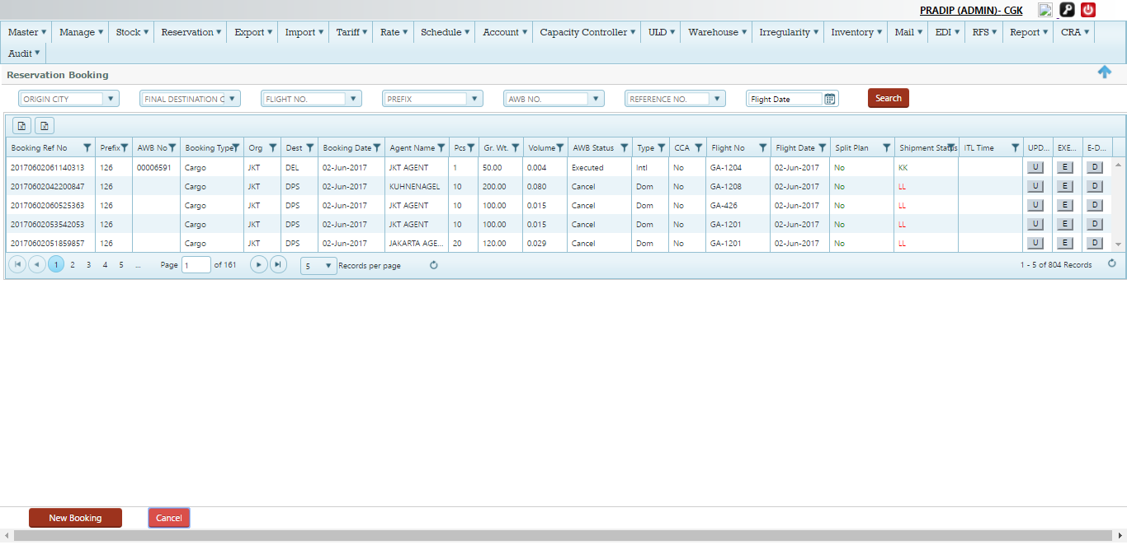

Figure U Tab

Click into the U Tab, it will open the respective information of that particular AWB as bellow

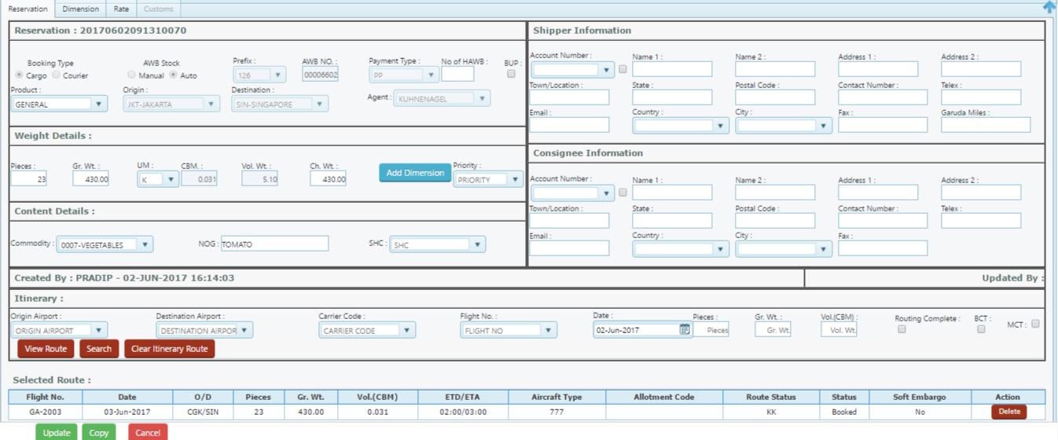

Figure Update Booking

User able to modify the bellow information (refer screen-15)

1. Product
2. No of pieces
3. Gross weight
4. Dimension
5. Commodity
6. NOG –Nature of goods
7. SHC
8. Flight route

Once it is modified and click into Update Button save the modified data into the main grid

Note- AWB Rate/charge will change based on modified information into the rate Tab

User can view the Rate information using the U Tab as well after shipment has booked, Once shipment executed system will not allow the U tab , in that case user can check using E Tab

### Execution of Shipment (Issue of AWB)

Execution process used to Issue the AWB while confirming all AWB data

Note- system check the ITL for execution, if ITL expired shipment will auto cancelled and cannot executed by user

Navigation-Click Reservation>Cargo Booking>Click into the E tab



Figure E Tab

Click into the E-Tab (refer to screen -16)to execute or issue the AWB, System will open the new Tab where users need to fill the Shipper and consignee data to execute

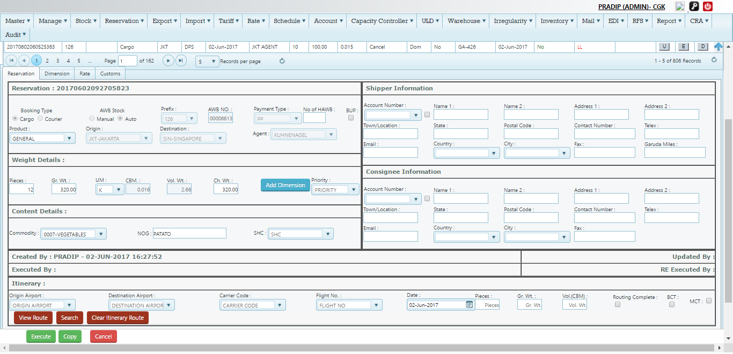

Figure Execution of AWB

Execution Process (Refer screen-17)

|  |  |
| --- | --- |
|  | Shipper Information |
| Account Number | It indicate the shipper Account number which saved in the master data , if user select the shipment account number system will auto populated the bellow information , for New shipper it has to fill by user manually  C:\Users\Pradip\Desktop\screen\shp.png  Note –user can save the new shipper information by clicking the small check box which located next to Account Number - |
| Name 1 | Type the Name of the shipper |
| Name 2 | Type the second Name of the shipper |
| Address 1 | Type the first address of the shipper |
| Address 2 | Type the second address of the shipper |
| Town/Location | Type the Town or Location of the shipper |
| State | Type the state of the shipper belongs |
| Postal Code | Type the postal code of the shipper |
| Contact Number | Type the contact Number of the Shipper |
| Telex | Type any telex number |
| E-mail | Type the E-mail Id of the shipper |
| Country | Select the Country from the drop down , type Two letter code of the country , Example-ID for Indonesia |
| City | Select the city from the drop down list , Type three letter city code ,Example-JKT for Jakarta |
| Fax | Type the Fax number |
| Garuda miles | Enter the Garuda miles if any (This only applicable for Booking at POS –Point of sale) |
|  | Consignee Information |
| Account Number | It indicate the Consignee Account number which saved in the master data , if user select the consignee account number system will auto populated the bellow information , for New Consignee it has to fill by user manually  C:\Users\Pradip\Desktop\screen\cne.png  Note –user can save the new Consignee information by clicking the small check box which located next to Account Number - |
| Name 1 | Type the Name of the consignee |
| Name 2 | Type the second Name of the consignee |
| Address 1 | Type the first address of the consignee |
| Address 2 | Type the second address of the consignee |
| Town/Location | Type the Town or Location of the consignee |
| State | Type the state of the consignee belongs |
| Postal Code | Type the postal code of the consignee |
| Contact Number | Type the contact Number of the consignee |
| Telex | Type any telex number |
| E-mail | Type the E-mail Id of the consignee |
| Country | Select the Country from the drop down , type Two letter code of the country , Example-ID for Indonesia |
| City | Select the city from the drop down list , Type three letter city code ,Example-JKT for Jakarta |
| Fax | Type the Fax number |

Once above information filled by the user can now execute by clicking the Execute Button (Located extreme button)



Figure Execute Button

Click Execute (Refer Screen -18) –It will show as shipment Executed successfully and AWB status will changed to Executed

Example- 126-00006613, Booked from JKT-SIN,

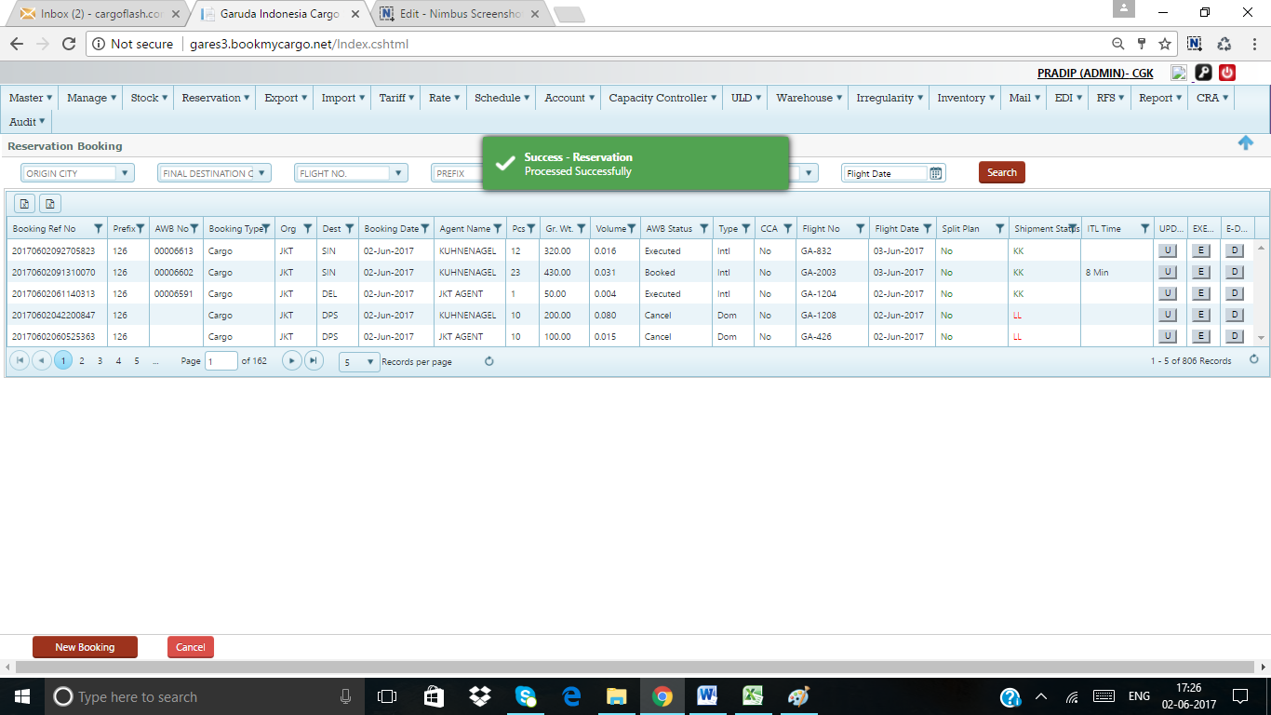

Figure Shipment Executed –appeared in Grid

Once shipment executed user able to view the Rate information from the Rate Tab and Able to print the AWB /Label as well

#### Rate Tab

Rate Tab used to view the rate, other charges and tax applied for a particular shipment

Navigation-Reservation>Cargo Booking >click E-Tab >Click Rate Tab

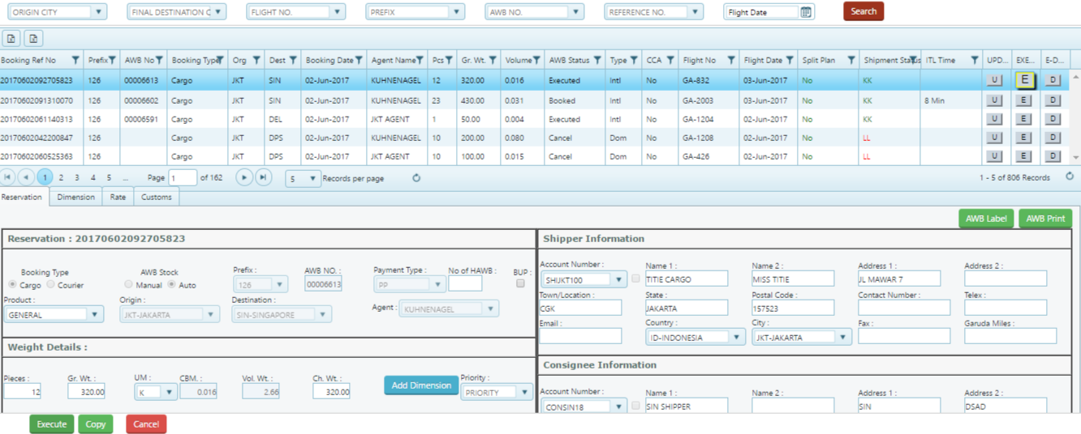

Figure Rate Tab

Click to Rate tab (Screen-20), system will open up new sub window for view (Screen -21)

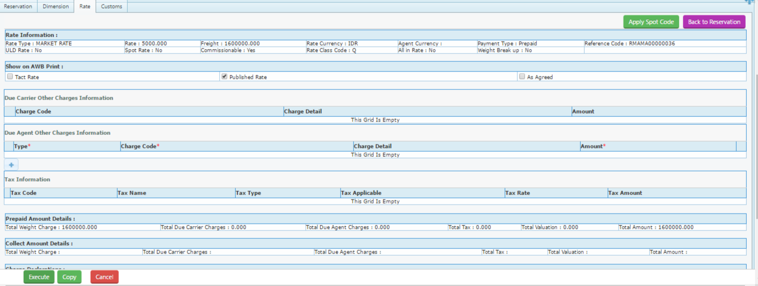

Figure Rate Tab

User can view and update bellow Information (Refer to Screen-21)

1. Rate information-rate type/rate/freight /currency/payment type etc.



1. Shown on AWB print –User can select the rate which to be printed in the AWB , can tick



1. Due carrier other charges – Can view if any Due carrier applied



1. Due Agent other charges –Can view if any due agent charges applied for AWB and can add manually by clicking to + Tab



1. Tax Information – Only view , If any applied Tax on AWB freight or other charges



1. Prepaid Amount details –It indicated the total charges that include Total Freight amount+ total other charges due carrier+total other charges due agent +total tax



1. Collect amount Details-user can view the rate information for CC shipments



1. Charge Declaration-Under this user can define the Valuation charges /Insurance etc. and it will get printed on AWB



1. CC charges in Destination –It will show the total charges under CC shipment to be collected at Destination



1. Charge Declaration Save-User can save by clicking this tab for any declared charges

#### Apply Spot code Tab

User can apply the spot code if any by using this Tab

Navigation-Reservation>Reservation & Booking >Click E-Tab >Click Rate Tab>Click Apply spot code

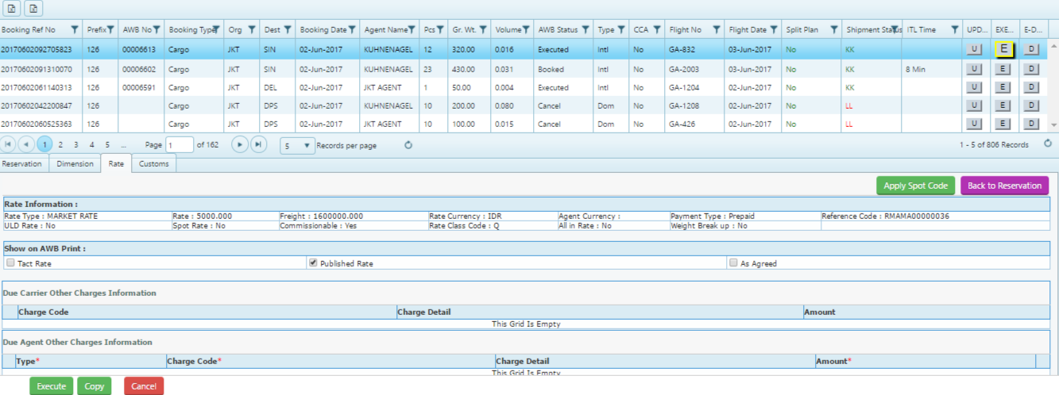

Figure Apply spot code

Click into the Apply spot code (Refer Screen -22) –It will open a new window as bellow (Screen-23)

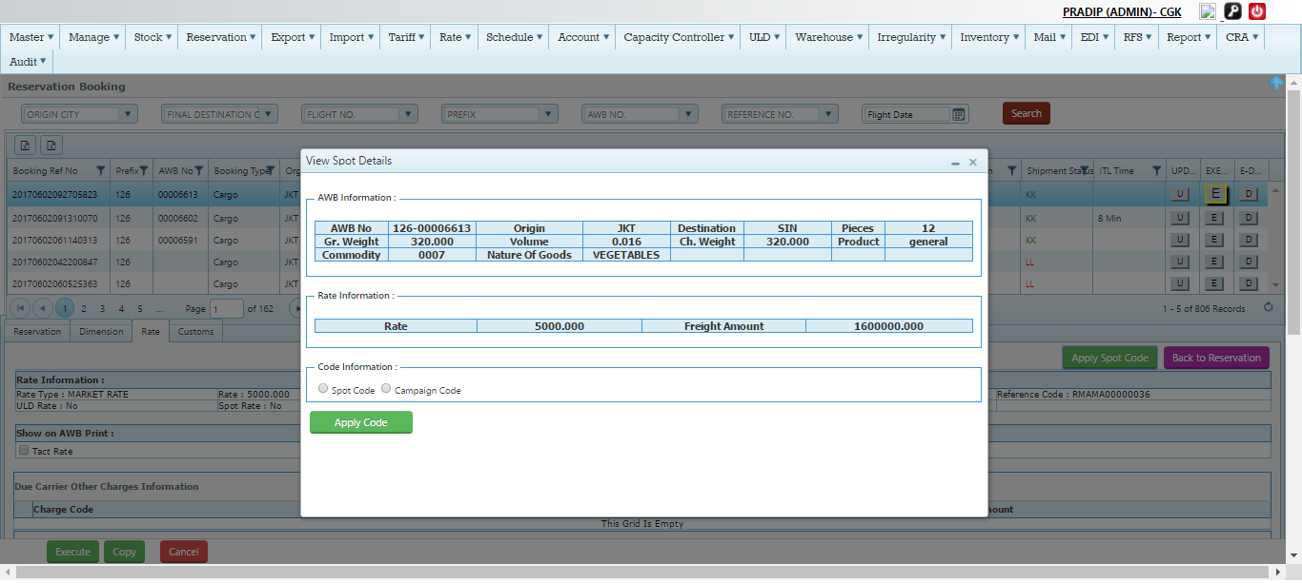

Figure spot code apply

Process Details (Refer Screen 23)

1-AWB Information >It will auto populated

2-Rate information >Auto populated by the system

3-Code information>User need to choose as Spot code or campaign code

1. Spot code > If user click into the radio button it will open a new window where user has to select the code from the drop down list

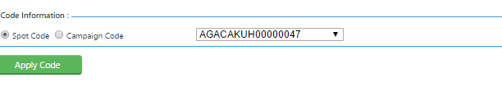

Select the code and click into the Apply code Button in the down , It will get saved and rate information will change accordingly in the Rate tab of that AWB

1. Campaign Code> If user click into the radio button it will open a new window where user has to type the code in the free text field

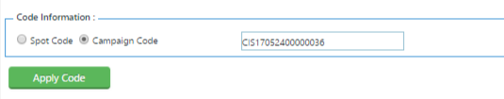

Type the code given and click into the apply code , if valid it will get saved and rate will get applied accordingly in the Rate tab

#### AWB Print

User can view the AWB print once shipment executed and able to take print as well in both format preprinted and Normal print

Navigation-Reservation>Cargo Booking>E Tab>AWB Print

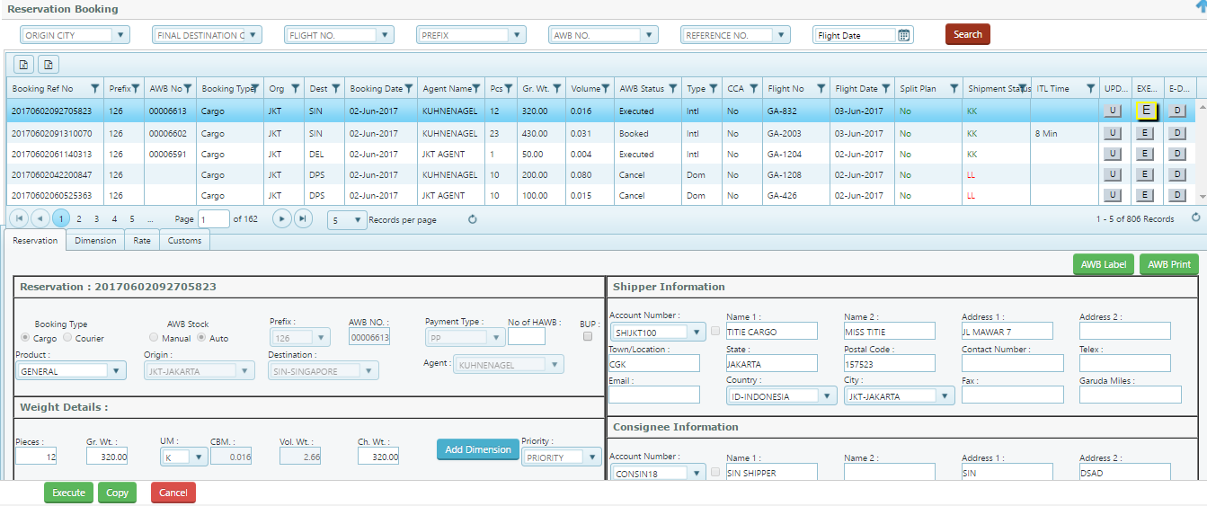

Figure AWB

Click into the AWB print Button (Refer screen-24), It will open the AWB Format as bellow (Screen 25)

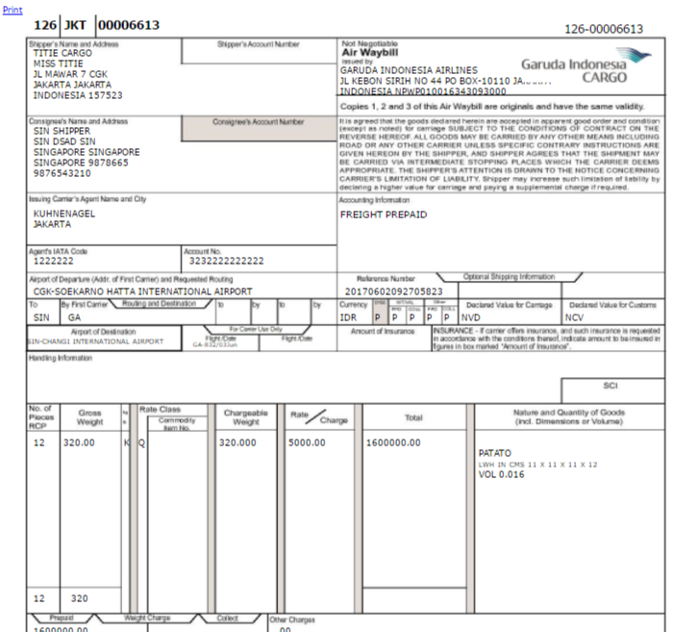

Figure AWB Copy Normal

For preprinted > user need to click the Print link located into the extreme left of the AWB print

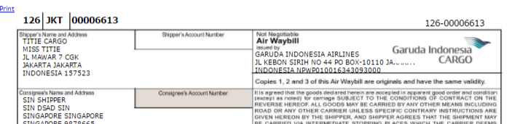

Figure Preprinted format

Click into the Print link (Refer Screen -26) and it will open as bellow

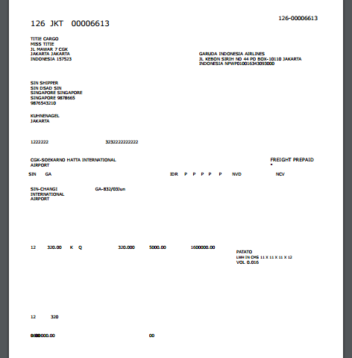

#### AWB Label

User can print the AWB label after shipment executed

Navigation-Reservation>Reservation & Booking>E Tab>AWB Label Print



Figure AWB Label

Click into the AWB Label Button (Screen -27) , It will open the Label

Note – AWB label based on AWB pieces, Example- If AWB is 10 pieces, 10 AWB label will open for print

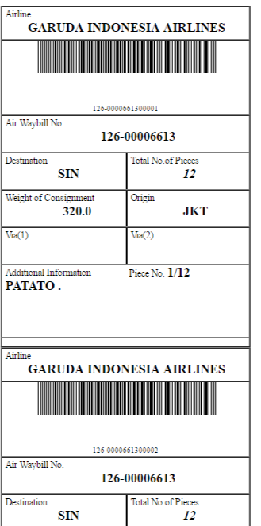

Figure IATA 606 label

### Copy Booking

Copy Booking used to copy the existing AWB data for Booked or executed shipment except the AWB serial Number; user simply can rebook with same data with New AWB number or can also modify the some of the field and Booed the shipment

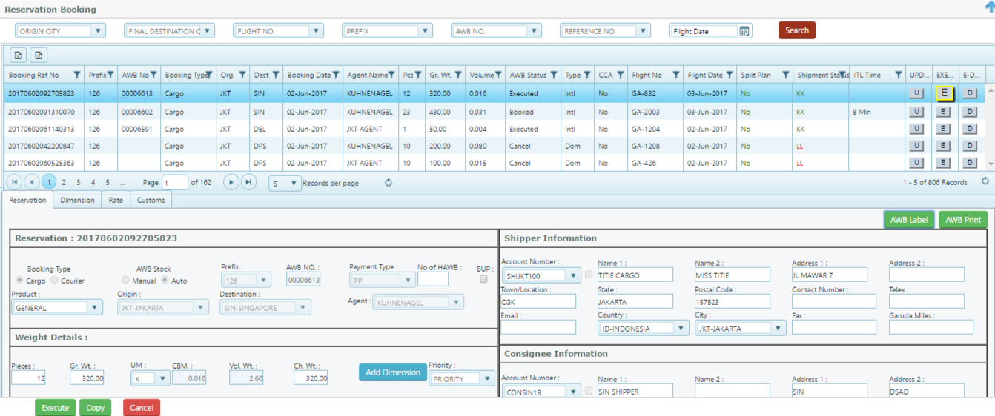

Figure Copy Booking

#### Copy Booking Process

Navigation- Reservation>Reservation & Booking >Click E Tab or U Tab> Click Copy Tab on down

Once click into the copy Tab (Refer Screen-29) , system will open the AWB information without the AWB number(Screen-30)

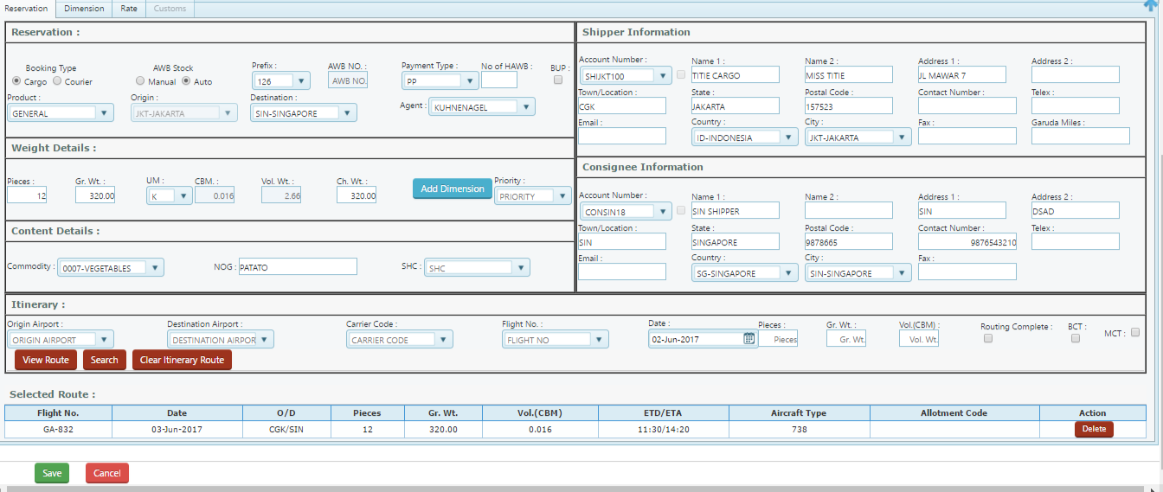

Figure New Copy Screen

User either can Book with same information or want to change or modify the information may proceed and can save by clicking the Save button

### Interline Booking

Interline Booking has similar process with normal cargo booking but has two little different selection, It has two sub process

a-Interline booking – GA into OAL (Other airline)

b-Interline Booking –OAL into GA

### Interline Booking –GA to OAL

Booking for GA AWB into OAL flight will have similar process to the normal booking except selecting the OAL flight .

Example-1 126-00001234 JKT-SIN on SQ231/20 sep

Example-2 126-00002343 JKT-SIN-SYD ON JKT-SIN on GA-689/20 sep , SIN-SYD on SQ456/20 sep

Navigation- Reservation>Cargo Booking

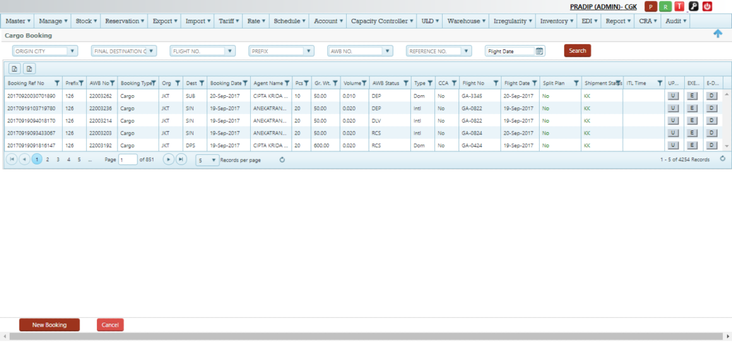

Figure Main Cargo Reservation page

Click into the New Booking to process Interline booking

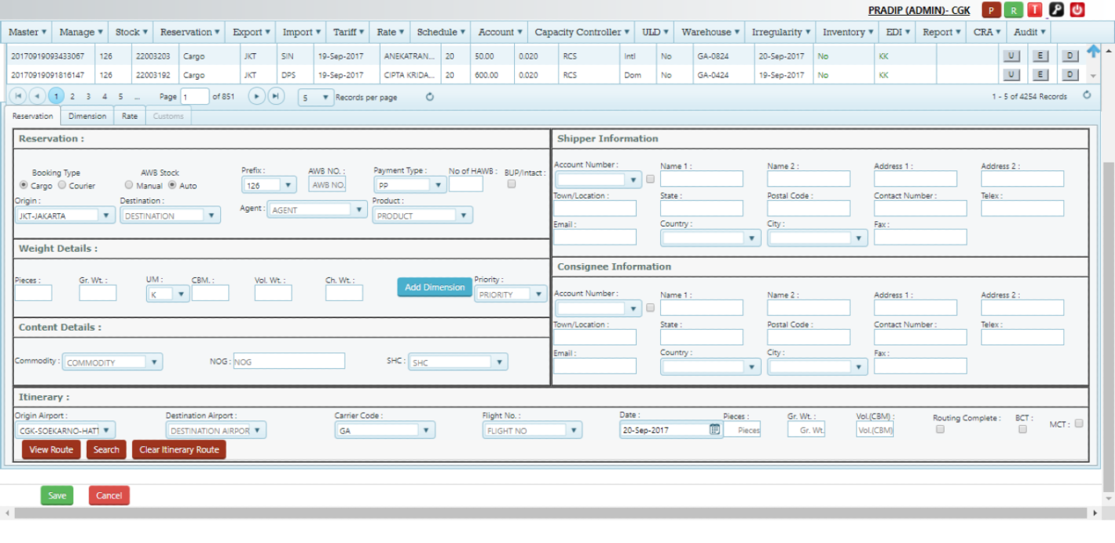

Figure New Cargo Booking

Process –

Step 1-select the AWB stock , if it is manual please put the AWB no on the AWB text field , select the Prefix (Booking from GA to OAL it will be always 126 )

Step2-select the Destination from the drop down

Step3-select the agent name from the drop down, If booking is done by the Agent log in then no agent will automatically will disable

Step4-select the product from the drop down

Step5-select the pc/weight and apply the dimension from the Dimension Tab

Step6-select commodity, Nature of goods, and SHC if any

Step7-select the itinerary , If shipment need to book into OAL flight , select the OAL carrier code , input the flight number on the text field and search flight

Step8-If it is booking into multi sector into GA and OAL , please select the GA flight and then select OAL code and flight number process and search

Step9-Save the entire information to book the shipment

Example 1- GA to OAL flight

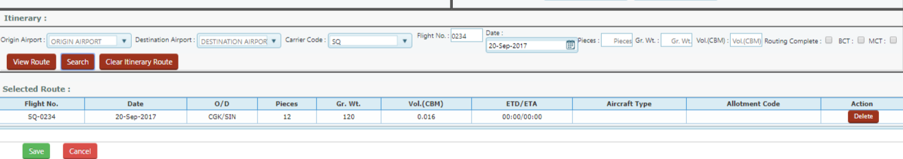

Figure OAL Itinerary selection

Example 1- GA to OAL , first sector on GA and second leg is OAL

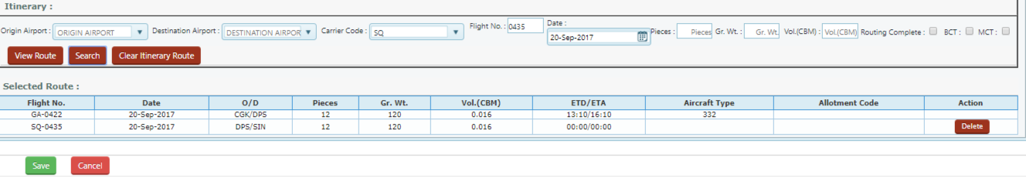

Figure GA and OAL flight selection

Click into save the Booking into the main grid as bellow

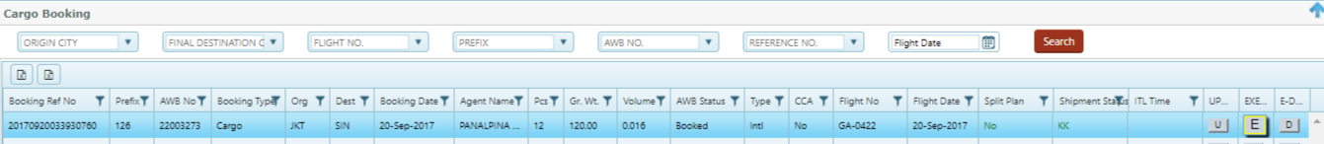

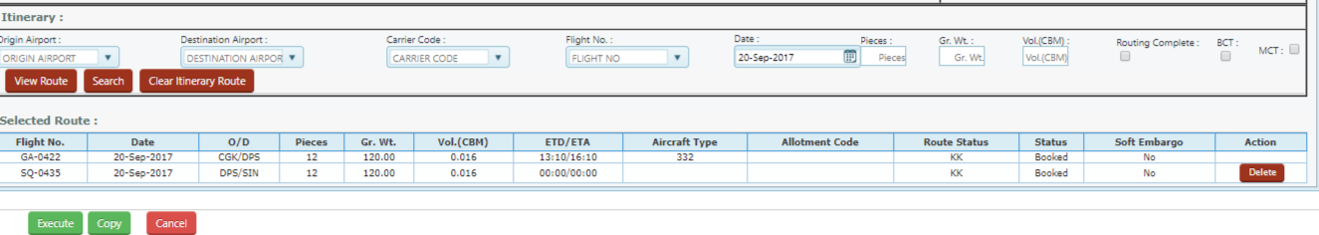

### Interline Booking –OAL to GA

OAL AWB can be book into the GA flight on single sector as well as multi sector.

Example1- AWB of QR can book from KIX to JKT on GA flight, 157-00001234, KIX-JKT on GA789/20 sep

Example2-AWB of QR can book from DOH-DPS via JKT, DOH-JKT on QR flight and JKT-DPS on GA flight

Navigation- Reservation>Cargo Booking



Click New Booking to process for Interline booking



Process –

Step 1-select the manual AWB stock (Note- for OAL AWB it has to be always Manual stock),

Step2-select the OAL prefix from the drop down, Example – if QR AWB it has to be 157

Step3-Type the AWB number manually

Step4-select the Origin and destination from the drop down,

Step5- Agent name will auto bind based on OAL AWB prefix, (system do not maintained the OAL agents)

Step6-select the product from the drop down list

Step7-Type pc/weight and select the dimension from the Dimension tab

Step8-select the commodity from the drop down list and type Nature of goods , select the SHC if any

Step9-select the itinerary , for OAL AWB on itinerary it will display the OAL carrier code followed by flight number text box , type the flight number and search

Step10-if it is multi leg into OAL and GA , for GA flight select from the drop down and search flight

Step11-click save button to save the reservation

Example1- QR AWB, from JKT-SIN via GA flight , 157-00002343, JKT-SIN on GA-834

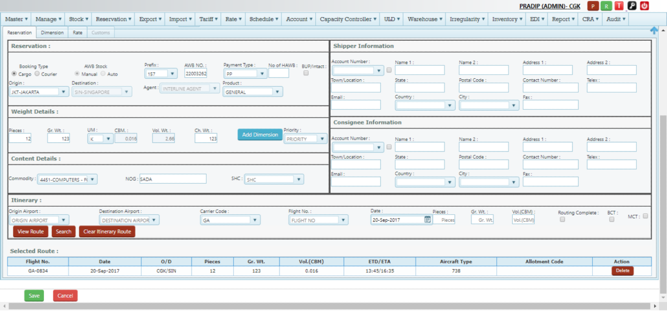

Example2- QR AWB, from JKT-SIN –DOH via GA flight and QR flight , 157-00002343, JKT-SIN on GA-834 and SIN-DOH on QR flight

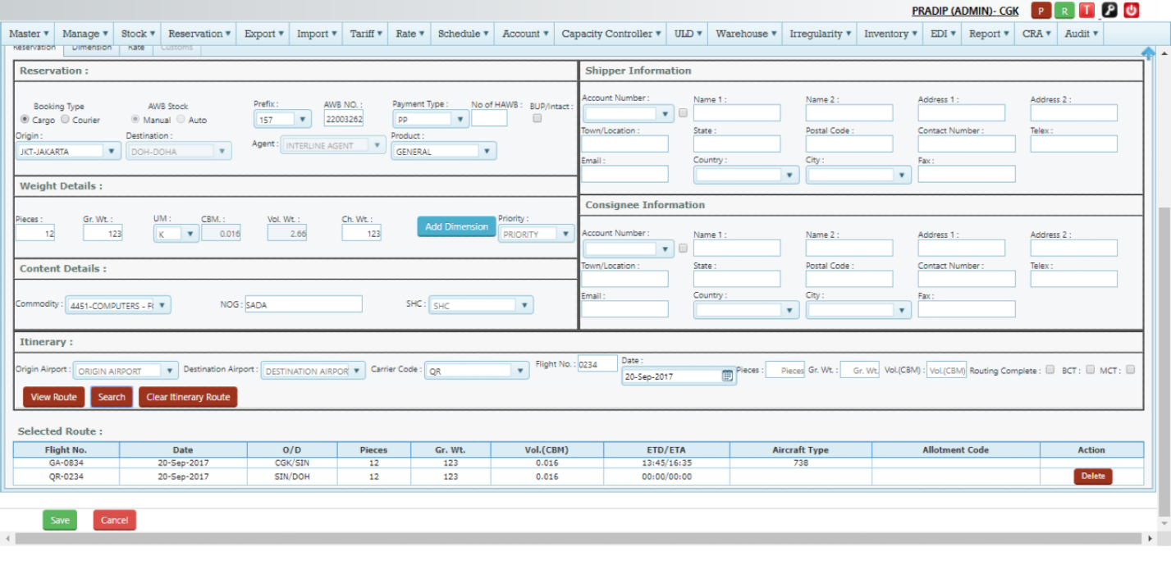

Clicks save to save the reservation

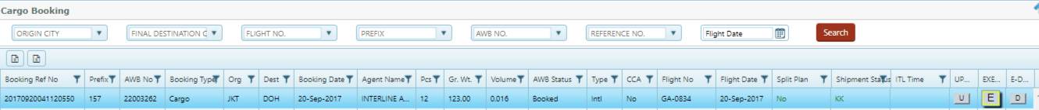

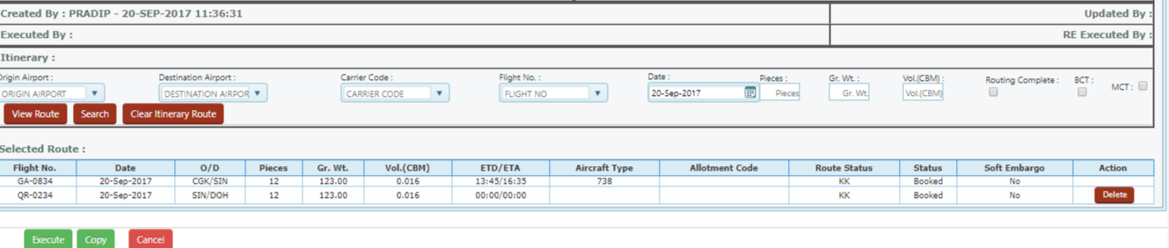

### Update Interline Booking

Please refer the Normal Cargo booking update process

### Execute Interline Booking

Please refer the normal cargo execution process

### House Airway Bill Capture (HAWB)

House Air waybills (HAWB) - User need to update the HAWB information in case of CONSOL shipment as MAWB

Note- On Reservation , If user given the details on No of HAWB details, then AWB number will reflect on HAWB screen on bellow .

Navigation –Reservation>HAWB Capture

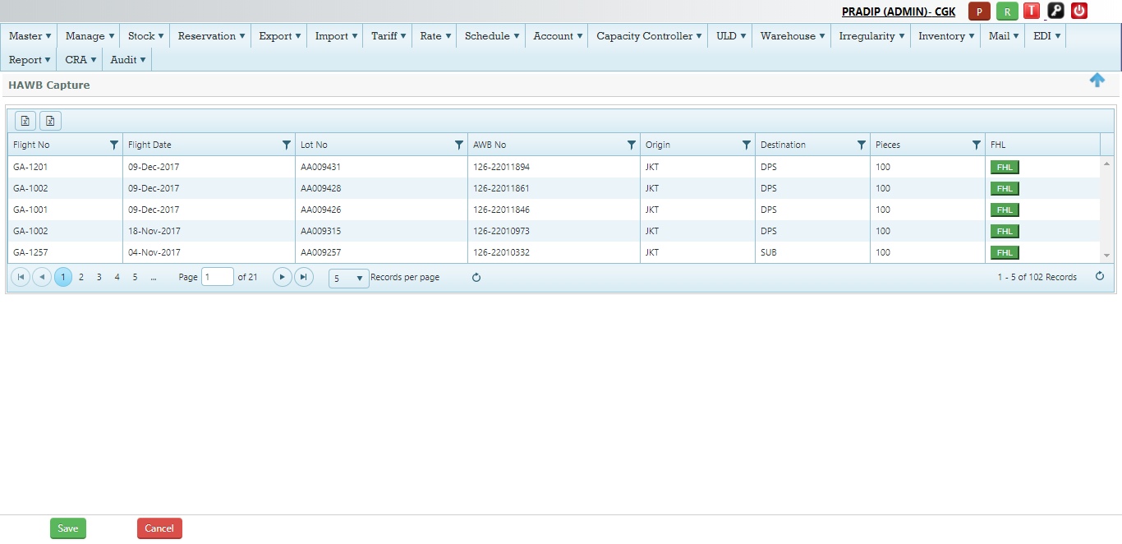

Figure HAWB Capture

Process to capture the HAWB –

|  |  |
| --- | --- |
| Flight No | Auto displayed , This is the flight no of the shipment booked |
| Flight Date | Auto displayed , This is the flight date of the shipment booked |
| AWB No | MAWB Number of the shipment listed , Note- Only CONSOL shipment having HAWB will display here |
| Origin | Auto displayed , Origin of the shipment –MAWB |
| Destination | Auto displayed , Destination of the shipment –MAWB |
| Pieces | Auto displayed , This is the total no of shipment for MAWB |
| FHL | HAWB details – User need to create this Tab to update the HAWB information |

Click into the FHL Tab to capture the HAWB information

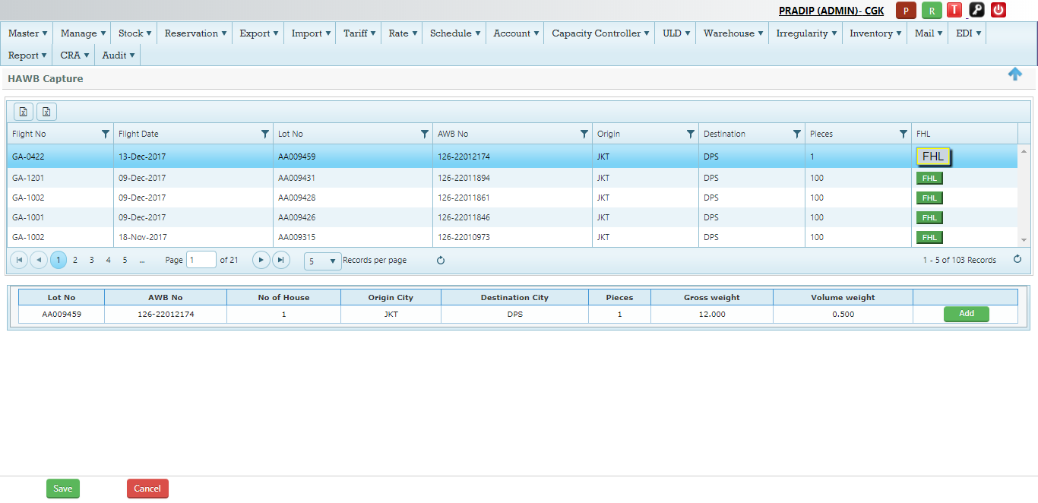

Figure HAWB information

Step 1-Click FHL Tab

Step 2-Click Add Tab to add the HAWB details as bellow

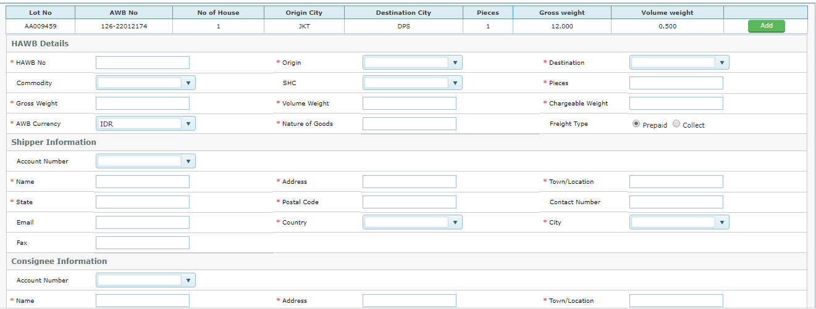

Figure HAWB Details

|  |  |
| --- | --- |
|  | HAWB Information |
| HAWB No | Type the HAWB number here |
| Origin | Select the origin city from the drop down , Note – HAWB origin can be different than the MAWB origin |
| Destination | Select the Destination city from the drop down list , Note-HAWB destination can be different from the MAWB number |
| Commodity | Select the commodity code from the drop down list |
| SHC | Select the SHC from the drop down list |
| Pieces | Type the total no of the pieces for that HAWB number |
| Gross weight | Type Gross weight of the HAWB number |
| Volume weight | Type the Volume weight of the HAWB manually |
| Chargeable weight | System will auto calculate the chargeable weight |
| AWB currency | It will auto pick up by the system from MAWB Number |
| Nature of Goods | Type the description of the commodity |
| Freight Type | It will auto select based on the mode of payment type selected from the MAWB number |
|  | Shipper Information |
| Account Number | This is the shipper account number -Select the shipper account number from the drop down , If this is selected all the relevant data will fetch by the system |
| Name | Free Text-Type the Name of the shipper |
| Address | Free text – Type the address of the shipper |
| Town/Location | Free test-type the name of the Town |
| State | Free text- type the name of the state |
| Postal code | Free text- type of the postal code |
| Contact Number | Free text – type the contact number of the shipper |
| E-mail | Free text- type the e-mail ID of the shipper |
| Country | Select the country name from the drop down list |
| City | Select the city from the drop down list |
|  | Consignee Information |
| Account Number | This is the consignee account number -Select the consignee account number from the drop down , If this is selected all the relevant data will fetch by the system |
| Name | Free Text-Type the Name of the consignee |
| Address | Free text – Type the address of the consignee |
| Town/Location | Free test-type the name of the Town |
| State | Free text- type the name of the state |
| Postal code | Free text- type of the postal code |
| Contact Number | Free text – type the contact number of the consignee |
| E-mail | Free text- type the e-mail ID of the consignee |
| Country | Select the country name from the drop down list |
| City | Select the city from the drop down list |

Note- Ignore the charge Declaration, harmonized commodity, Description of goods – this is the optional field

Step 3 – Click Save button to save the HAWB number

Step 4- Once it is saved the information, the FHL Tab will become green and save into the HAWB grid as bellow

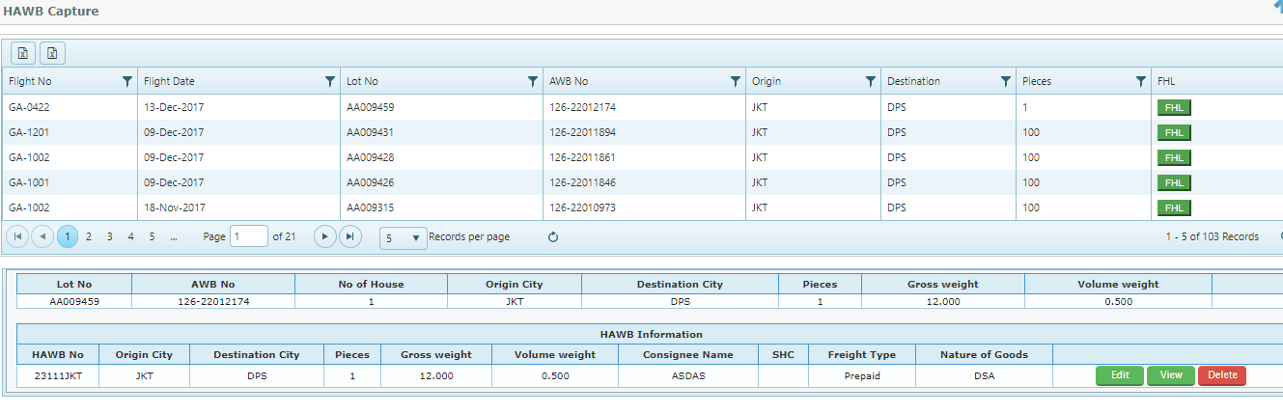

Step 5-Click Edit button to modify the data if any

Step 6-Click View Button to view the HAWB information

Step 7-Click Delete button if user need to delete the HAWB number

## Cross Border function

Making the Booking from another city from the log in city, Example- Agent Panalpina, JKT can make booking from DPS-SIN

Process Flow –

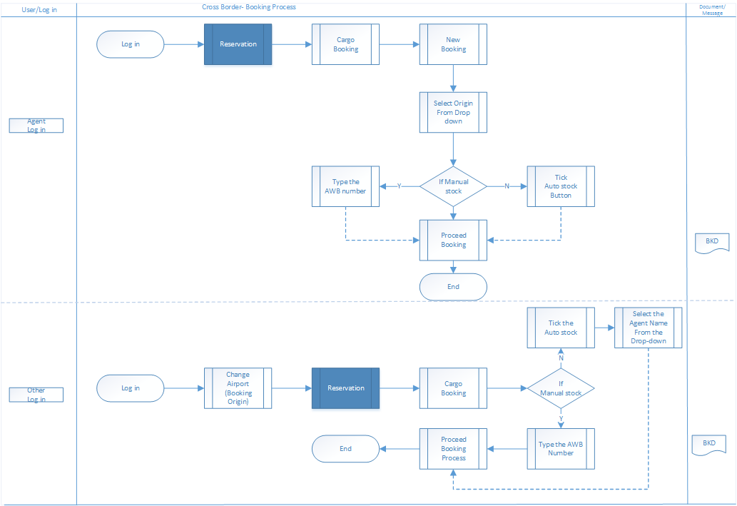

Figure 1 Process Flow -Cross Border

### Cross Border Booking –Agent Log in

Option 1/Process Details (Manual stock)

Agent Name –SKK/JKT

Log in –SKK

Airport Access-DPS

Manual AWB stock no- 126-23232226

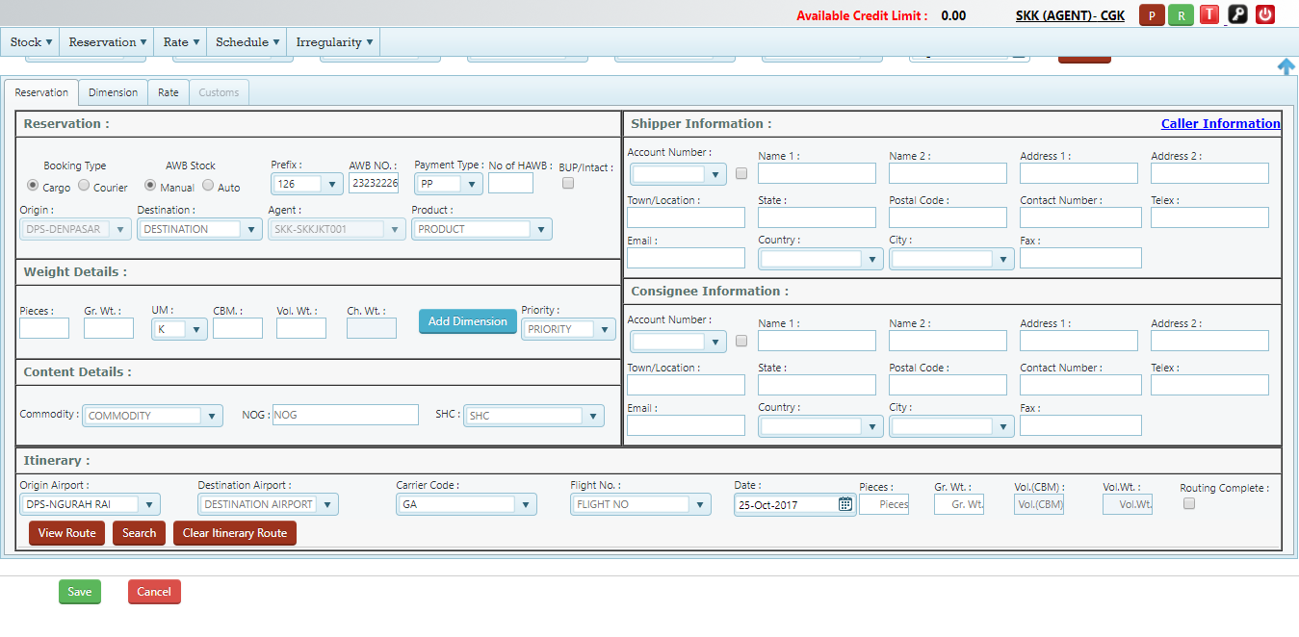

Figure 2 Agent Log in

Option 1/Process Details (Manual stock)

Step 1-slect the Origin from the origin drop down, Note Origin city will show here for which access given on the User creation master (Example- DPS )

Step 2- select the manual stock and Type the AWB number, Note AWB stock which issued to this agent by GA –Airline,

Step 3- Select the destination from the drop down

Step 4-Agent name will display automatically, example- SKK (as AWB has issued to SKK)

Step 5-select the Product from the drop down,

Step 6- Proceed the other normal booking process

Option 2/Process Details (Auto stock)

Agent Name –SKK/JKT

Log in –SKK

Airport Access-DPS

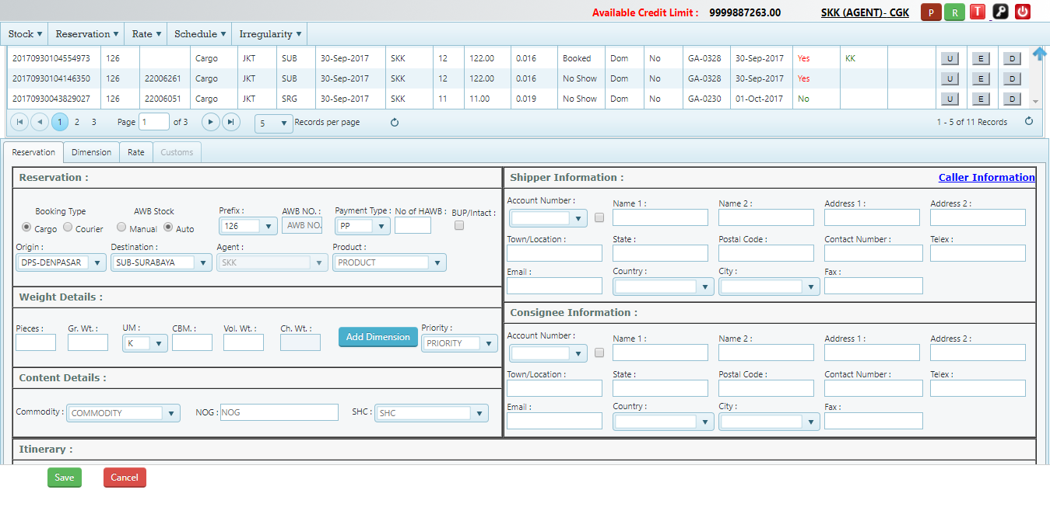

Figure 3 Airline Log in

Process -

Step 1-select the Auto stock option

Step 2-select the origin from the drop down , Note Origin city will show here for which access given on the User creation master

Step 3- select the Destination from the drop down

Step 4-select the Product from the drop down,

Step 5- Proceed the other normal booking process

### Cross Border Booking –Other Log in

Cross Border for other Log in are defined – Admin/Super admin/Airline/GSSA/POS-CSC/POS-KSO /Outlet

Option 1- Manual stock

Log in –Airline /Startup /JKT

User ID-startup

Airport Access-SUB/DJJ

Agent Name-SKK/JKT (Agent User has access airport –SUB /DPS)

AWB no-126 23232226

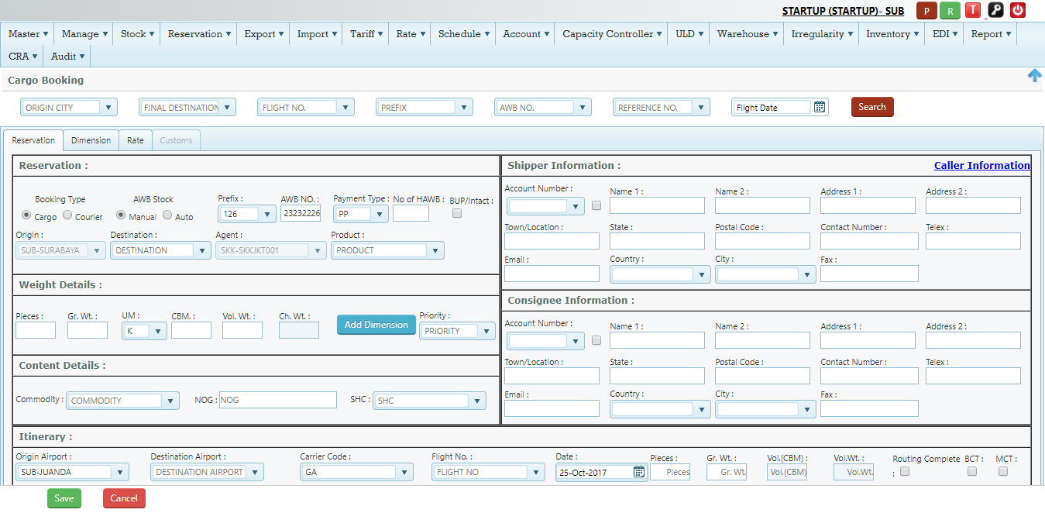

Figure 4 Airline Log in -Cross border Booking

Process Details -

Step 1- change the airport //SUB

Step 2-slect the Manual stock option and Put the AWB number

Step 3-Select the destination

Step 4-Agent name will display automatically as SKK (as stock has issued with that agent name)

Step 5- Select the product from the drop down

Step 6- process with other Booking details

**Note**- Booking origin should have same access of Agent user

Example- If Booking is done from SUB, agent user (SKK should have access of SUB), if Agent user has different access than the booking origin, will not able to process as cross border booking

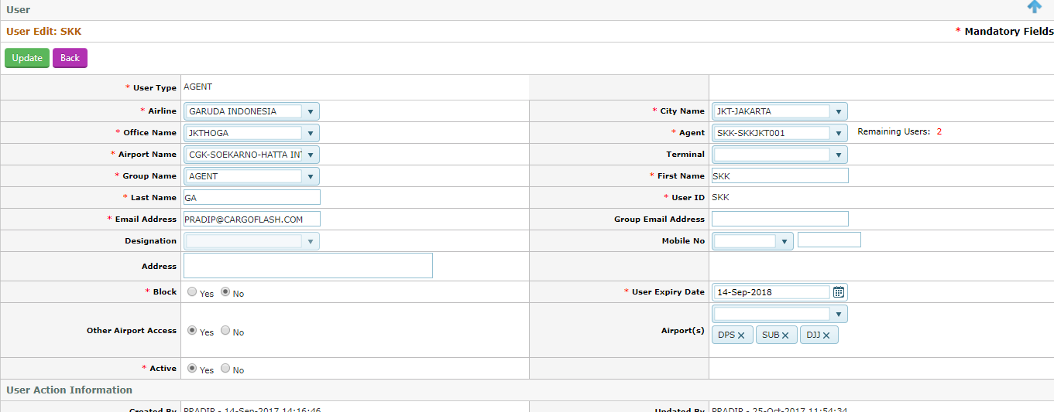

Figure 5 User SKK with Airport Access

### Cross border booking will displayed on Log in station (Change process)

Current Process – If shipment booked for origin is different than the log In , it get displayed on origin station

Example- Log in SUB , and booking is done from JKT- DPS , after booking it get displayed at JKT reservation grid

Change Process - On above booking it will still display on SUB log in with origin as JKT,

Example- Booking from JKT- DPS from SUB log in access, all booking will displayed on SUB log in

## Booking List

Booking List used by Airline user to confirm the no of shipments for a particular flight. All executed shipments only will be available in the Booking list,

Navigation-Capacity Control>Booking list

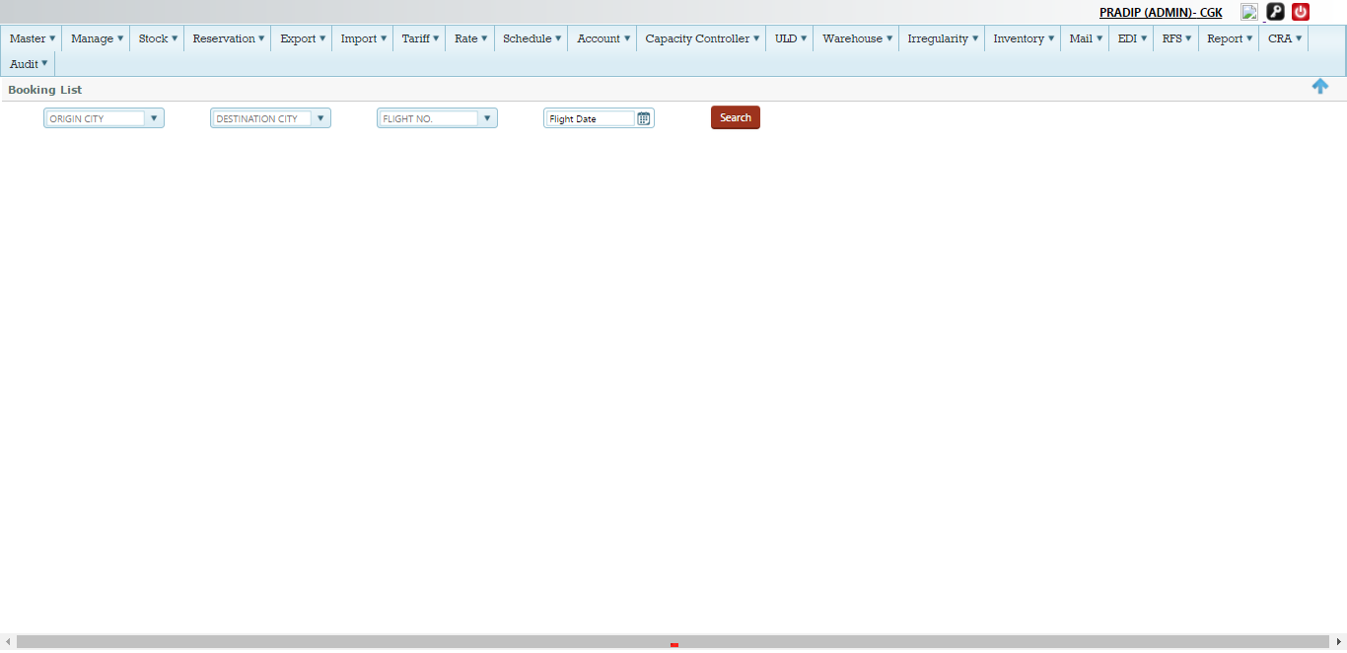

Figure Booking List

### Search Booking List

User can search the Booking list based on Flight number and Date , For Example user is searching the Booking list for flight GA-832/03June 2017

Process –User need to select the flight number from the drop down and date and click into the Search Button



Figure Search Booking List

Click search, It will open the Booking list of that particular flight

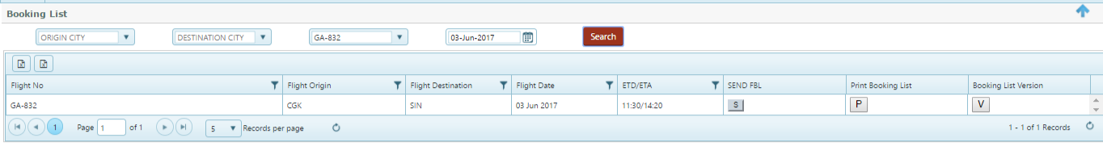

Figure Print Booking list

Details Print Booking List (Screen -40)

|  |  |
| --- | --- |
| Send FBL | User can send the FBL Message by clicking the S tab |
| Print Booking List | User can create the Booking List by clicking the P Tab and also user can save the Booking list on this Tab , On clicking the P tab system will open a Bellow New window as Booking List  C:\Users\Pradip\Desktop\screen\screenshot-cfrespreuat.cargoflash.com-2017-12-13-13-01-09-854.png  Print Button – User can print the Booking list by clicking the print sign  Save Button –User save the information by clicking the Save button and it get save and version get maintained by the system |
| Booking List Versions | User can view the Different versions by clicking the V Tab  C:\Users\Pradip\Desktop\screen\screenshot-cfrespreuat.cargoflash.com-2017-12-13-13-02-20-195.png |

## Loading instruction

Loading instruction used by Airline to instruct the warehouse or GHA for loading the shipments for a flight, All executed shipments only will be available in LI only,

Navigation –Export >Flight Control>LI Tab

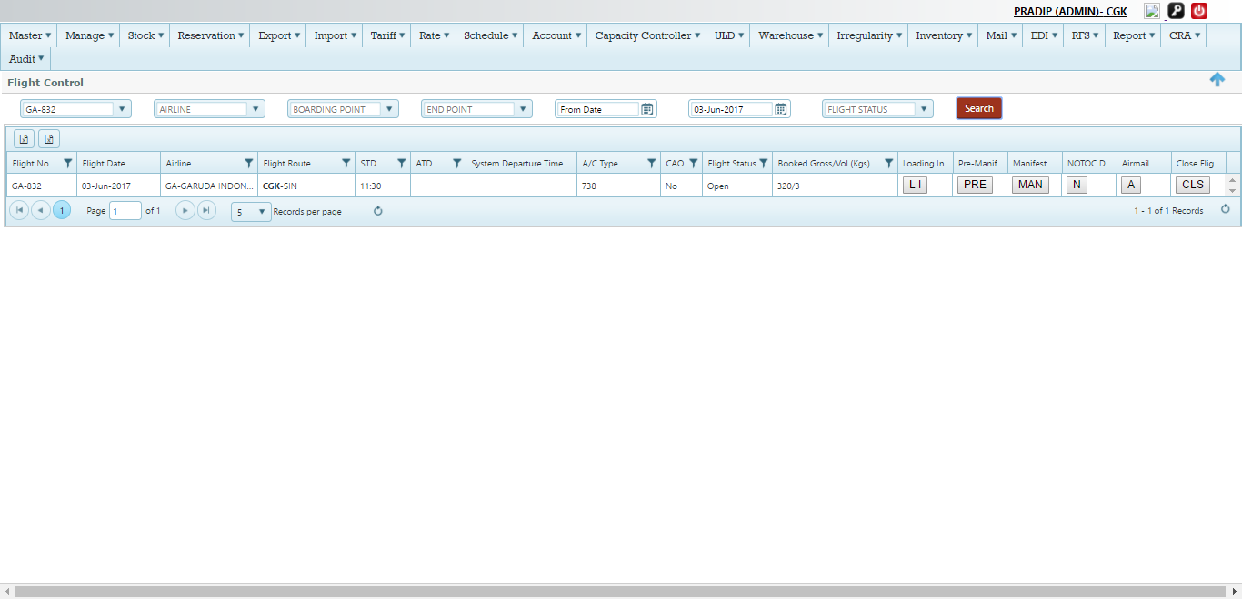

Figure Loading Instruction

### Create Loading Instruction

To Create LI user need to click into the LI Tab under flight control based on flight, Example- Lets create loading Instruction for flight GA-832/03June

Enter the Flight Number from the drop down and flight date from the calendar and click search Button , Then click into the LI , It will open the LI window for Creation

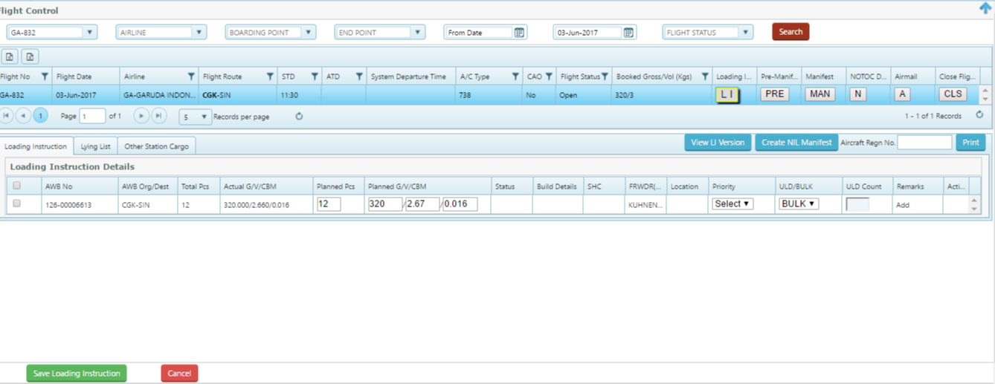

Figure Create LI

Details Create LI-(Refer Screen -42)

|  |  |
| --- | --- |
| AWB No | It will auto populated by the system from the reservation |
| Org/Dest | Origin and Destination of the shipment –auto populated |
| Total pc | Total pieces of the shipment , auto populated by the system |
| Actual Gr/V/CBM | Actual gross weight , Volume and CBM of the shipment |
| Planned pieces | It indicates the no of Pieces to be planned for that flight in Bulk or ULD |
| Planned Gr/V/CBM | It indicates the weight of Pieces to be planned for that flight in Bulk or ULD |
| Status | It shows the status of the shipment |
| Build Status | It shows the Build Up status |
| SHC | It will auto populated the SHC if any for that shipment |
| Forwarder | It will auto populated the Agent Name of that shipment |
| Location | It indicates the Location of the shipment |
| Priority | User need to select the Priority from the drop down list |
| ULD/Bulk | Select the ULD Type or Bulk to be load |
| ULD count | NA |
| Remarks | Click ADD to put the remarks for the shipment , |
| Action | It use to delete the Row |
| Save Loading Instruction | Select the AWB by ticking the check box from the left hand of the AWB and click Save Instruction Button , On successful LI Tab will become green |

#### Print Loading Instruction

Once LI has created, it will available for print, To print the LI user need to click into the LI Tab and then click Print

Once user click into the Print , It will Open the LI print page

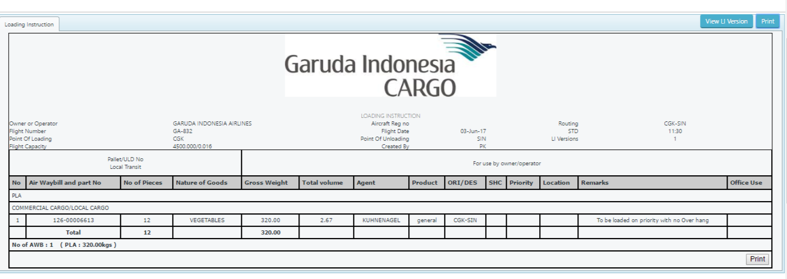

Figure LI print preview

Click into the Print Tab to printed

#### Loading instruction Versions

Loading versions are maintained in the system to tack the any changes of LI , LI version created on each click of Save button on LI page

View LI Version – Click into the LI version on Print preview or LI screen, It will open and show as bellow

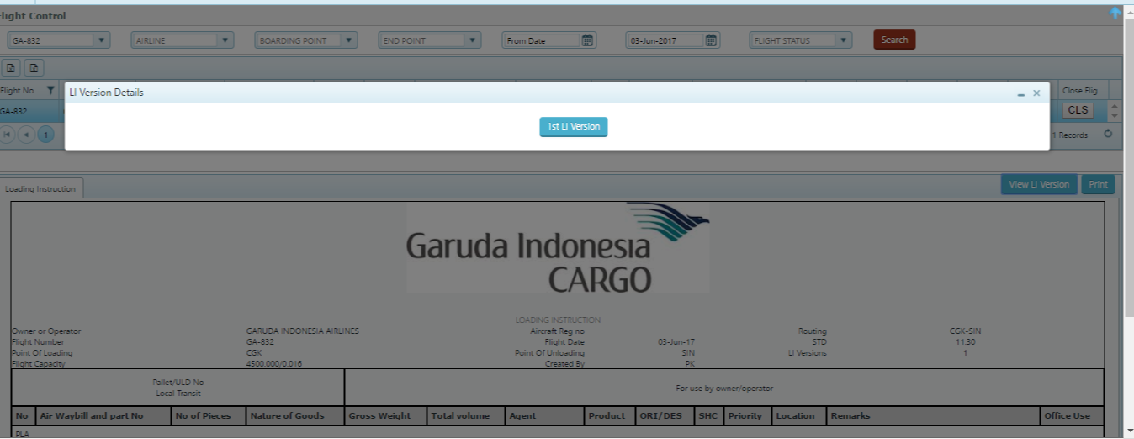

Figure LI Version

## AWB Penalty

ICMS has managed different type of penalty for the shipment and two different category as Auto /manual penalty based on shipment category

Following penalty parameter has been defined for ICMS

1-BKD Vs Execution (Applied automatically)

2-Cancelation (Applied manually)

3-Exe Vs RCS (Applied automatically)

4-ITL (Applied automatically)

5-Late Acceptance (Applied automatically)

6-No show (Applied automatically /manually)

7-RCS Greater than Execution (Applied automatically)

8-RCS less than Execution (Applied automatically)

9-Void (Applied automatically)

Navigation –Export>AWB Penalty

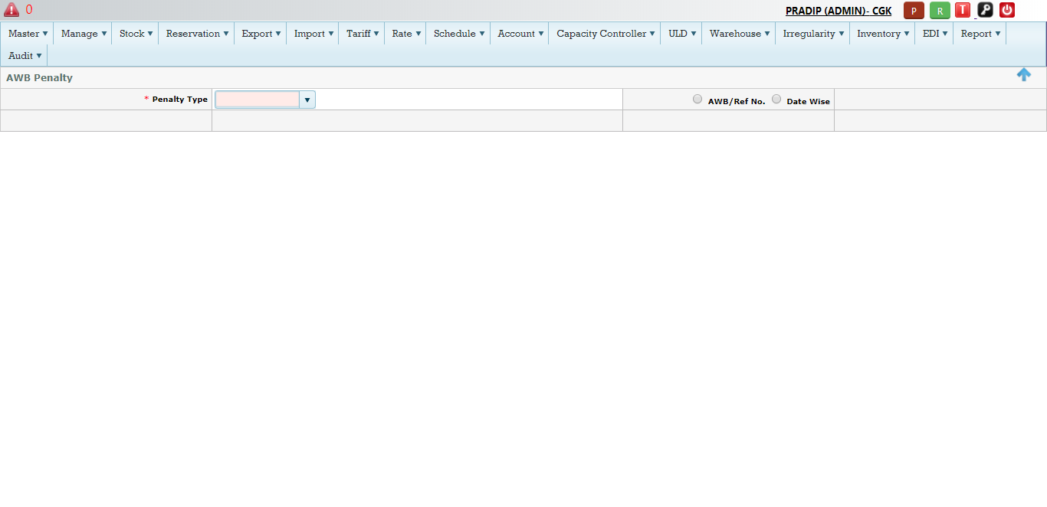

Figure AWB Penalty

### Cancel Shipment

User can cancel the shipment using AWB penalty module , to cancel the shipment user need to select the Cancelation parameter from the drop down .

System has two option to make cancel, It can cancel Individual shipment or number of shipments in a specific Date range

#### Select Cancellation parameter >Click AWB/Reference Number >click search

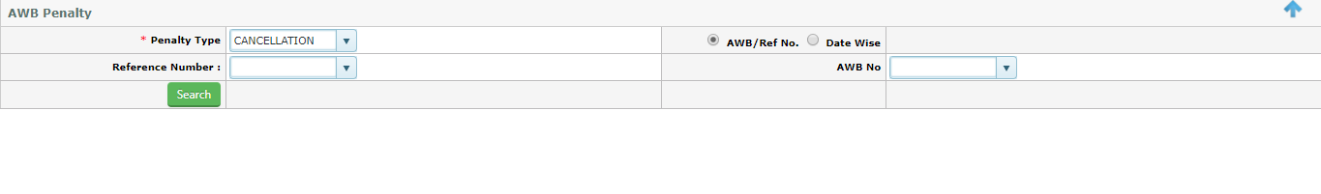

Figure Shipment Cancelation

Process-

1. Select Reference Number (if it is Domestic shipment )
2. Or select the AWB Number if it is International shipment
3. Click Search

Once it is search by clicking the search Button, system automatically open the new window with details of that Ref/AWB number on the bellow grid

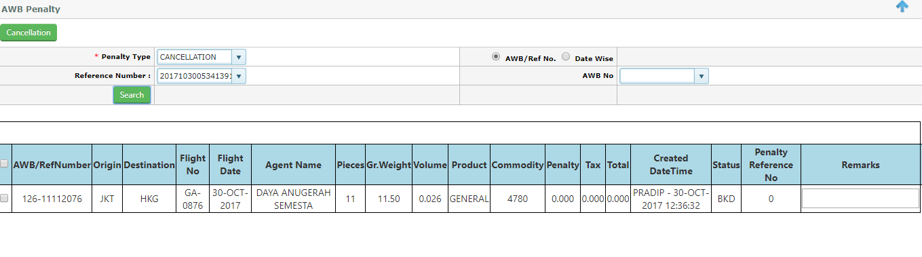

Figure Cancel Mark

Click the Tick Box location just left hand side of the AWB

1. Click the check box
2. Then click the Cancel Button ,

Shipment will mark as cancel, user can check all cancel shipment on the Report called – Penalty Report (Located in Module-Penalty >Penalty Module)

#### Select Cancellation parameter from the drop down >Click Date wise

#### C:\Users\Pradip\Desktop\screen\screenshot-cfrespreuat.cargoflash.com-2017-12-13-12-29-49-538.png

Figure Date wise cancel

Process-

1. Select the Date from
2. Select the date to
3. Click search , It will display above screen (ref Fig 48)
4. To cancel , select the AWB/ref number using the tick box on the left and
5. Click the Cancel Button

To check the all cancel shipment, User need to go to Penalty Report (Penalty module>Penalty Report)

Process-

1. Select the cancellation parameter from the drop down
2. Select the Airline as GA
3. Select the Date from
4. Select the Date to
5. Click the Search Button

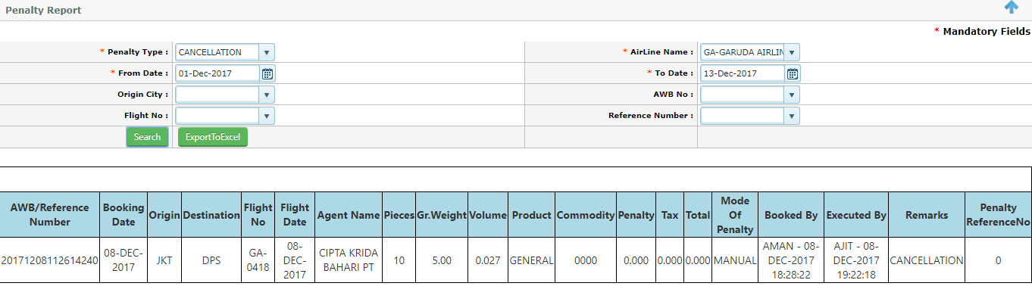

Figure Penalty Report –Cancellation

Note-User can also Export this report to Excel format by clicking Export to Excel Button

### Void Shipment

User can void the shipment using AWB penalty module, to void the shipment user need to select the Void penalty parameter from the drop down list

System has two options to make Void; it can void Individual shipment or number of shipments in a specific Date range

#### Select Void parameter >Click AWB No

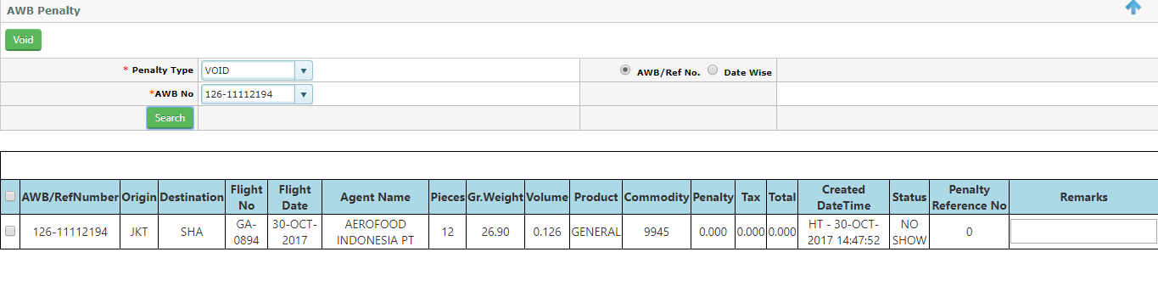

Process to Void

1. Select the AWB no from the drop down list
2. Click the search Button
3. It will open the new window with details of AWB that need to Void



Figure Void Shipment

1. Select the AWB by clicking the tick Box on the left of the AWB (ref Fig 50)
2. Click the Void Button to void the shipment

All Void shipment can be show in the Reservation Grid and also user can view in the Penalty report (Report module>Penalty Report)

Process-

1. Click the Void radio box
2. Select Airline as GA
3. Select From date
4. Select to date
5. Click the Search Button
6. It will display as bellow(Ref Fig 51)

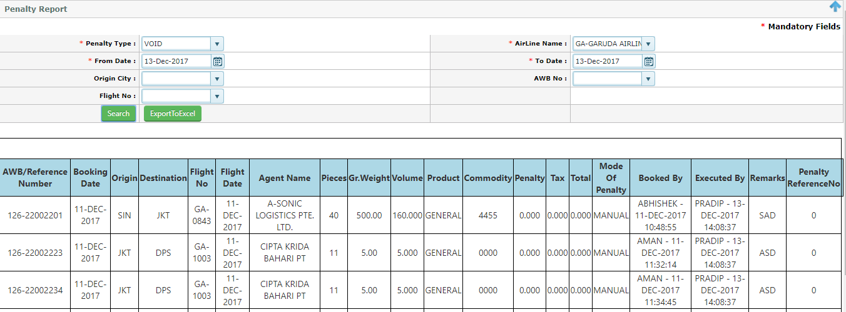

Figure Void Report

#### Select Void parameter >Click date wise

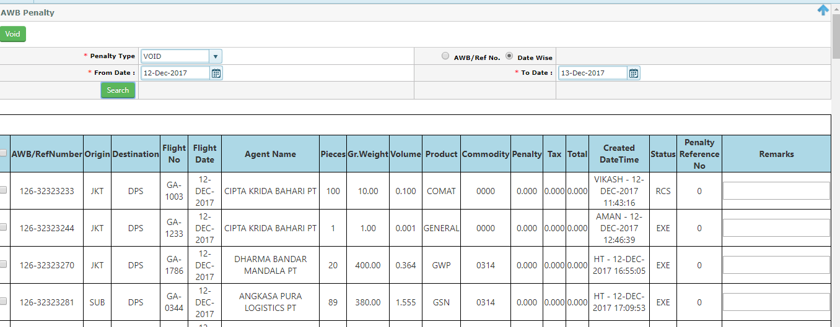

Process

1. Click the date wise Button
2. Select the Date from
3. Select the date to
4. Click search button
5. It will open up new window as bellow (Ref Fig -52)



Figure Date wise Void

Process to Void

1. Select the No of AWB that need to Void by clicking the tick box located just left hand side of the AWB
2. Click the Void Button
3. Once it is void , all shipments will listed marked as Void in the reservation grid as well as will listed in the Penalty Report (Penalty module>Penalty Report )
4. Refer the bellow screen (Fig -53)

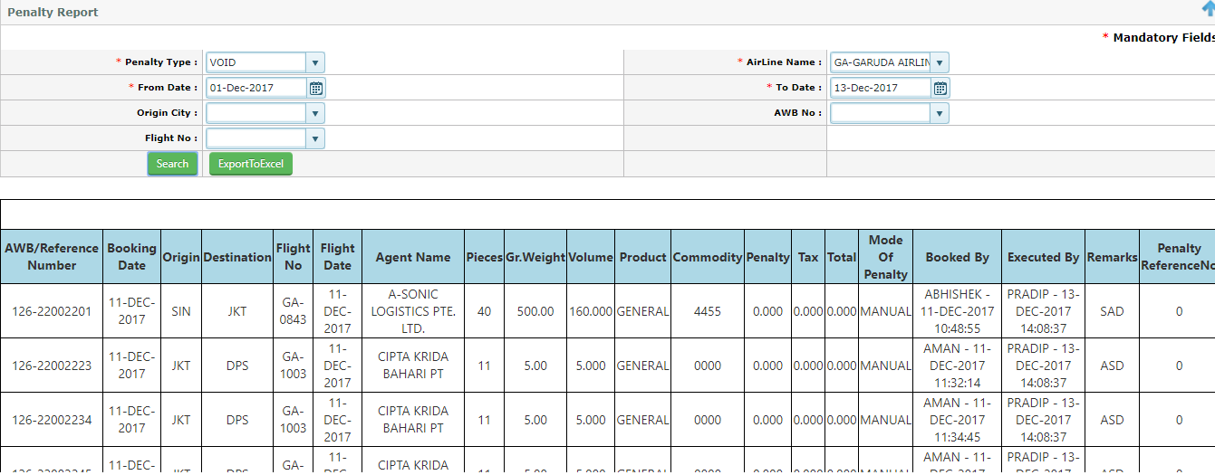

Figure Date Wise Void Report

### No show shipment

User can make No show manually using AWB penalty module, to make the No show shipment user need to select the No show parameter from the drop down list

System has two options to make No show, It can make No show for Individual shipment or number of shipments in a specific Date range

#### Select the No show parameter from the drop down >Click AWB No

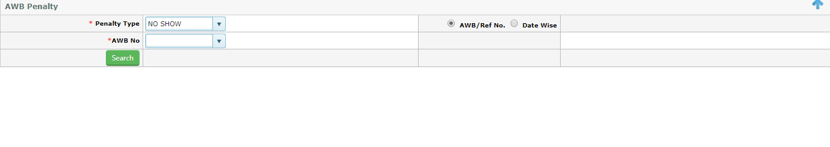

Figure No Show

Process to make No show

1. Select the AWB no from the drop down
2. Click the search Button
3. System will pull the AWB data in new grid for making as No show (refer Bellow screen )

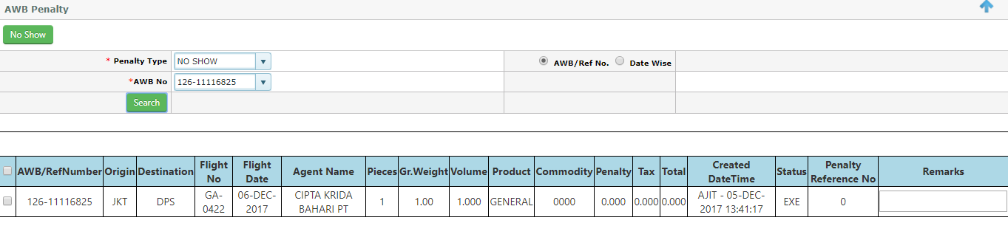

1. Select the AWB by clicking the check box
2. Click No show button , then shipment will marked as No show ,

Note- all No show shipment will only available in Penalty Report (Penalty module>Penalty Report)

To check the No show Penalty Report, Go to Penalty module>click Penalty Report >click No show Button

Select Airline>select from date>select to date and search

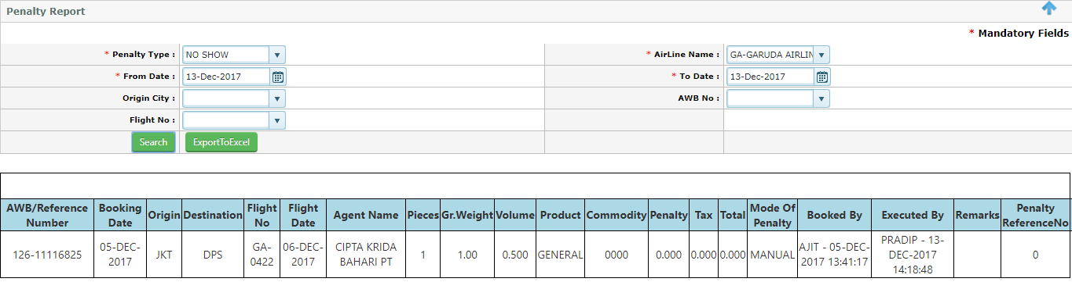

Figure No show Penalty Report

#### Select No show>Click Date wise

#### C:\Users\Pradip\Desktop\screen\screenshot-cfrespreuat.cargoflash.com-2017-12-13-12-50-02-466.png

Figure No Show Date wise

Process to make No show date wise

1. Click Date wise check box
2. Select from date
3. Select to date
4. Click search
5. System will search and will display all AWB data for making No show

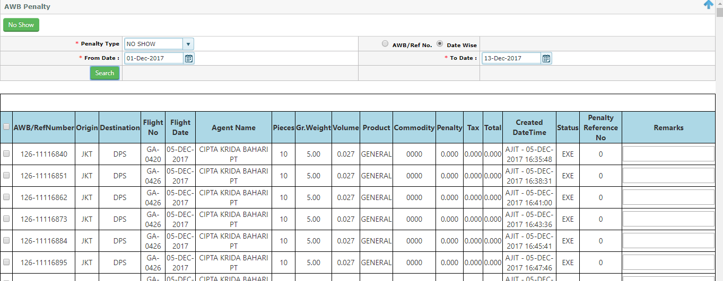

Figure Create No show Date wise

1. Select the AWB that need to make as no show
2. Click No show Button to make the No show

Note- all No show shipment will only available in Penalty Report (Penalty module>Penalty Report)

To check the No show Penalty Report, Go to Penalty module>click Penalty Report >select No show parameter

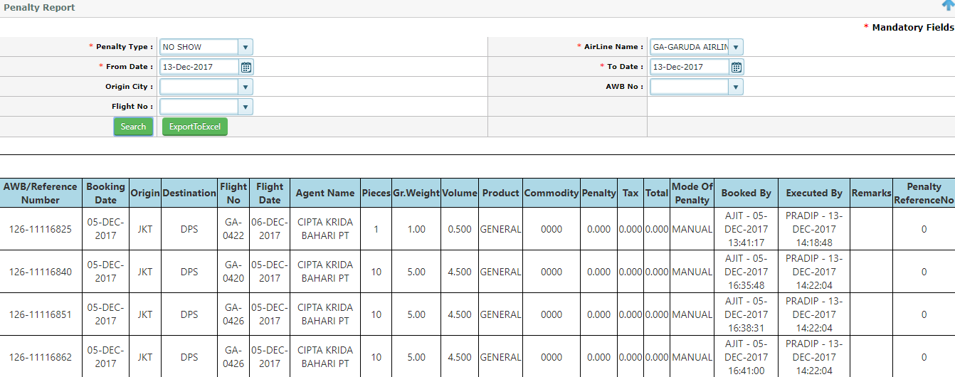

Note- User can export the No show report into excel by clicking the ExportExcel Button , located next to search Button

## Group Booking

Group Booking is the function that use to Transfer Multiple shipments from one flight to other flight

However By using the Group Booking user can perform two activities, transferring multiple shipments into another flight and also user can change the flight status as well (Amend flight )

### Transfer Flight (Group Booking)

Navigation – Capacity control>Group Booking

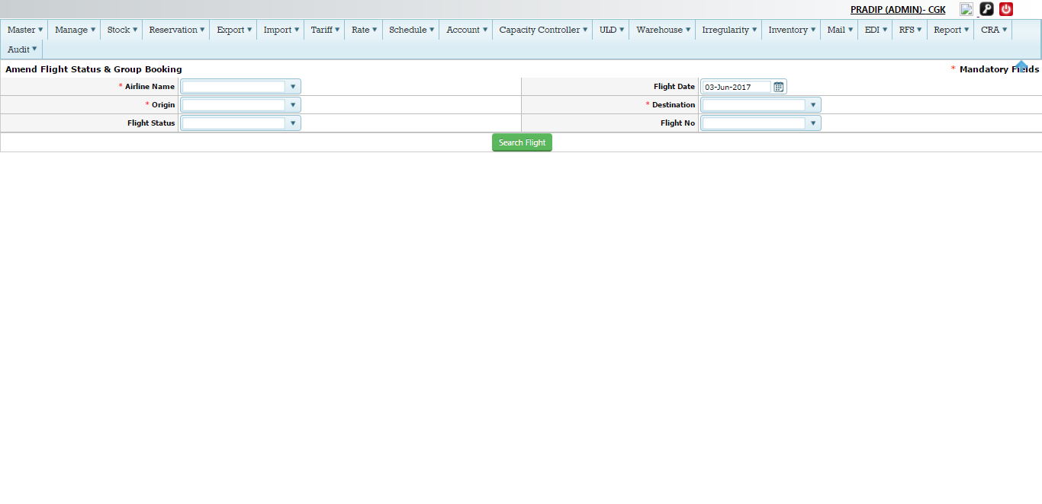

Figure Group Booking

Process Group Booking (Fig-50)

|  |  |
| --- | --- |
| Airline Name | Select the airline (By default it will show as GA), Example –Garuda Indonesian Airlines |
| Flight Date | Select the flight date from the calendar |
| Origin | Select the Origin from the drop down , By default it will be the log in city as a origin |
| Destination | Select the Destination from the drop down |
| Flight status | This function for Amend flight |
| Flight No | Select the flight number from which user need to transfer the shipments |
| Search Flight | Click the button to get the flight data |

Once search Button clicked by the user it will open the bellow screen

Note- user also can search without flight Number (In this case all flights operating from that Origin to destination selected by user will display

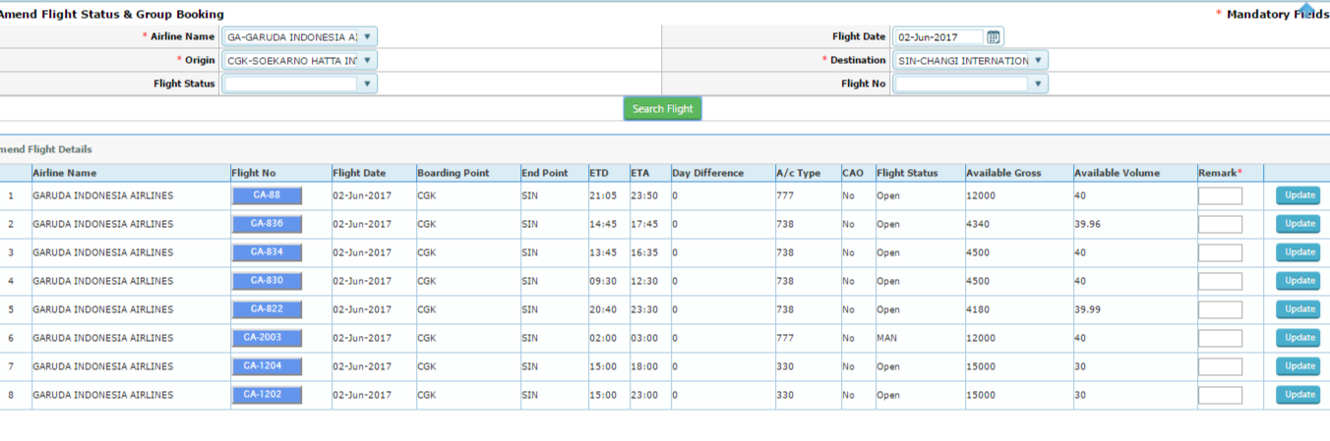

Figure Group Booking Flight search

Click the Flight Number for which user need to transfer the shipment, Example – Let’s try for a flight GA836/02june

Click into the flight GA836, It will open a new pop window as bellow (refer screen -53)

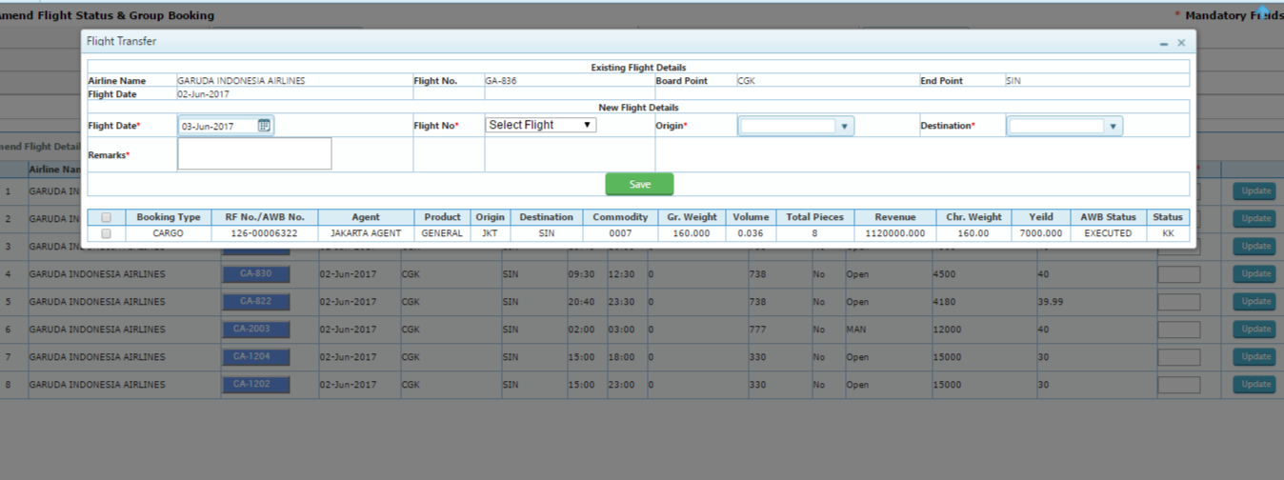

Figure Transfer shipments

Process to transfer the shipments from flight GA-836/02 (Refer screen-53)

|  |  |
| --- | --- |
|  | Existing flight details(Transferring from ) |
| Airline Name | It will auto populated as GA –Garuda Indonesian airlines |
| Flight no | It will auto populated , Example GA836 |
| Board point | It will auto populated ,Example-CGK |
| End point | It will auto populated , Example-SIN |
| Flight Date | It will auto populated as -02/June/2017 |
|  | New Flight details(Transfer to ) |
| Flight date | Select the flight date from the calendar |
| Flight No | Select the flight number from the drop down list , On selecing the new flight number system will pop-up with flight capacity information  C:\Users\Pradip\Desktop\screen\cap.png |
| Origin | Select the origin , By default it will be log in origin |
| Destination | Select the flight destination from the drop down list |
| Remarks | This is the mandatory , user need to type |
| Select The AWB | Select the No of AWB to be transfer by clicking the tick box , located in the left hand side of the AWB |
| Save | Click the Save to confirm transfer of AWB to New flight |

On Clicking save, system will give successful message as confirmation, See bellow

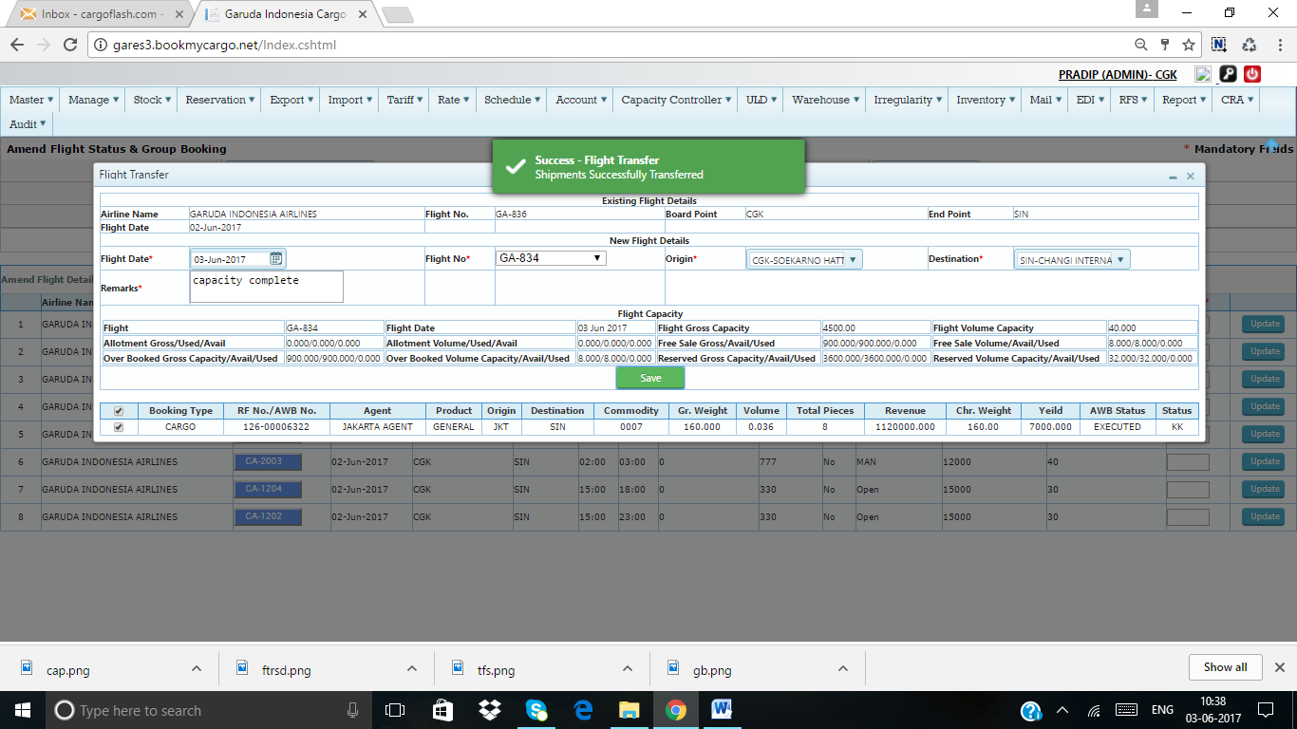

### Amend Flight status

To amend the flight user need to go to same screen as like Group Booking



Figure Amend Flight status

Example – Lets Amend the flight status of Flight Number –GA-2003/02 June from the above screen (Fig-53)

Note-Current status of the flight as MAN(Manifested )

Process to amend the flight status (refer Fig 53)

1. Click the Update Button just extreme right of the same flight row
2. Type the Remarks as a mandatory

Once Update button is clicked by putting the remarks, flight status will change to previous stage as ‘PRE” from MAN

Here is how it changed the status

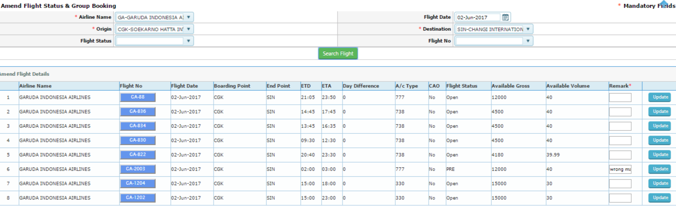

Note 1- Flight status always changed to its previous status , For Example- if DEP is the status and if user amend the flight it will changed to MAN and then to PRE then to Open

Note 2-If flight status is CLS (Closed), User will not able to amend the status.

## Master Booking List (MBL)

MBL Function used to view the complete flight details with the shipments, following details user able to view as bellow

1. Actual Capacity (Free sale/reserve capacity)
2. Used capacity (Free sale/reserve capacity)
3. Over Booking Vs used Over Booking
4. All Confirm and queue shipments
5. Allocated Vs used for allotments

Navigation-Capacity Controller>Master Booking List

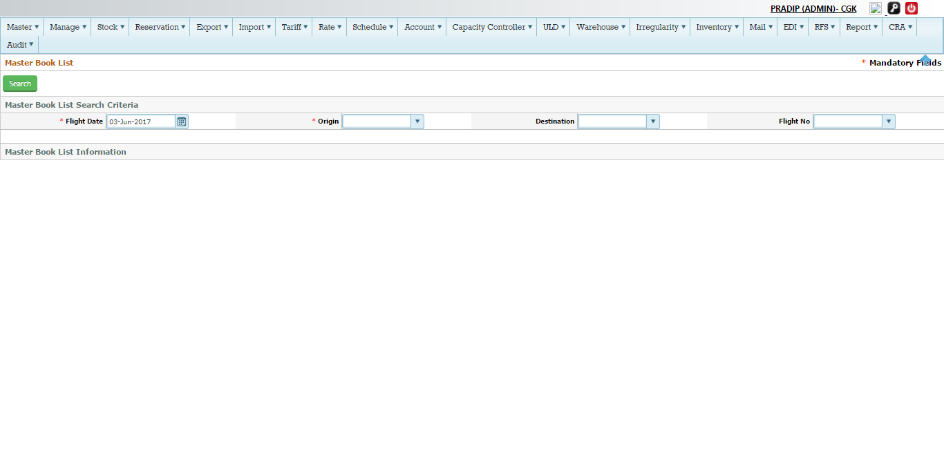

Figure MBL

MBL Process Details (refer Screen-55)

1. Select the Flight date from the calendar , By default system will display the current date
2. Select the Origin from the drop down ,By default system will display the log in city
3. Select the destination from the drop down list ,Its optional
4. Select the flight No from the drop down –Its optional ,
5. Click Search Button to fetch the data as bellow (Refer the screen -56)

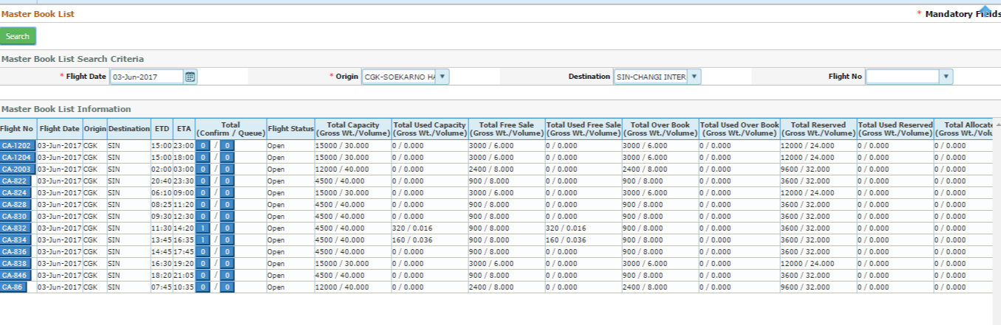

Figure MBL Search

MBL Information Details (refer screen-56)

|  |  |
| --- | --- |
| Flight No | Click into the flight No it will show the total shipments with the status  C:\Users\Pradip\Desktop\screen\flt dtls.png  Following details will auto populated   1. Ref/AWB number 2. Origin/Destination 3. Pcs 4. Gross weight 5. Volume 6. Allotment code 7. Status 8. Revenue 9. Yield |
| Flight Date | It will auto populated |
| Origin | It will auto populated |
| Destination | It will auto populated |
| ETD | It will auto populated |
| ETA | It will auto populated |
| NA  Total (Confirm/Queue) | NA  Click confirm Button –will show the only KK (confirm)shipment  C:\Users\Pradip\Desktop\screen\kk.png  Click into the Queue Tab –it will display the all LL(Queue shipment for that flight )  C:\Users\Pradip\Desktop\screen\ll q.png |
| Flight status | It indicates the current status of the flight -It will auto populated  Example- DEP/MAN etc. |
| Total Capacity  capacity(Gross/Volume) | It indicates the actual cargo capacity of the flight in Gross/Volume –It will auto populated  C:\Users\Pradip\Desktop\screen\cpt.png |
| Total used Capacity  capacity(Gross/Volume) | It indicates the actual used capacity(total Booked shipment in the flight) of the flight in Gross/Volume –It will auto populated  C:\Users\Pradip\Desktop\screen\used.png  Gross/Volume |
| Total free sale  capacity(Gross/Volume) | It indicates the free sale capacity of the flight in Gross/Volume –It will auto populated  C:\Users\Pradip\Desktop\screen\free.png |
| Total used free sale  capacity(Gross/Volume) | It indicates the total used free sale capacity of the flight in Gross/Volume –It will auto populated  C:\Users\Pradip\Desktop\screen\fr.png |
| Total Overbooking  capacity(Gross/Volume) | It indicates the total Overbooking capacity of the flight in Gross/Volume –It will auto populated  C:\Users\Pradip\Desktop\screen\ovbk.png |
| Total used Overbooking  capacity(Gross/Volume) | It indicates the total used Overbooking capacity of the flight in Gross/Volume –It will auto populated  C:\Users\Pradip\Desktop\screen\uobc.png |
| Total Reserved  capacity(Gross/Volume) | It indicates the total reserve capacity of the flight in Gross/Volume –It will auto populated  C:\Users\Pradip\Desktop\screen\reserv.png |
| Total used Reserved  capacity(Gross/Volume) | It indicates the total used reserve capacity of the flight in Gross/Volume –It will auto populated  C:\Users\Pradip\Desktop\screen\used res.png |
| Total Allocated  capacity(Gross/Volume) | It indicates the total Allocated capacity (Allotments)of the flight in Gross/Volume –It will auto populated  C:\Users\Pradip\Desktop\screen\alt.png |
| Total used Allocated  capacity(Gross/Volume) | It indicates the total used Allocated capacity (Allotments)of the flight in Gross/Volume –It will auto populated  C:\Users\Pradip\Desktop\screen\aualt ca.png |

## Allotment

Allotment used to allocated specified space for a flight or Number of flights to the Agents/GSA , Allotments can be given for Cargo/Mail as well

Allotments are of Four Type –Hard Block/Soft Block/Fixed allotment /Open Allotment

Note – Open allotment only given to GSA (Not for any Agent –FF)

Different type of Allotments can be given to an Agent for same flight

Navigation –Schedule>Allotment

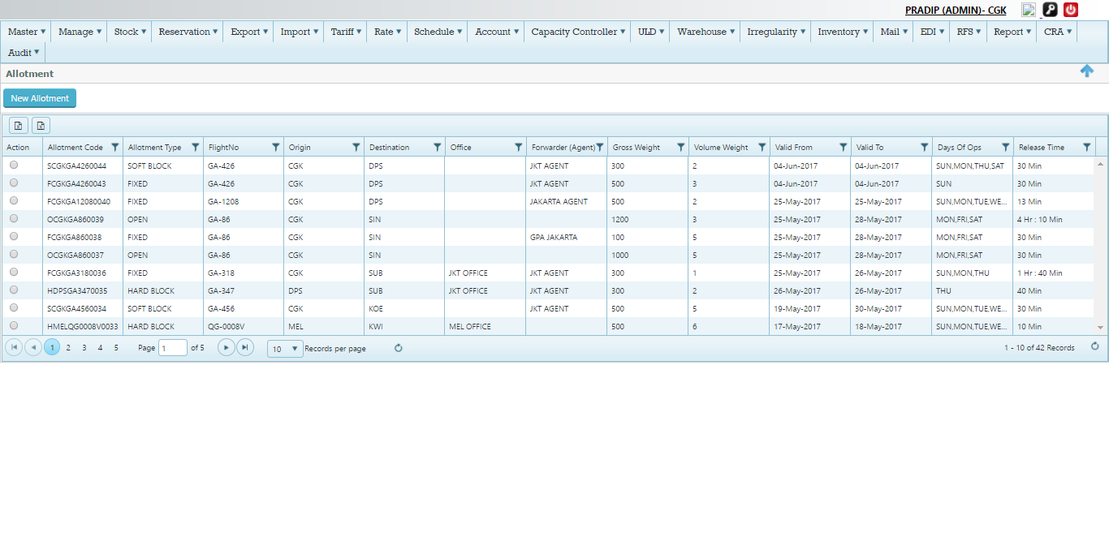

Figure Allotment

Allotment Screen Details (Refer Screen-57)

|  |  |
| --- | --- |
| Action | Action Button used to Read or Edit the created allotment information , Click into the Button system will show the two option as Read/Edit  C:\Users\Pradip\Desktop\screen\action.png  Click Read as option , it will open the complete allotment option as read only mode  C:\Users\Pradip\Desktop\screen\read.png  Click into the Edit Button – It will open complete Allotment information with edit mode  C:\Users\Pradip\Desktop\screen\edit.png  Note –User can modify the allotment record using the Edit Button and then can update |
| Allotment Code | It indicate the Allotment code Based on allotment information system generate a unique code for identification and same Code to be used during the Reservation  C:\Users\Pradip\Desktop\screen\code.png  Note – S for Soft block allotment followed by station of origin and Numeric Number  Allotment Code during the reservation –It reflect the while selecting the flight route as bellow  C:\Users\Pradip\Desktop\screen\res aL.png |
| Allotment Type | It indicate the four type of allotment –Hard block/soft block /Fixed /Open allotment  C:\Users\Pradip\Desktop\screen\try.png |
| Flight No | It indicates the flight Number of for which allotment has given |
| Origin | Origin station of flight , |
| Destination | Destination of the flight |
| Office | It indicates the Office like GSA /Airline for which allotment given |
| Forwarder (Agent) | Name of the Agent for whom allotment given  C:\Users\Pradip\Desktop\screen\age.png |
| Gross weight | Total allotted gross weight  C:\Users\Pradip\Desktop\screen\gr weight.png |
| Volume weight | Total allotted volume |
| Valid from | Allotment Valid from –which date |
| Valid to | Allotment Valid till which date |
| Days of Operation | It indicates the days of operation for that flight |
| Release Time | It Indicate the release time of that specific allotment Code  C:\Users\Pradip\Desktop\screen\reease.png |

### Create New Allotment

Navigation>Schedule>Allotment>Click New allotment



Click New Allotment –System will open new window for filling the data

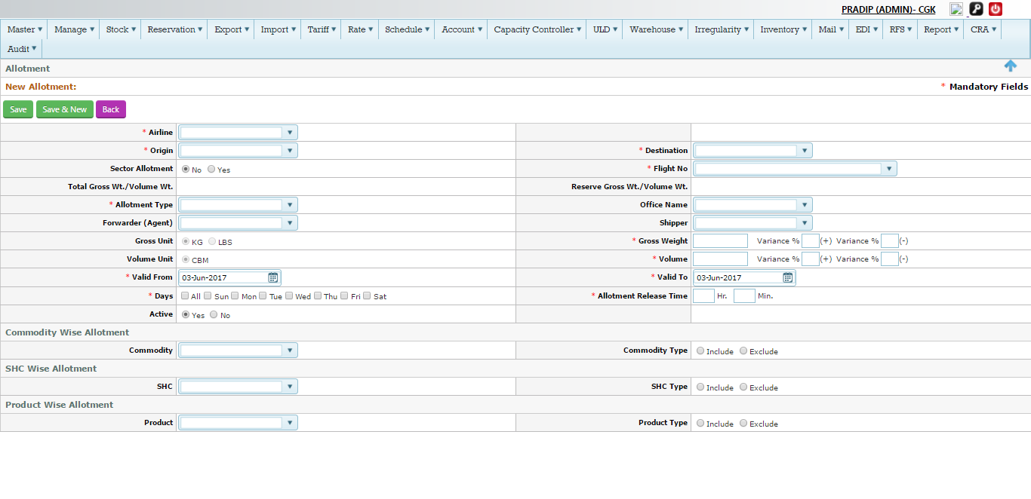

Figure Create Allotment

Create New Allotment process (Refer Screen-58)

|  |  |
| --- | --- |
| Airline | Select the airline as GA – Garuda Indonesia airlines , By default it will show as GA |
| Origin | Select the Origin city from the drop down , Example-SUB |
| Destination | Select the Destination city from the drop down , Example-DPS |
| Sector Allotment | Sector allotment used to give the allotments for a sector and it will apply for all flights in that sector  If user click to Yes Radio Button , Flight No drop down list disappear  C:\Users\Pradip\Desktop\screen\sector.png  If click as No ,Flight No drop down list will available for selection  C:\Users\Pradip\Desktop\screen\flit.png |
| Flight No | Select the flight Number from the drop down list , Note- If flight selected the created allotment will valid for that flight only |
| Total Gross Wt/Volume wt | It will auto populated by the system once user select the Flight No  C:\Users\Pradip\Desktop\screen\wt.png |
| Reserve Gr wt/Vol wt | It will auto populated by the system once user select the Flight No  C:\Users\Pradip\Desktop\screen\wt.png |
| Allotment Type | Select the Allotment Type from the drop down  C:\Users\Pradip\Desktop\screen\type al.png |
| Office name  (Optional) | Select the Office from the drop down Once office selected , the Forwarder (Agent ) will filter based on the Office |
| Forwarder (Agent) | Select the Forwarder(Agent Name) from the drop down list |
| Shipper | Select the Shipper name from the drop down list |
| Gross unit | Select the Unit –Kg or Lbs |
| Gross weight | Type the gross weight , This is the allotment weight that given to the customer  Note Gross weight can not be greater than the reserve capacity |
| Variance (Gross weight) | It indicate the Variance of the gross weight , It means any booking with that variance will still customer can book using the allotment code ,  It can be define + variance and – variance  C:\Users\Pradip\Desktop\screen\var.png |
| Volume unit | By default it will be as CBM |
| Variance (Volume unit) | It indicate the Variance of the gross weight , It means any booking with that variance will still customer can book using the allotment code ,  It can be define + variance and – variance  C:\Users\Pradip\Desktop\screen\var.png |
| Valid from | Select the valid from date from the calendar , It indicates the allotment will valid from that date range , so any booking from this date range only user able to view the code for applying |
| Valid to | Select the valid to date from the calendar , It indicates the allotment will valid to that date range , so any booking from this date range only user able to view the code for applying |
| Days | It auto populated based on operating flight , |
| Allotment Release  Time | Type the release time in Hr and minute , It is defined from the ETD of the flight ,If any allotment not used with that time specified it will auto released by the system , User also can release the allotment manually before it get expired (refer Allotment release Module for more details )  C:\Users\Pradip\Desktop\screen\release.png |
|  | Commodity wise Allotment |
| Commodity | Select the commodity from the drop down list , It indicates that the allotment will be applicable for that commodity only , If shipment Booked using other commodity user not able to view the allotment code |
| Commodity Type | NA - |
|  | SHC wise Allotment |
| SHC | Select the SHC from the drop down list , It indicates that the allotment will be applicable for that SHC only , If shipment Booked using other SHC user not able to view the allotment code |
| SHC Type | NA- |
|  | Product wise Allotment |
| Product | Select the Product from the drop down list , It indicates that the allotment will be applicable for that Product only , If shipment Booked using other commodity user not able to view the allotment code |
| Product Type | NA- |
| Save | Click save to save the allotment record ,  C:\Users\Pradip\Desktop\screen\sv.png  On Saving the record it will save into the main grid    Save& New- By clicking the Save & New it will save the allotment record and will open new allotment record for creating  Back Button- By clicking the Back button will take the main grid of allotment |

### Edit/Update Allotment

User can Edit/Modify the allotment using two options –

1. From the Allotment grid (Using Action Tab)
2. From The View and Edit flight Module

#### From the Allotment Grid (Using Action Tab)

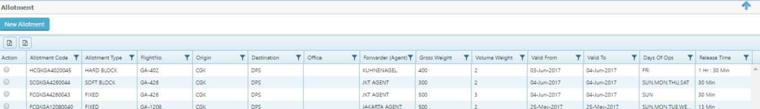

Figure Edit Allotment

Process to Edit the Allotment Record(Screen -59)

1. Click the Action Tab of any Existing Allotment record
2. Click Edit , system will open the allotment record in edit mode as new window

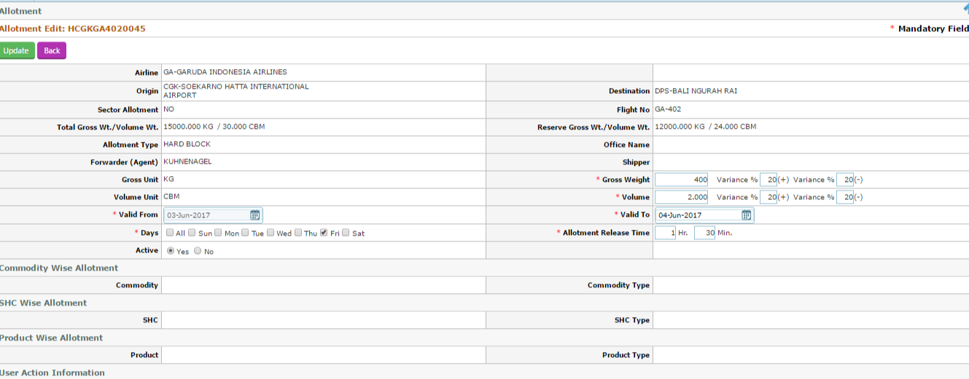

Figure Edit Allotment Record

User can edit bellow information from this screen (Refer screen fig-59)

1. Gross weight
2. Gross weight variance
3. Volume
4. Volume Variance
5. Allotment Release time

Update – Click update to save the modify data

#### From the View and Edit flight module

#### Navigation –schedule>View & edit>Search Flight >Click edit Tab

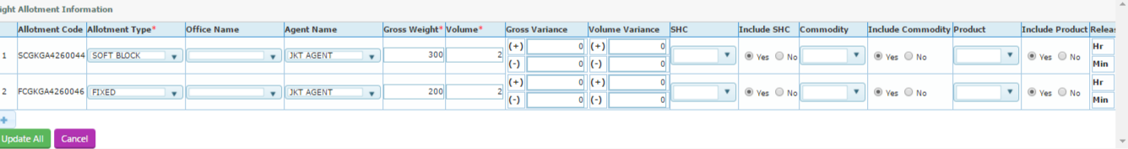

Figure Modify Allotment

Process to Edit the Allotment Record

User can Edit bellow information

1. Allotment type
2. Gross weight
3. Volume
4. Variance Gross
5. Variance Volume
6. SHC
7. Commodity
8. Product
9. Release time

Click Update all to save the modify information

### Release Allotment

Allotment released function used to release the allotment manually; System has both Auto and manual option for releasing the Allotment

Note-Allotment can be release partially as well

Navigation >Schedule>Release Allotment

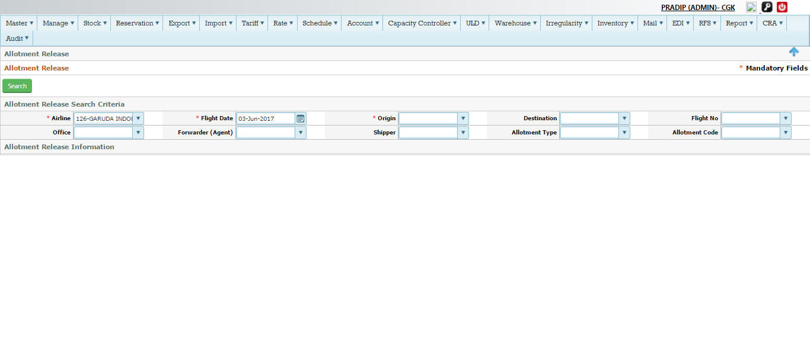

Figure Allotment Release

Search Allotment Release (Refer screen -62)

1. Select Airline from the drop down
2. Select the Flight date from the calendar
3. Select the Origin from the drop down list
4. Select the destination from the drop down (Optional)
5. Select the Flight no from the drop down (Optional)
6. Select the office from the drop down (Optional)
7. Select the Forwarder from the drop down (optional
8. Select the shipper from the drop down (Optional)
9. Select the allotment type from the drop down (Optional)
10. Select the allotment code from the drop down list (Optional)
11. Click search Button to fetch the Allotment Information (refer bellow screen )

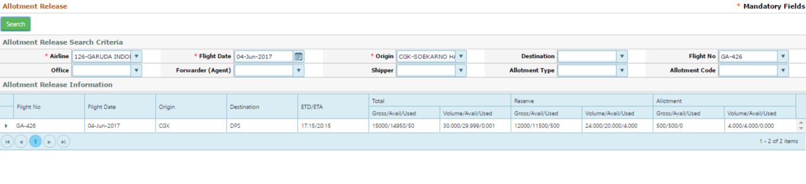

Click the > sign to expand the allotment record as bellow

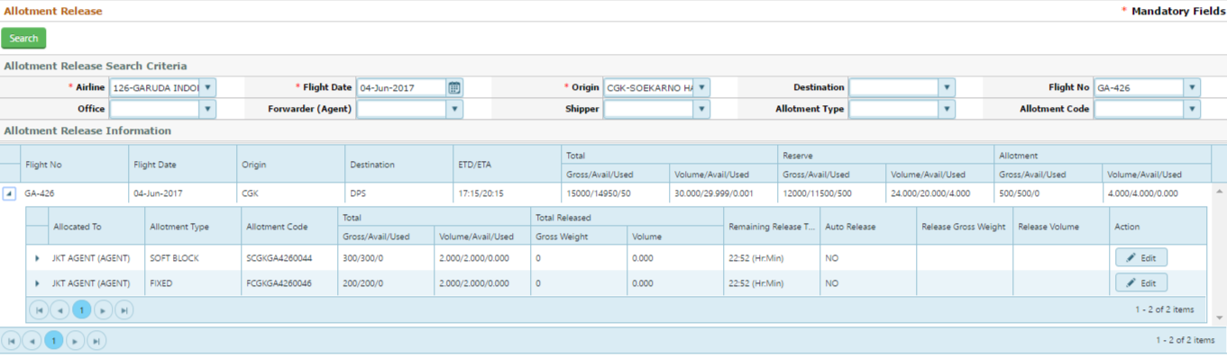

Figure Release Allotment

Process to release the allotment (Refer fig -62)

1. Click the edit button located in extreme right hand side of the allotment code
2. Once it is clicked system will enable few information for edit as bellow

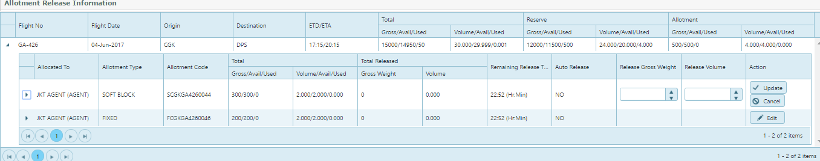

C. Type the Gross weight to be release (It can be same and partial as well , Example If total allotment created as 300 Kgs , it can release complete 300 kgs or less than the 300 kgs as well )

d. Type the Volume to be release (It can be same and partial as well , Example If total allotment created as 2 CBM , it can release complete 2 CBM or less than the 2 CBM as well )

e. Click update Button, it will save the information and allotment will get release form the flight

Example – user has released the allotment from the flight GA426/04 June and it get reflect n bellow

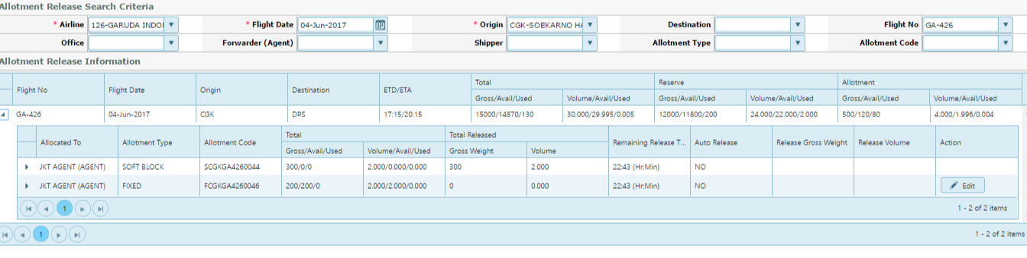

#### Auto Allotment Release

System will release the allotment automatically based on the allotment release time defined while creating the Allotment



Figure Auto Allotment Release

Condition-If allotment release time becomes Zero, the allotment will get released automatically

## Capacity Management

Airline manages the various type of Capacity for a flight wise for better profitability and utilizes the maximum load for the customer

Type of Capacity-

1. Actual Capacity (Cargo capacity in the aircraft , this is managed in Aircraft master )
2. Free sale Capacity –(It is the confirm space and open for customer on first come first basis)HDQ decide the % of Free sale capacity for individual flight , this maintained in the Airline master in terms of %
3. Reserve Capacity-(Actual capacity minus the free sale capacity to be consider as reserve capacity
4. Over Booking capacity –Additional stand by capacity with compare to actual capacity considering the No show of the shipments – This is maintained in the airline master as well in terms of %
5. Commercial Capacity –It’s the capacity based on the PAX load information ,if less PAX then commercial capacity can more than the actual capacity and vice versa

### Search/view the Capacity

Under this module user able to search /view the all capacity of a particular flight

Navigation-Schedule>View & Edit Flight

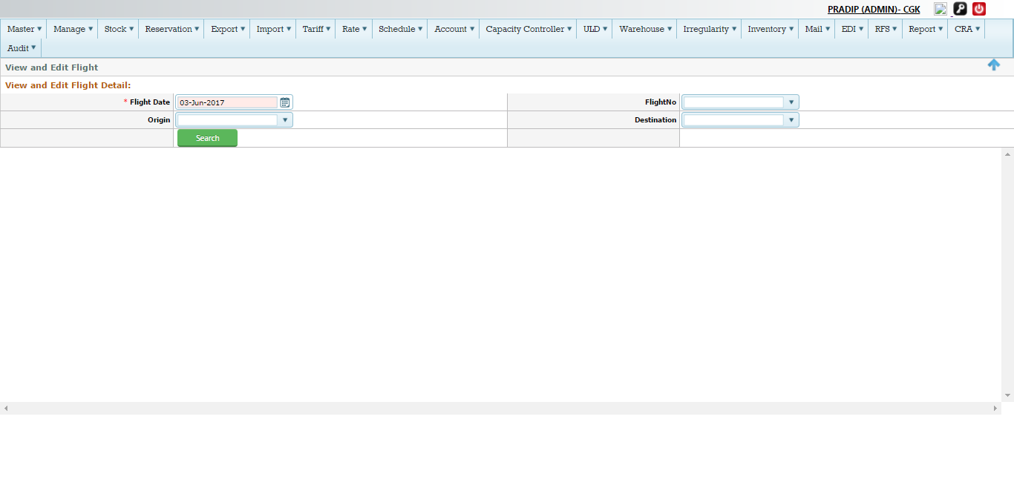

Figure View & Edit flight

Process to search

1. Select the flight Date from the drop down
2. Select the Flight Number from the drop down (Optional )
3. Select the origin from the drop down list (Optional)
4. Select the destination from the drop down (Optional)
5. Click search Button to fetch the information as bellow

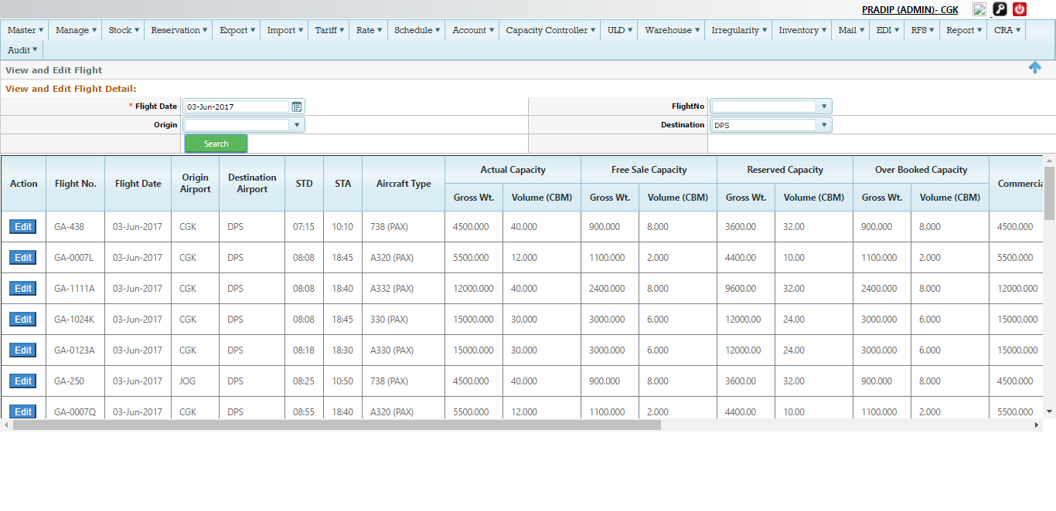

Figure Search Details

Detailed information (Refer screen -66)

|  |  |
| --- | --- |
| Action | Edit Button used to modify the information to capacity, Cancel the flight , change of aircraft etc.  (Refer 1.8.2) for more details |
| Flight no | It will auto populated based on search criteria |
| Flight date | It will auto populated based on search details |
| Origin Airport | It will auto populated based on search details |
| Destination Airport | It will auto populated based on search details |
| STD | It will auto populated based on schedule |
| STA | It will auto populated based on schedule |
| Aircraft Type | It will auto populated based on Master |
| Actual Capacity  (Gross/volume) | It will auto populated based on master  C:\Users\Pradip\Desktop\screen\scr.png |
| Free Capacity  (Gross/volume) | It will auto populated based master  C:\Users\Pradip\Desktop\screen\fre ca.png |
| Reserve Capacity  (Gross/volume) | It will auto populated based on master  C:\Users\Pradip\Desktop\screen\recap.png |
| Over Booking Capacity  (Gross/volume) | It will auto populated based on master  C:\Users\Pradip\Desktop\screen\obv cap.png |
| Commercial Capacity  Used Capacity  (Gross/volume) | It will auto populated based on Pax information  C:\Users\Pradip\Desktop\screen\com.png |
| Allocated weight  (Gross/volume) | It will auto populated based on Allotment master  C:\Users\Pradip\Desktop\screen\alcated.png |
| Released weight  (Gross/volume) | It will auto populated based on Release allotment master  C:\Users\Pradip\Desktop\screen\relsd.png |
| Flight status | It will auto populated based on current status of the flight  C:\Users\Pradip\Desktop\screen\status.png |
| Cancelled | It will auto populated based on schedule  C:\Users\Pradip\Desktop\screen\cand.png |

### Edit/Modify Capacity

User under this module able to edit/modify the capacity manually and other information as change of flight status, Aircraft change, marked as cancel or re instate etc.

Navigation-Schedule>View and Edit flight>search flight >click Edit Tab



Figure Edit Capacity

Process to Edit- Click the Edit Button (refer screen-Fig 66), system will open the new window to modify the data

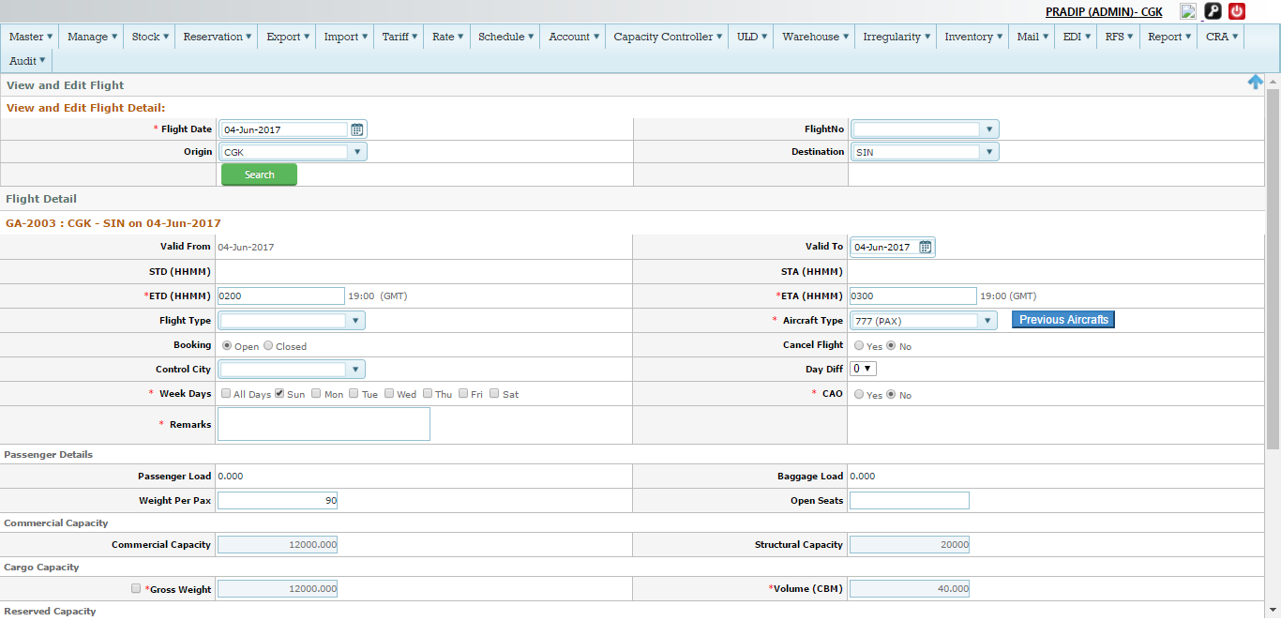

User Able to modify the following details from the above screen

1. Flight Type
2. Aircraft Type(refer to 1.8.4 for more details
3. Booking status(Open /close )
4. Cancel flight (Yes or No – refer to 1.8.3 for more details )
5. Passenger details
6. Cargo capacity (Both Gross/volume) – To edit user can click to the check box , then text field will be enable to change manually



Modify the Goss/volume weight and click Update All button on down of the screen to save the data

1. Reserve Capacity (Gross/Volume ) To edit user can click to the check box , then text field will be enable to change manually



Modify the Goss/volume weight and click Update All button on down of the screen to save the data

1. Free sale Capacity (Gross/Volume ) To edit user can click to the check box , then text field will be enable to change manually



Modify the Goss/volume weight and click Update All button on down of the screen to save the data

1. Over Booking Capacity (Gross/Volume ) To edit user can click to the check box , then text field will be enable to change manually



Modify the Goss/volume weight and click Update All button on down of the screen to save the data

### Cancel Flight (Manual Option)

User can mark cancel the flight manually under this module

Navigation >Schedule>View and Edit flight>Search flight >Click Edit Tab>Click Cancel check box

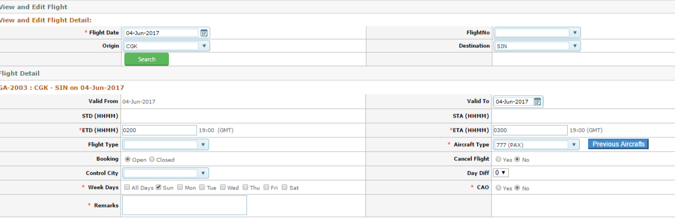

Figure Cancel Flight

Process to cancel (refer to screen-67)

1. Click Yes , (system by default will show as No )
2. Type remarks if any on the Remark field (mandatory)
3. Click update all button on the extreme down of the screen

Once it is marked as Yes , status of fight will be shown in main grid of View and edit Flight

Example- Lets cancel the flight GA-2003/04June

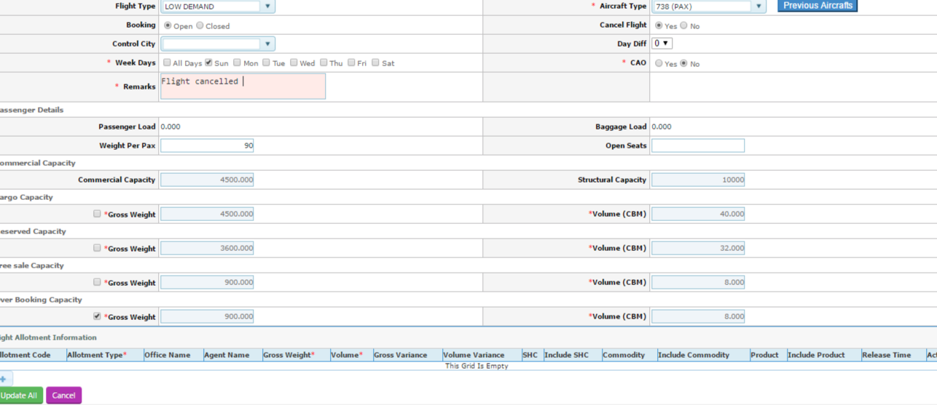

Once it is clicked Update all , it will successfully save

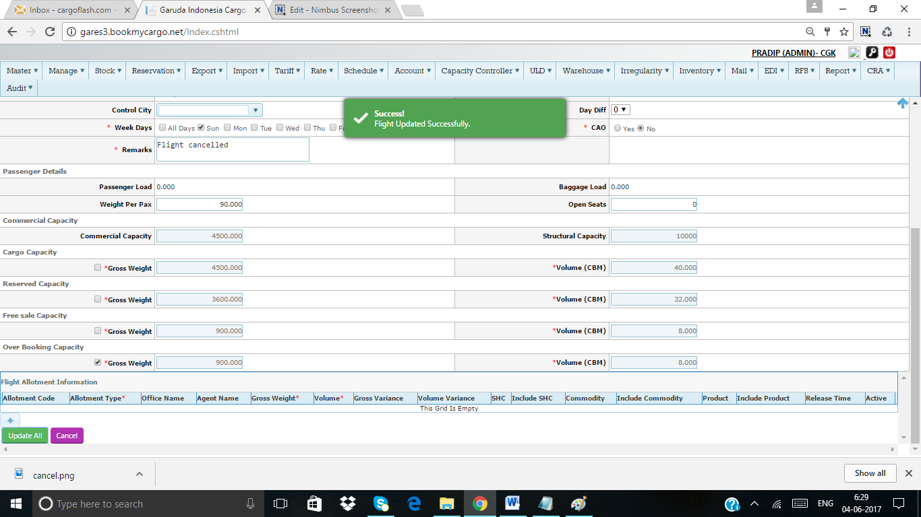

It will change the status in View and Edit flight main grid

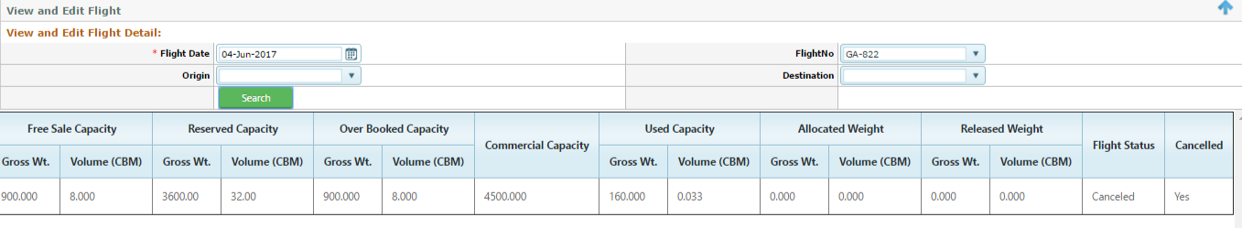

Note- Flight can be marked Cancel automatically based on ASM messaged

Note2- If flight marked as Cancel(All Booked shipment will be marked as LL )

### Change of Aircraft (Manual option)

User can manually able to change the Type of Aircraft due some reason

Navigation >Schedule>View and Edit flight>Search flight >Click Edit Tab>select Aircraft Type



Figure Change of aircraft

Process to change of Aircraft

1. Select the Aircraft to be change from the drop down
2. Enter the remarks on the remarks field (mandatory )
3. Click Update Button to save the information , system automatically change the Aircraft

Previous Aircraft- This Button indicates the previous Aircraft Type if in case any change of Aircraft (system display the Current Aircraft Type

Example- In Screen 68/ For the flight GA2003/04 June the current Aircraft Type is B777(pax) , if user then change into B738 or other any Aircraft type selecting from the drop down , The B777 information will be listed on the Previous Aircraft Button

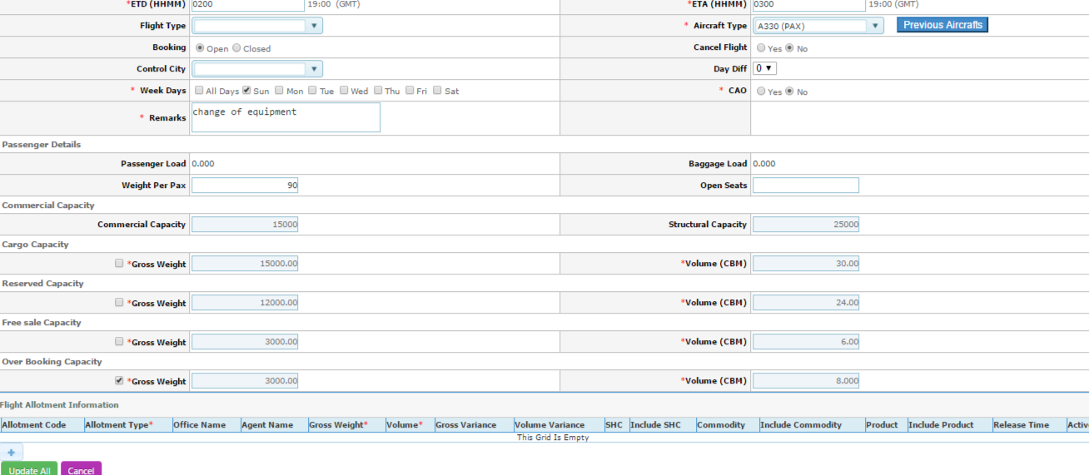

Now user has change the Aircraft Type to A330 for same flight GA2003/04June and click Update all ,

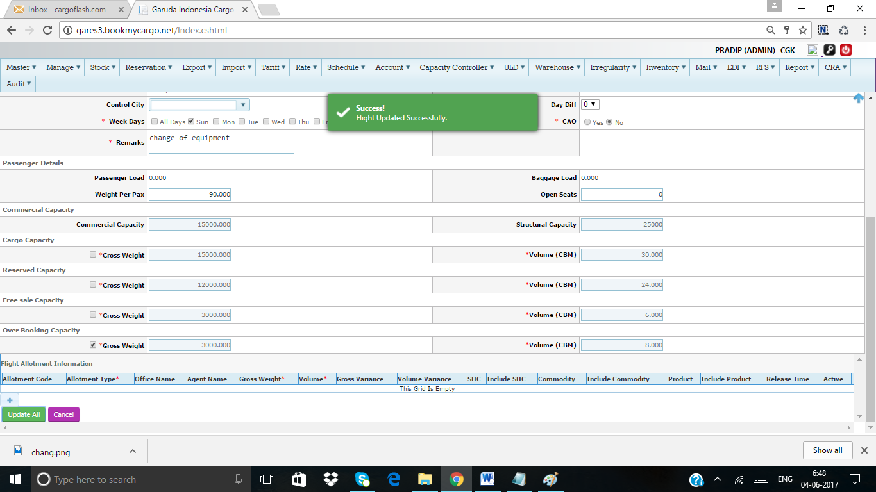

Now Aircraft Type has changed to A330 , lets see what is showing in the Previous Aircraft Button , Click into the Previous Button

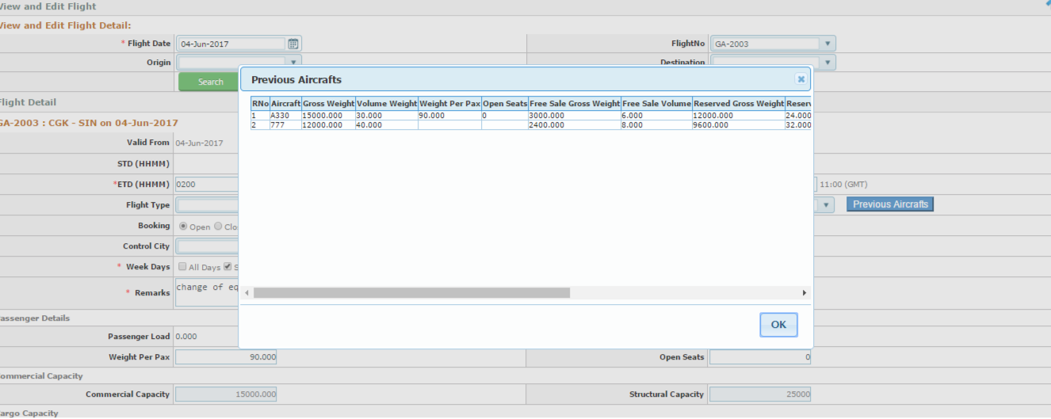

Note1- Aircraft Type can be change automatically based on ASM messaged

Note2- If change of Aircraft is down grade (All Booked shipment will be marked as LL)

Note3- If change of Aircraft is Up grade (All Booked shipment will be marked as KK)

## Mail Reservation

Mail Reservation normally used for making the Booking of CN-38 /CN 47 Document

Navigation –Reservation>Mail Booking

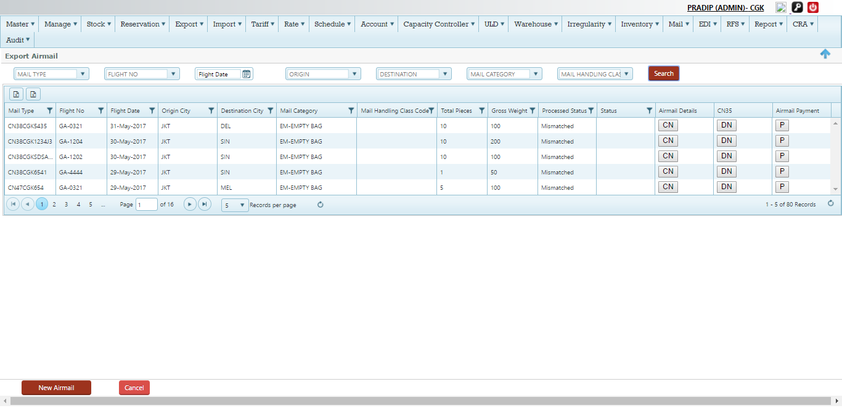

Figure Mail Reservation

### Search Panel (Mail Booking )

User able to search the existing Mail reservation data based on various criteria



Details

|  |  |
| --- | --- |
| Mail Type | It Indicate the type mail such as –CN38/Cn47 , user can search by Select the Mail type from the drop down list  C:\Users\Pradip\Desktop\screen\typ.png  System will automatically will search and display the information based on Mail type |
| Flight No | User can search the information based on Flight No by selecting flight no from the drop down list  C:\Users\Pradip\Desktop\screen\flt d.png  System will automatically will search and display the information based on flight No |
| Flight Date | User can search the information based on Flight date by selecting flight date from the date calendar  C:\Users\Pradip\Desktop\screen\flt.png  System will automatically will search and display the information based on flight date |
| Origin | User can search the Mail information based on Origin by selecting from the drop down |
| Destination | User can search the Mail information based on Destination by selecting from the drop down |
| Mail category | It indicate the mail category such as –Mail bag /Empty Mail bag  User can search the Mail information based on Origin by selecting from the drop down  C:\Users\Pradip\Desktop\screen\cat.png |
| Mail handling Class | NA |
| Search | Click search to fetch the Data based on above search criteria |

Search Main Mail reservation Grid

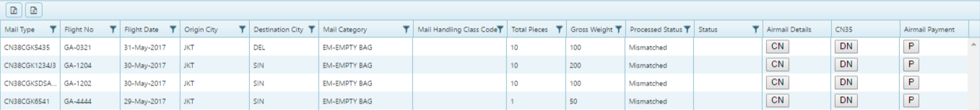

Details

|  |  |
| --- | --- |
| Mail type | It Indicate the type mail such as –CN38/Cn47, Click the filter button and type the CN38/Cn47 and filter  C:\Users\Pradip\Desktop\screen\type fil.png |
| Flight No | User can filter the data based on Flight No |
| Flight date | User can filter the data based on Flight date |
| Origin city | User can filter the data based on origin city |
| Destination city | User can filter the data based on Destination city |
| Mail category | User can filter the data based on Mail category  C:\Users\Pradip\Desktop\screen\mail handl cat.png |
| Mail Handling class | NA |
| Total pieces | User can filter based on No of pieces |
| Gross weight | User can filter based on gross weight |
| Process status | User can filter based on process status |
| Status | It indicate the Booking status of the Mail (Cn38/47)User can filter based on status |

### New Air Mail Booking

User able to make Mail booking under this function

Navigation-Reservation>Mail Booking



Click the New Airmail Booking Button, system will automatically open the new window for update the information

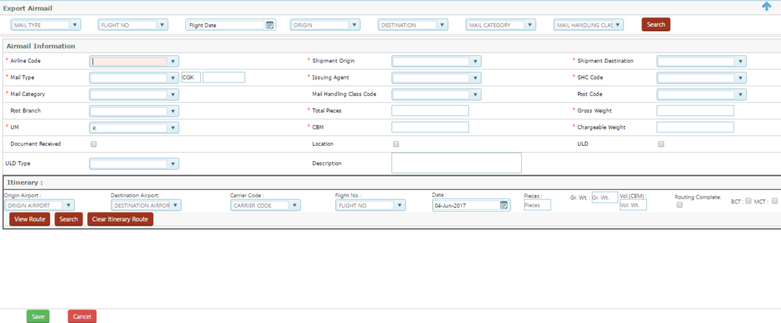

Figure New airmail Booking

New Mail Booking process (Refer screen –Fig70)

|  |  |
| --- | --- |
|  | Air Mail Information |
| Airline Code | Select the Airline code from the drop down , Example –126, By default system will show as Garuda Indonesian Airlines |
| Shipment Origin | Select the origin from the drop down , by default it will be Log in origin |
| Shipment Destination | Select the Destination from the drop down |
| Mail Type | Select the mail type from the drop down , Example –CN38/CN47  C:\Users\Pradip\Desktop\screen\mailt.png  And then type the CN38/CN47 Number in the free text field next to CGK (Origin Code ) |
| Issuing Agent | Select the name of the agent from the drop down list , Example-GPA Jakarta  Note- Account type Post office will only display here |
| SHC Code | Select the SHC code as Mail from the drop down  C:\Users\Pradip\Desktop\screen\code.png |
| Mail Category | Select the mail category from the drop down list |
| Mail Handling class  Code | NA |
| Post code | Select the Postal code from the drop down |
| Post Branch | Select the Branch from the drop down list |
| Total Piece | Type the no of total pieces |
| Gross weight | Type the total gross weight |
| UM | UM- Unit of measurement ,select from the drop down , Example-Kg or Lbs |
| CBM | Volume unit-Type the volume |
| Chargeable weight | Type the chargeable weight or system will calculate based on Volume |
| Document received | NA |
| Location | NA |
| ULD | Tick the ULD check box if Mail to be as ULD booking |
| ULD Type | Select the ULD type |
| Description | Type description if any |
|  | Itinerary Information |
| Origin Airport | Select the origin airport ,System will display the airport based on origin city |
| Destination Airport | Select the Destination airport from the drop down list , it will auto populated based on Destination city |
| Carrier code | System will auto populate the carrier code based on Airline code |
| Flight No | Select the flight number from the drop down |
| Flight Date | Select the flight date from the date calendar |
| Pieces | It indicate the part shipment to be planned by the user , Once user type the piece here will automatically split the shipment |
| Gross weight | It indicated the weight of the split pieces |
| Volume | It indicate the volume of the split pieces |
| Route Complete | It indicate that if user need to override the route with compare with the final destination  Example-If shipment Origin city as JKT to SYD via DPS , user can complete the route as JKT -DPS if user tick the route complete radio button |
| BCT | BCT-Booking closer time , If user tick the BCT it will override the BCT |
| MCT | MCT-Minimum connection time ,If user tick the MCT it will override the MCT |



Search Button –Click search to view the flights available for Mail Booking

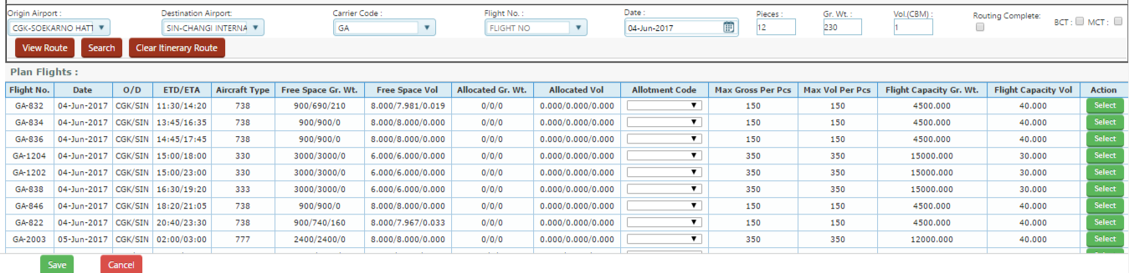

Figure Search Flight

Select Button –Click select button to select the flight, once clicked it will save as route plan

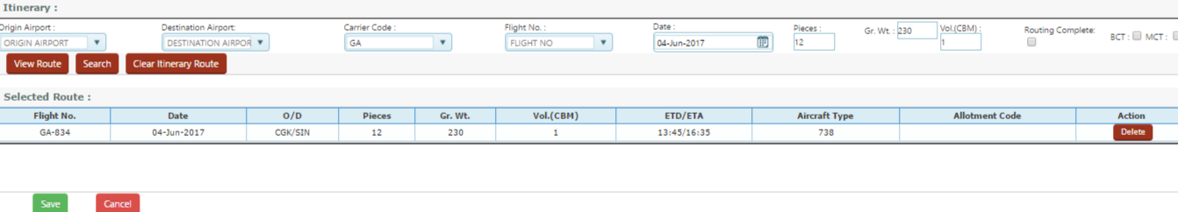

Save- Click Save button to make reservation complete, Lets Save above Mail reservation by clicking the Save button

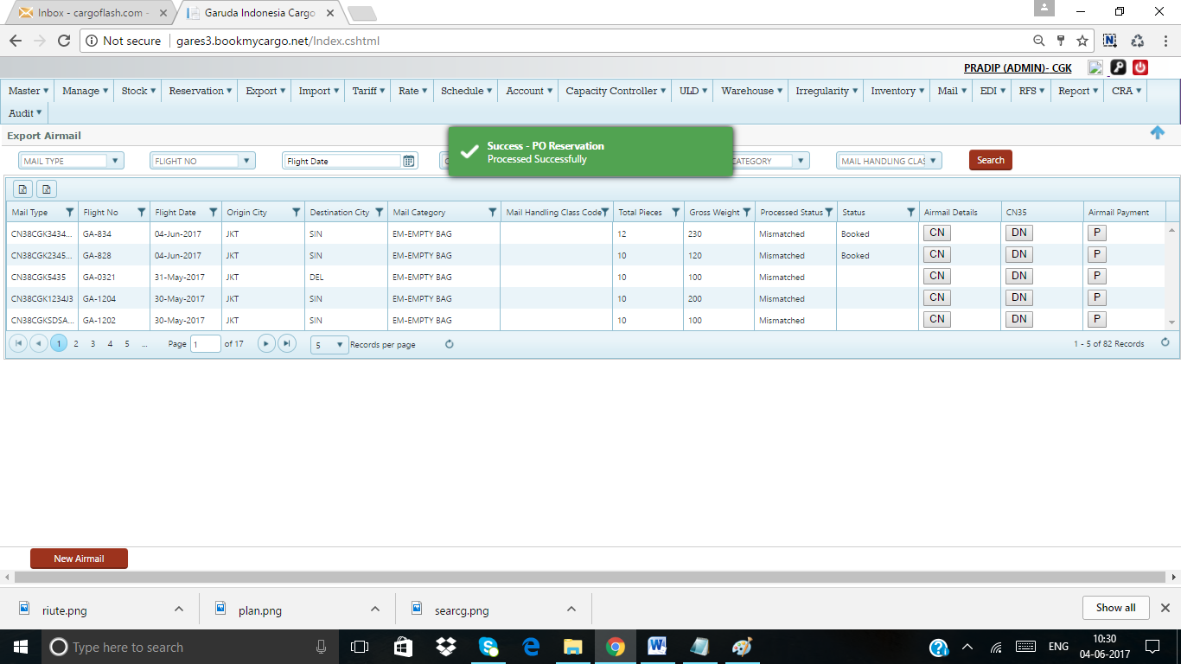

Figure save Mail Booking

### Update Mail Booking

User can edit or modify the Existing Mail Booking on this module

Navigation>Reservation >Mail Booking >Click CN Tab

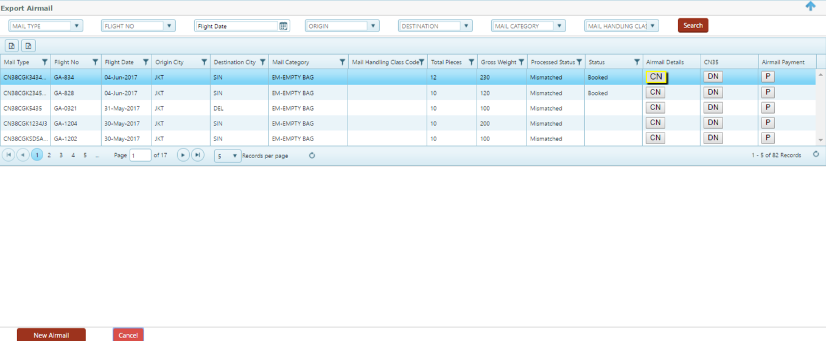

Click to CN Tab, it will open the exiting Mail booking information for update

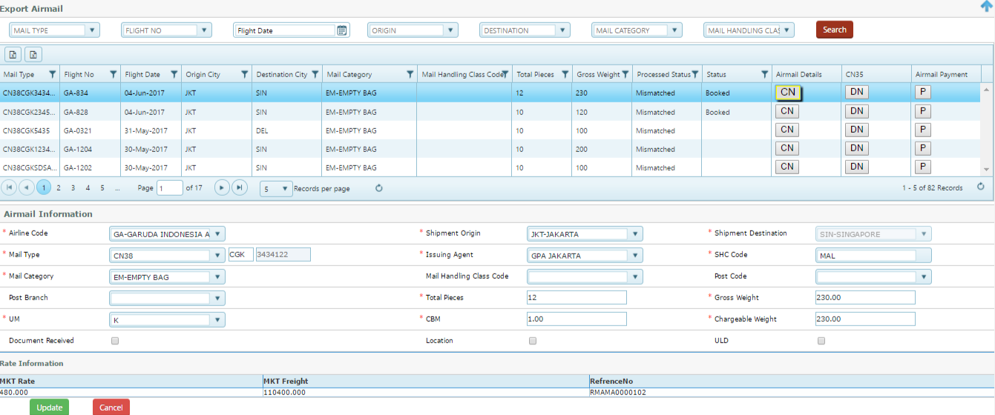

Figure Update CN

User can modify the Bellow information and click Update Button to save data

1. Mail type
2. Issuing agent
3. Mail category
4. Pc
5. Weight
6. Volume
7. Chargeable weight
8. Route

Click Modify to save the information

### Mail under Cargo

Mail under Cargo is the normal Cargo Booking process, for Mail under cargo user need to select the Product type as Mail and process normal cargo booking process

Navigation-Reservation>Cargo Booking

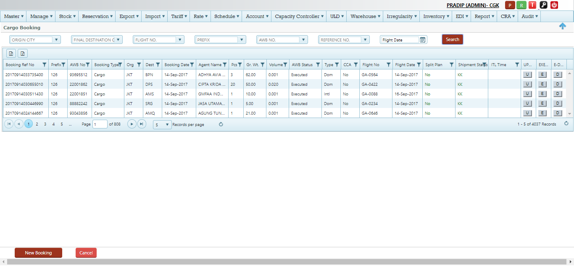

Figure Reservation cargo

Create New Booking using the Product as Mail

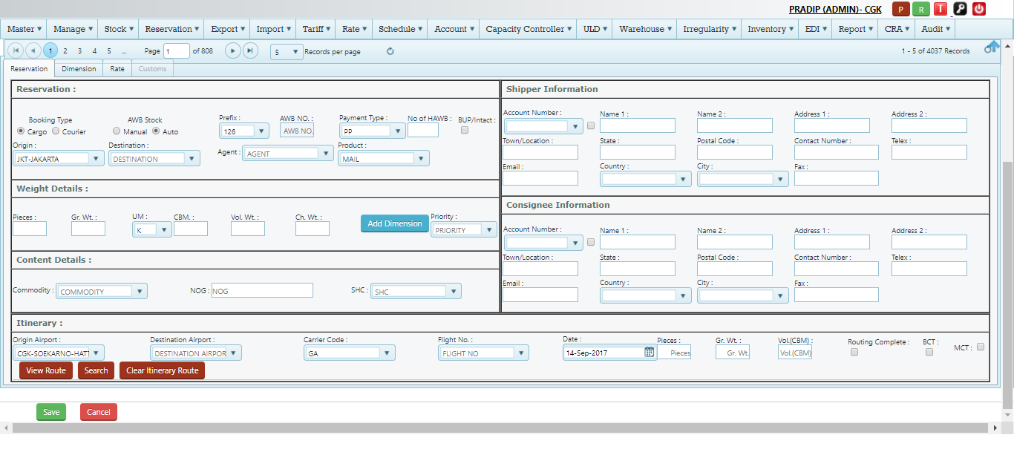

Figure Mail under cargo

Note- please refer to Cargo Reservation manual for complete booking process with details

## AWB Tracking

AWB Tracking used to tack the shipment status at any given point from Booking till delivery of shipment

Navigation-Audit>AWB Tracking or Log in > T button (next to user group)

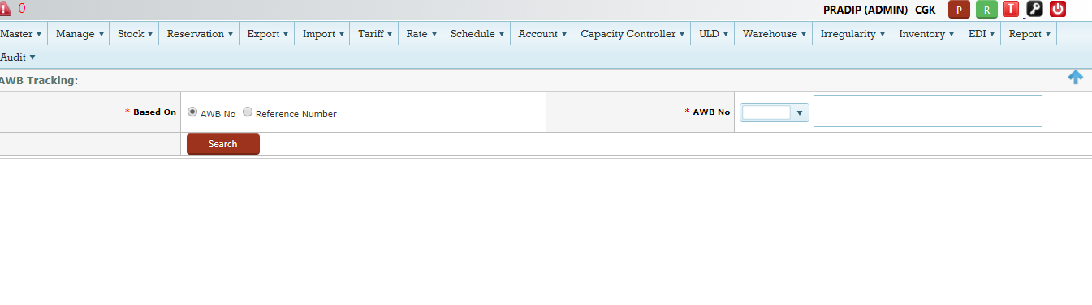

Figure AWB Tracking

Process to Track

1. Select the Based on –AWB No or Reference No
2. Type the serial number or reference number in AWB no Tab
3. Click search , system will fetch the data and will display as bellow

Example – Lets Track for AWB no -126 32323896

Click search Button (Refer screen-84)

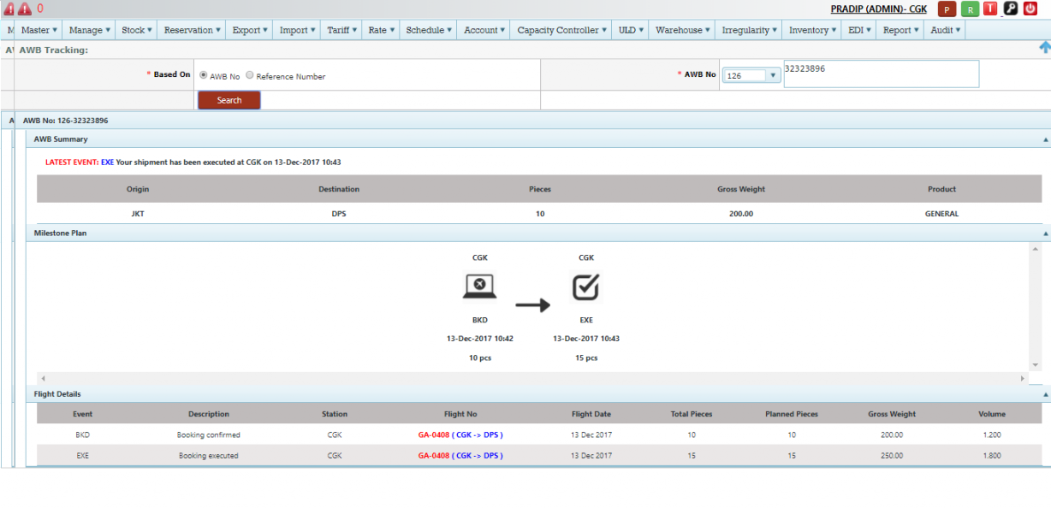

## Search schedule

User can search the flight schedule under this module

Navigation-Schedule >Search schedule

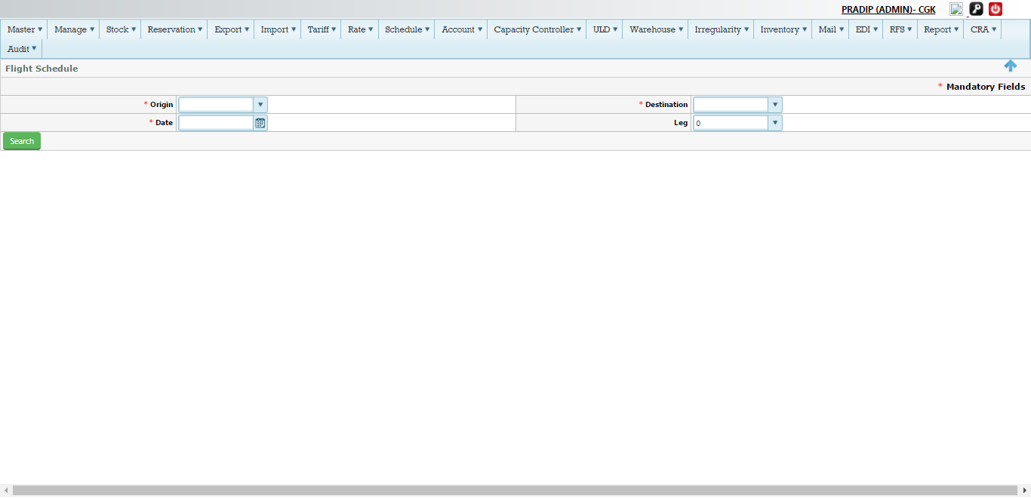

Figure Search schedule

Process to search the schedule (screen -86)

|  |  |
| --- | --- |
| Origin | Select the origin city of the flight from the drop down list |
| Destination | Select the destination city of the flight from the drop down list |
| Date | Select the date from the calendar |
| Leg | Select the Leg from the drop down (Optional ) |
| Search | Click search to fetch the schedule information |

Example 1- lets search schedule from CGK to SIN for date -4th June with No leg

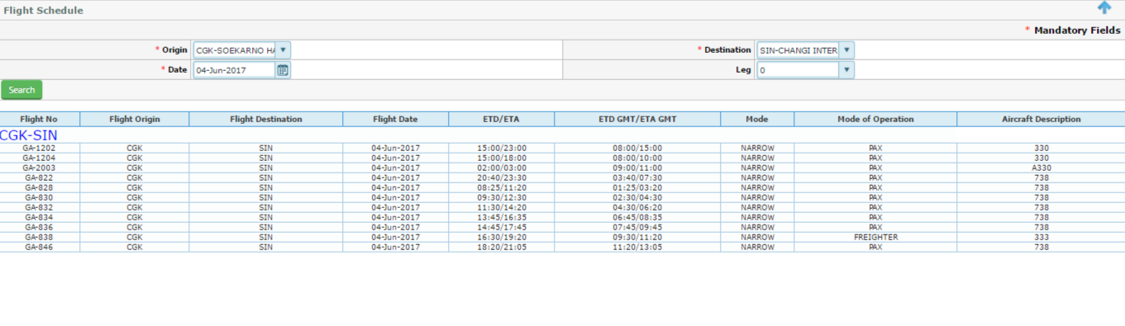

Figure Schedule search with No leg

Example 2- lets search schedule from CGK to SIN for date -4th June with 1 leg

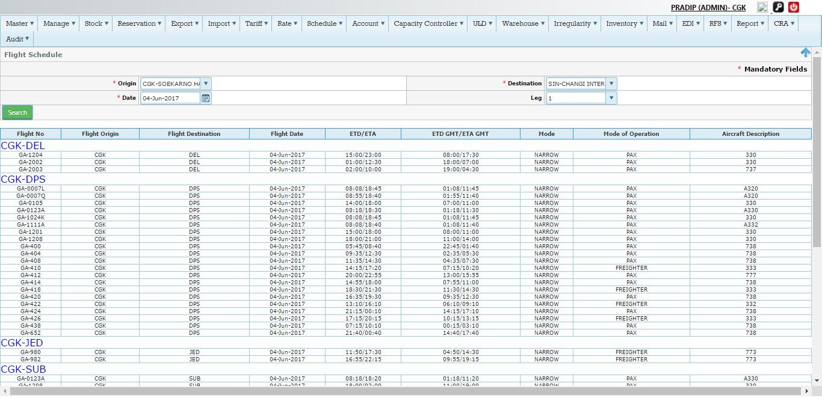

Figure Search schedule with 1 leg

## Rate

Rate module used to defined the various rate, other charges, Tax for Cargo and Mail as well

System manages different Rates as bellow

1. RSP Rate –Cargo and Mail
2. Tact rate
3. ULD rate
4. Allotment Rate
5. Class rate
6. Ad-Hock Rate
   1. Spot rate
   2. Campaign rate

### Spot rate

Spot rate used by the Airline to give the any special rate to a specific forwarder (agent) for specific shipment in different condition

System manage spot rate hire cay to create and approve the spot rate to a agent for applying the rate

Navigation –Rate >Spot rate request

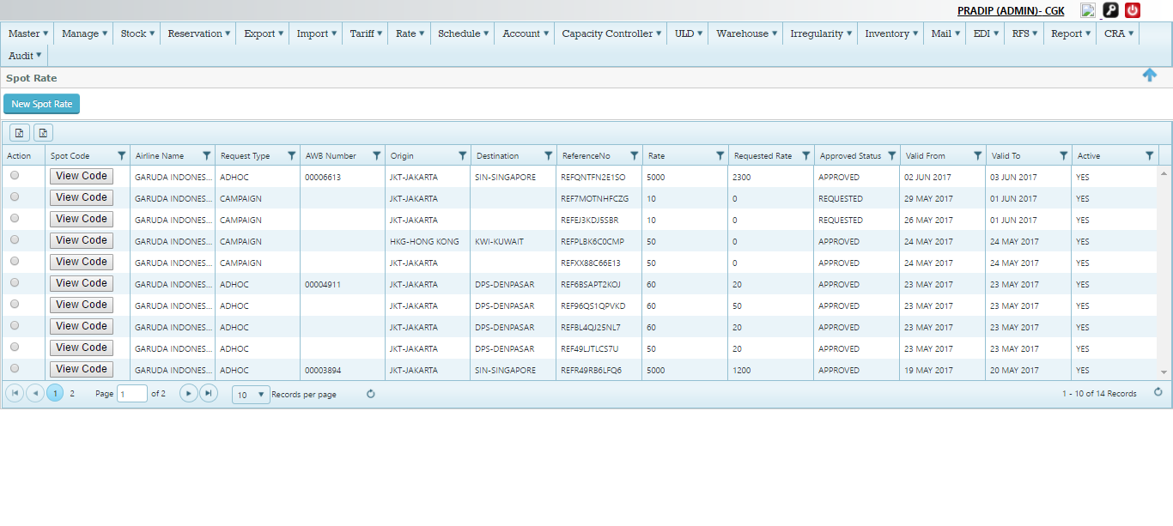

Figure Spot Rate

Spot Rate screen Details (Refer screen 89)

|  |  |
| --- | --- |
| Action | Action Button used to view/approve the existing Spot code or Campaign code  C:\Users\Pradip\Desktop\screen\act.png  Click View , to view the existing information  Click Approve to approve the request spot rate/campaign rate |
| Spot Code | This indicate the code of the spot rate/campaign rate  Note – Spot code generated when rate is approved by the user for spot rate  Note 2-Campagin code generate while on request status as well  C:\Users\Pradip\Desktop\screen\code.png  Click view Code to get the code details  C:\Users\Pradip\Desktop\screen\vew.png |
| Airline Name | Name of the Airline –Its GA by default |
| Request Type | It indicates either Ad hock(spot rate) or campaign rate type  C:\Users\Pradip\Desktop\screen\typ.png |
| AWB Number | AWB Number of the sport rate |
| Origin | Origin of the shipment |
| Destination | Destination of the shipment |
| Reference number | System creates the unique rate reference number for each spot rate or campaign rate to identify the rate  C:\Users\Pradip\Desktop\screen\ref.png |
| Rate (Approved Rate ) | This the approved rate by the authorized user |
| Request Rate | This the rate requested by the user |
| Approved status | Status of the Rate, Example- Request/approved /rejected etc.  C:\Users\Pradip\Desktop\screen\status.png |
| Valid from | It is the Valid from date of the spot/campaign rate |
| Valid to | It is the Valid to date of the spot/campaign rate |
| Active | User can make inactive of the rate , Note –If t is marked as Yes only code able to get applied |

#### Create Spot Rate

Navigation-Rate>Manage spot rate >Create new spot rate



Click the New spot Rate , system will open new window to create the rate

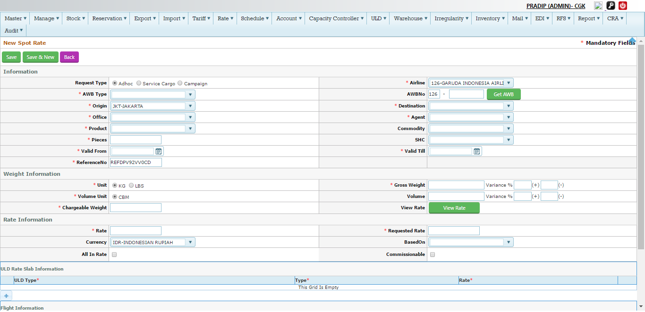

Figure Create Spot rate

Create Spot rate Process

|  |  |
| --- | --- |
|  | Information |
| Request Type | It indicate the type of rate –Ad-hoc (Spot Rate ) or Campaign rate  Click to Ad-hoc check Box  C:\Users\Pradip\Desktop\screen\awb p.png |
| Airline | System will auto populated the Airline Name as GA |
| AWB Type | Select the AWB type –Cargo /courier etc.  C:\Users\Pradip\Desktop\screen\tr.png |
| AWB Number | Spot rate can create for a specific AWB number or without AWB no , If user need to create spot rate without AWB number then just leave this as blank  If user need to create rate for Executed AWB , then just type and click Get AWB Tab C:\Users\Pradip\Desktop\screen\get.png  Once user click into the Get AWB , the AWB number and other details will populated automatically |
| Origin | Origin will auto populated by the system |
| Destination | Select the Destination from the drop down |
| Office | Select the Office (GSA/Branch etc.) |
| Agent | Select the Agent name from the drop down list |
| Product | Select the product from the drop down list |
| Commodity | Select the commodity from the drop down –Optional field |
| Pieces | Type the no of pieces |
| SHC | Select the SHC from the drop down –Optional field |
| Valid From | Select the valid from date using calendar |
| Valid till | Select the valid to date using calendar |
| Reference No | Auto fill by the system |
|  | Weight information |
| Unit | Kgs or Lbs |
| Gross weight | Type the Gross weight |
| Variance | Type the variance weight –Optional  If shipment booked within the tolerance spot rate will get applied or else it has to exact weight to get the spot code applied |
| Volume unit | CBM |
| Volume | Type the Volume |
| Volume Variance | Type the variance Volume –Optional  If shipment booked within the tolerance spot rate will get applied or else it has to exact weight to get the spot code applied |
| Chargeable weight | Type or it will auto populated based on Volume |
| View rate | Click View rate Button to check the RSP Rate of that O-D  C:\Users\Pradip\Desktop\screen\vrat.png  Once it will open a small pop up with RSP rate  C:\Users\Pradip\Desktop\screen\slb.png |
|  | Rate Information |
| Rate | It will auto populated once user click into the View rate Button on above |
| Requested rate | This is the actual requested rate higher authority to approve  Note-request rate cannot be greater than the actual RSP Rate |
| Currency | Auto populated by the system as Log in city |
| Based on | Rate Type –RSP |
| All in rate | NA |
| Commissionable | Click Tick to get commissionable for this spot rate |
|  | ULD Rate information |
| ULD Type | Info-Spot rate also can be given for ULD Booking (BUP)  Click+ sign to add ULD Type –AKE ,PMC etc. |
| ULD rate Type | It indicates the ULD rate type –Pivot and over pivot |
| Rate | Type the rate |
|  | Flight Information |
| Flight origin | Info- Spot rate also can be given for a specific flight if it is selected on this Flight information  Select the Origin |
| Final Destination | Select the destination |
| Flight No | Select the Flight No from the destination |
| Flight Date | Select the flight date |
| Remarks | Please put remarks on free text field |
| Created By | It will auto populated by the system |

Click Save to send the spot rate request

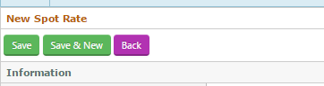

On sussfull it will save into the Main grid as bellow



#### Approve Spot rate

Navigation –Rate>Spot rate request >Action tab>Click Approve



Figure Approve Spot Rate

Click Approve- It will open a same window with option to approve or reject Box

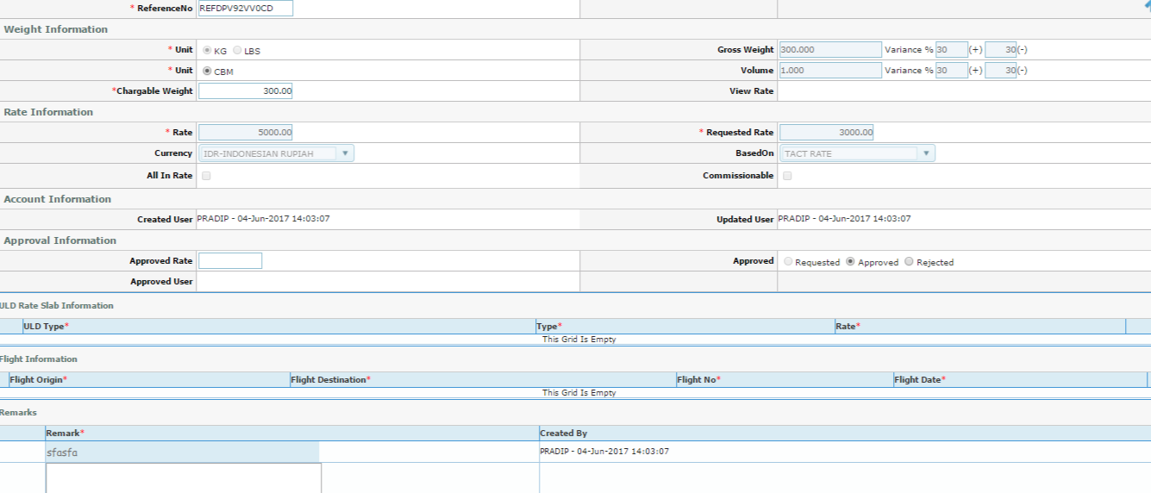

Figure Approve screen

Approve Process

1. Select Approved check Box , user also can reject in this stage using Reject check Box
2. Put the Approve Rate (It can be more or less than the request rate but not more than the RSP rate
3. Put remarks if any

Click Update Button to Approve , It will save into the grid as bellow

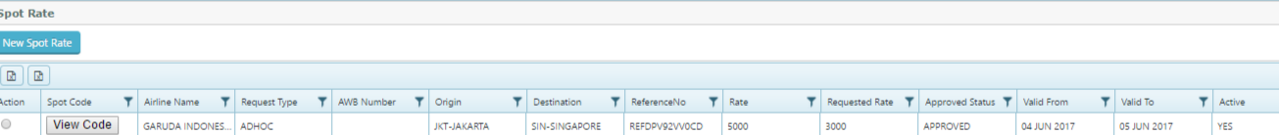

Click to View code to see the Spot code generated

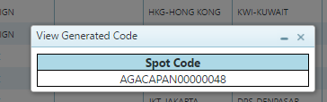

### Campaign Rate

Navigation-Rate>Manage spot rate >Create new spot rate



Click the New Spot Rate, system will open new window to create the Campaign rate



Figure Create Campaign rate

Process to create the Campaign Rate

1. Click to the Request type as Campaign



Note- campaign rate can created for both domestic and International shipments

Click Domestic or International and Follow same process as Spot rate process except the bellow details to be fill by

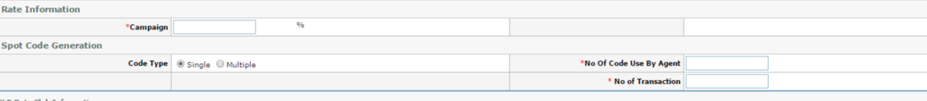

Details –

1. Campaign –Rate to be defined as %
2. Code Type –select single or Multiple code , if selected as Multiple system will campaign code
3. No of Code use by Agent – type the no of code to be use by agent
4. No of Transaction- Type the No of transaction to be used for that code

All other information same as spot rate process and information – click save to save in the main grid as request and approval as same process as same as spot rate process

### Rate search

Rate search able to search the various rates for specific O-D ,

Navigation –Rate>Search rate

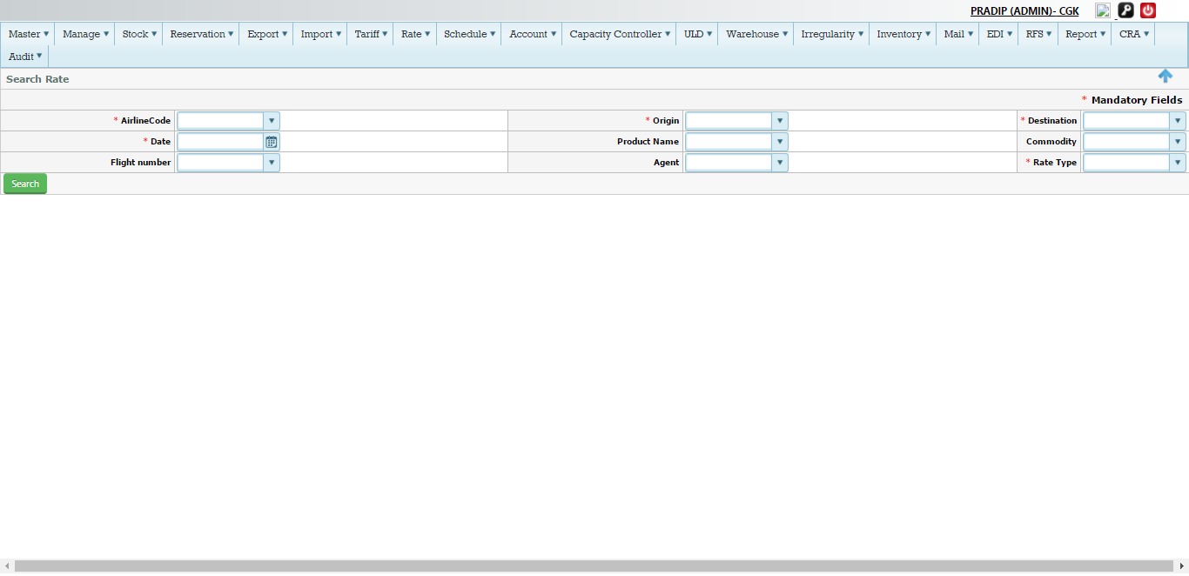

Figure Search Rate

Search Rate Process –

1. Airline code -Select the Airline Code from the drop down list
2. Origin-Select the Origin from the drop down list
3. Destination-Select the Destination from the drop down list
4. Date-select the date from the calendar
5. Product Name –select the product name from the drop down –Optional
6. Commodity –select the commodity from the drop down list –Optional
7. Flight Number-select the flight number from the drop down list –Optional
8. Agent –select the agent name from the drop down list –optional
9. Rate Type – select the Rate type from the drop down

Click Search Button to get the Rate information as bellow (Let search from JKT-DPS for Published rate on 19th Oct June)

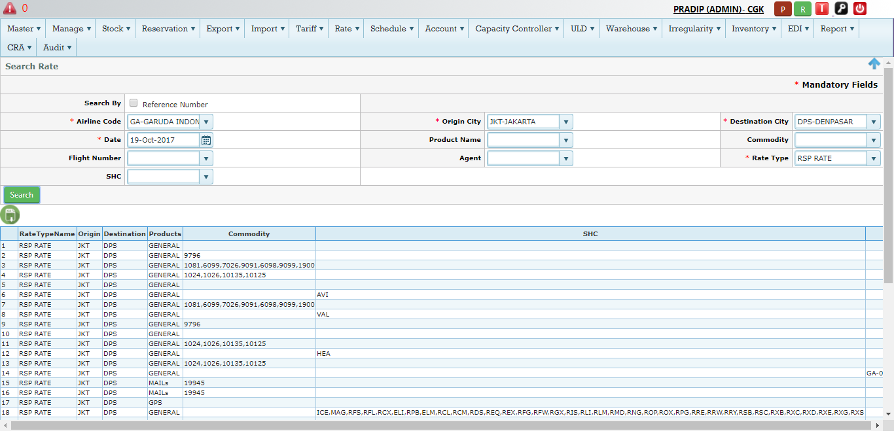

Figure Rate Information

### Rate search by Reference Number

User also can search the rate based on rate reference number,

Navigation-Rate>search rate > click Search by Reference number

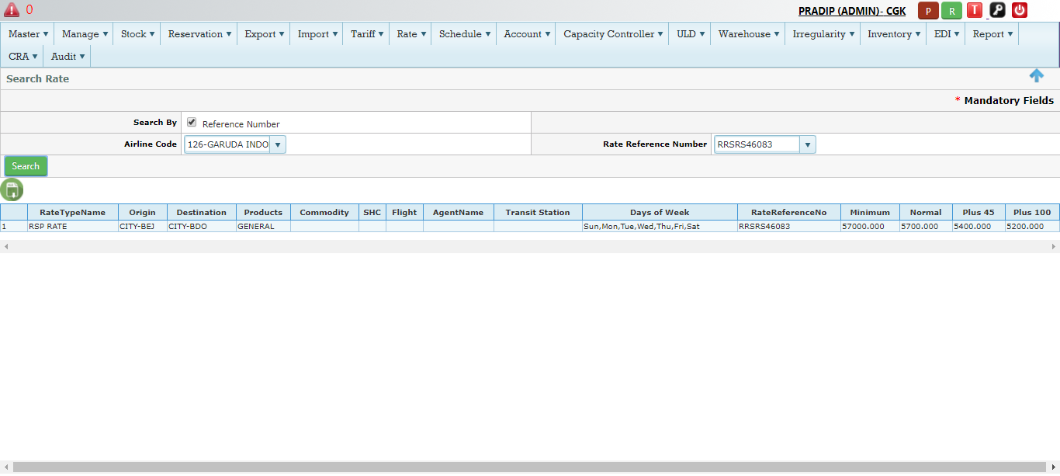

Figure Search by Reference

### Rate priority (precedence)

Rate priority used to maintained on the master to get the rate applied rate precedence if more than one rate available for a given O-D pair

Navigation –Master>Rate>Rate Type Priority

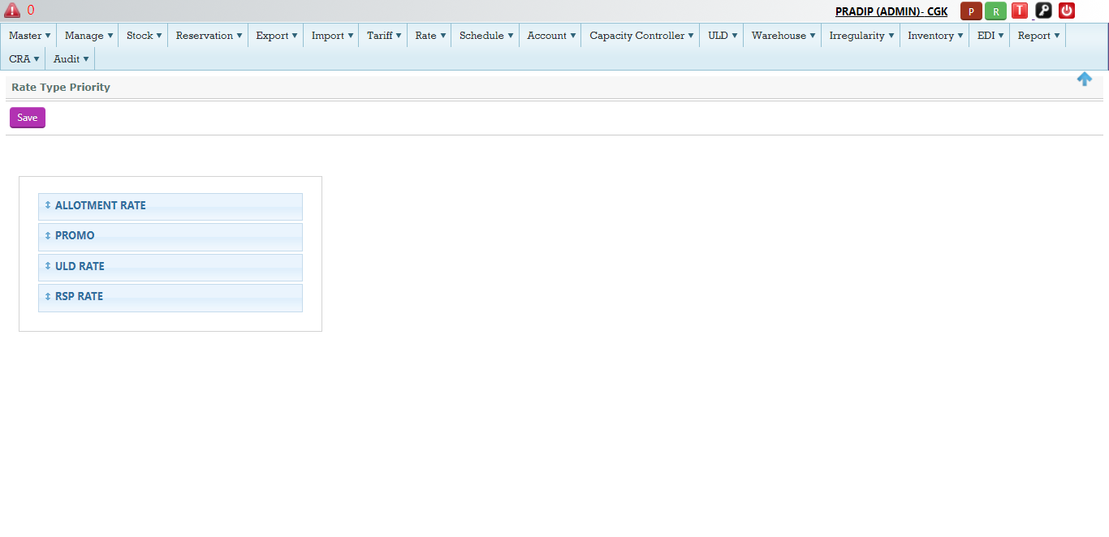

Figure Rate priority

Process –

This is the Drag and drop solution to define the priority, simple just drag the Rate type and click the Save button,

Example- current sequence - Allotment rate, Promo, ULD rate, RSP rate

Case 1- If all the four type of rates are available on particular O-D , then Allotment rate will be applied

Case 2- If only two rates are available (Both RSP and promo), then it will Promo will get applied, as Promo is on second line

Case 3-If Allotment and RSP rate is available, then Allotment will get apply

Case 4- If promo, RSP and ULD rate is available, then Promo will get applied

Note – As rate priority on master module, this is only available for authorized user only

## Stock Management

In the Air cargo Business, Air waybill stock control is the most integral part before customer goes for Booking & reservation Process

Following activity can be perform on this module

* Manage and control bulk –store stock at the Airline HDQ and then distribute to station , where station will distribute to agent
* Performing stock blacklisting
* Update stock status
* Void the stock
* Check Stock Report

### Distribute the stock (Manual)

Branch office or GSA will distribute the AWB stock to the Forwarder (Agent) , AS HDQ is the only authorized to Create the AWB stock both Manual/Auto stock and issue to the Branch , Now Branch will issue to their Agent (Or else HDQ can also distribute to the agent )

Navigation-Stock >Issue Available stock

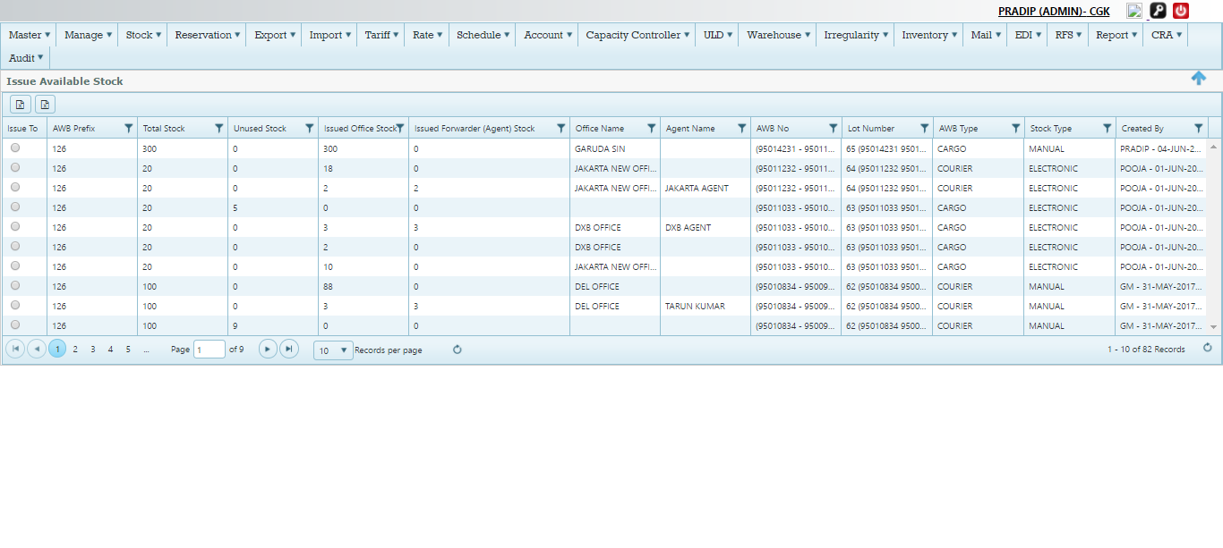

Figure Issue AWB Stock

Issue AWB Stock Details (Refer screen-98)

|  |  |
| --- | --- |
| Issue To | This is used to issue the stock to office/Agent (for more details refer to 1.13.1.1 |
| AWB prefix | AWB prefix of the airline -126 |
| Total stock | It indicate the total stock created on the system by HDQ  C:\Users\Pradip\Desktop\screen\ttl stock.png |
| Unused stock | This is the total stock on hand with HDQ  C:\Users\Pradip\Desktop\screen\hdw.png  Note-zero indicates no stock at HDQ level |
| Issued Office stock | This is the total stock issued to Branch office/GSA  C:\Users\Pradip\Desktop\screen\agent issued.png |
| Issued Forwarder(agent)  Stock | This the total stock issued to an Agent  C:\Users\Pradip\Desktop\screen\awb stk to ff.png |
| Office name | Name of the Office/Branch or GSA |
| Agent Name | Name of the forwarder (Agent ) |
| AWB No | This is the range of serial that generated |
| Lot Number | This is the Lot (No of AWB ) |
| AWB Type | This is the AWB type such as –Cargo/courier/Mail etc  C:\Users\Pradip\Desktop\screen\sto type.png |
| Stock Type | This is indicate type to stock created such as –Electronic or Manual or Auto  C:\Users\Pradip\Desktop\screen\ele.png |
| Created By | It indicates the user of system who has created the stock –it generated by system automatically  C:\Users\Pradip\Desktop\screen\cret.png |

#### Issue stock to Forwarder (Agent)



Figure Issue to Forwarder

Process to issue stock to forwarder (Refer screen 99)–

1. Click issue to Tab and click forwarder

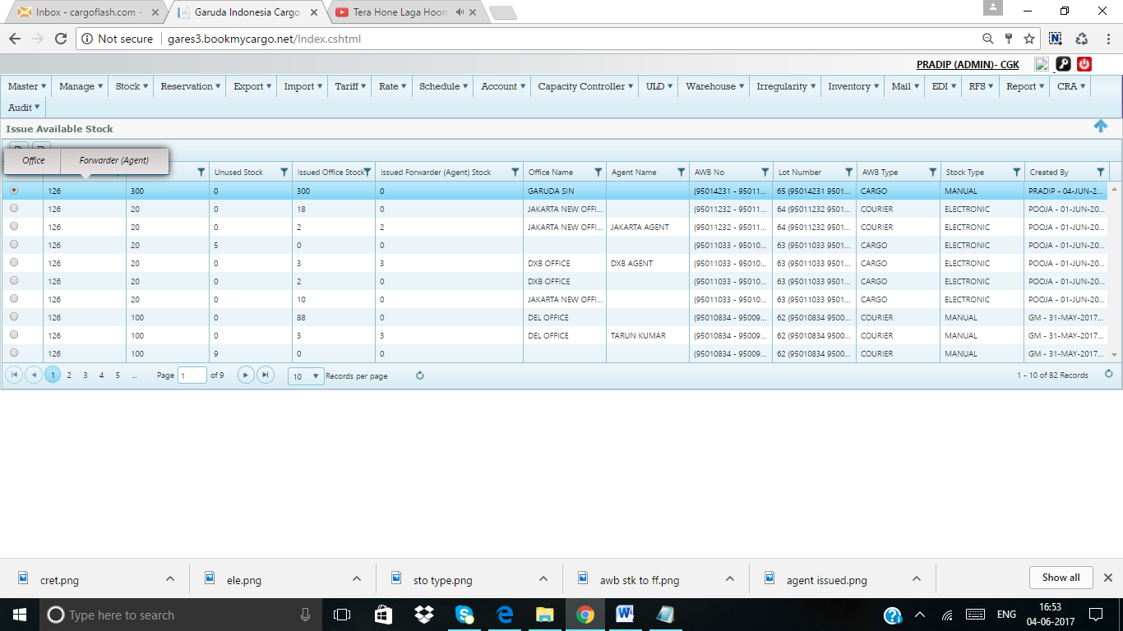

It will open to a new window as bellow

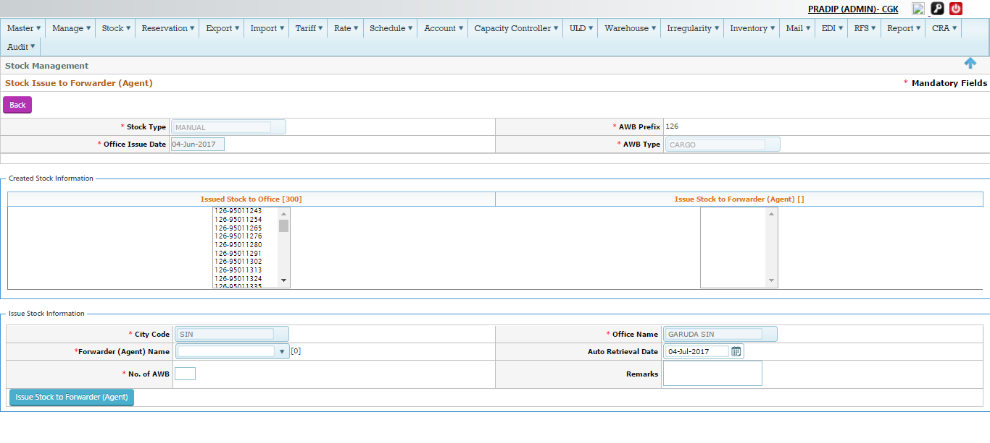

Figure Issue process

Process details (Refer screen -100)

|  |  |
| --- | --- |
| Stock Type | It will auto populated , Example-Manual |
| AWB Prefix | Auto populated -126 |
| Office issue date | It is the date of issue to office /Branch |
| AWB Type | It will auto populated –Cargo |
|  | Created Stock Information |
| Issued stock o office | This is total no of stock on hand with office  C:\Users\Pradip\Desktop\screen\ttl at of.png |
| Issue stock to forwarder | This is the total no of stock on hand with Agent |
|  | Issue stock information |
| City Code | Branch City , |
| Office name | Name of the Branch /office or GSA |
| Forwarder (Agent )  Name | Select the name of the forwarder (agent ) to whom Branch office/GSA is going to issue the stock  Note – If any stock available with that forwarder will show here |
| Auto retrieval Date | This is the date when it will auto retrieve the stock |
| No of AWB | This is the No of AWB to be issued/distribute to that agent |
| Remarks | Type the if any remarks - |
| Issue stock to forwarder  (Agent) | Click into the  C:\Users\Pradip\Desktop\screen\tab.png  It will issued to agent and save into the grid  C:\Users\Pradip\Desktop\screen\issued.png |

### Return from Forwarder (Agent)

Airline can also able to return the AWB stock from the forwarder (agent)

Navigation –Stock>Return from Office

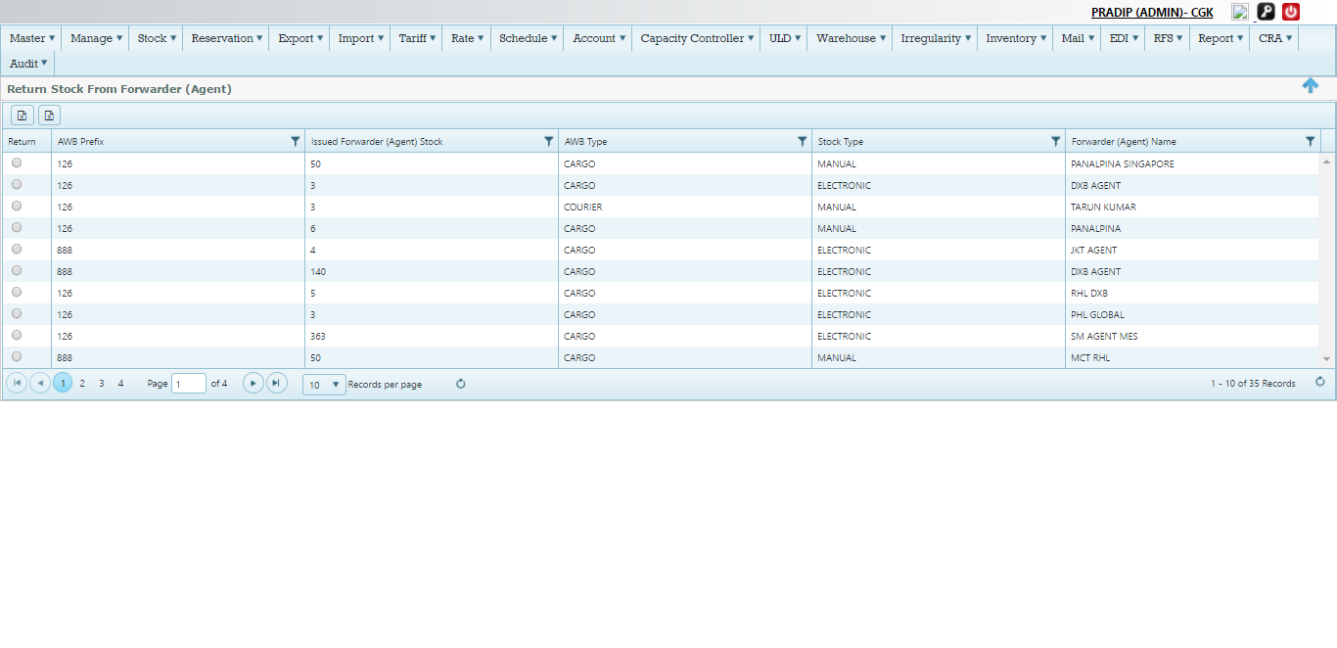

Figure Return from Agent

Return from Agent Screen (Screen -101)

|  |  |
| --- | --- |
| Return | Return check Box used to return the stock from Agent to Office/Branch ,GSA |
| AWB prefix | AWB prefix |
| Issued forwarder (Agent) stock | Total no of stock with Forwarder(Agent) |
| AWB Type | AWB type such –cargo/courier |
| Stock Type | AWB stock Type –Manual/Electronic |
| Forwarder Name | Name of the Forwarder or Agent |

#### Return from Forwarder to office

Navigation-Stock>Return from Agent >Click Return Check Box



Figure Return Process

Click Return Check box>click Return (Refer Screen-102)

System will new window as bellow

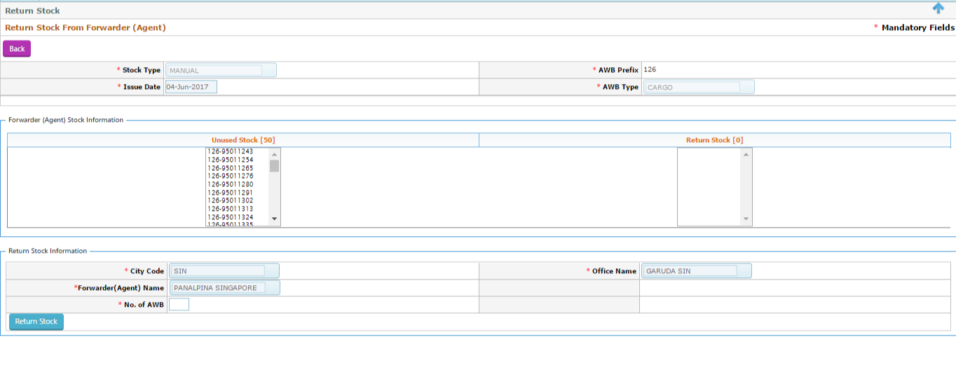

Figure Return process

Stock Return process

1. Type the No of AWB to be return , Example –Lets return 10 AWB from agent –Panalpina to the office
2. Click Return , It will return 10 awb to the that office



Figure Returned to Office

It shows Now 40 AWB where as it was 50 AWB, 10 AWB returned to office



Figure Office Stock

Office stock now got 260 AWB, where it was 250

### AWB Blacklisting

User can Black list the AWB using this module

Navigation-Stock>Blacklist AWB

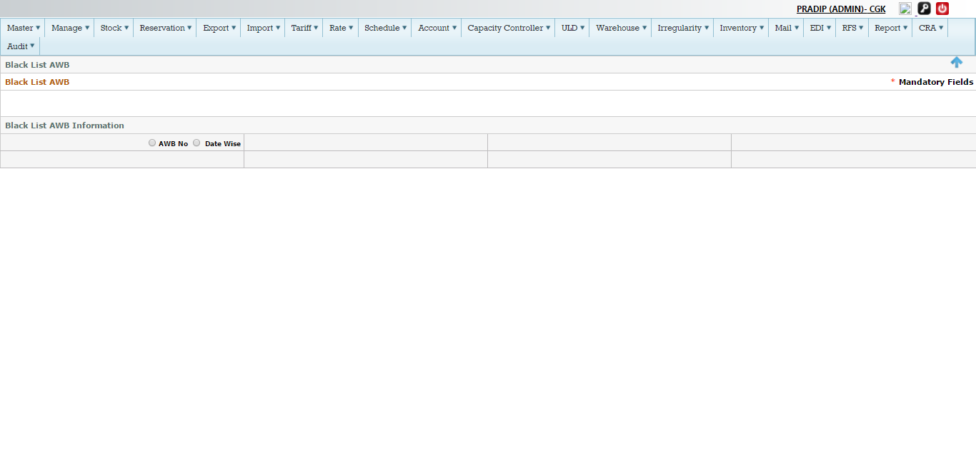

Figure Blacklist AWB

System has two options to make Blacklist the AWB, 1-For individual AWB or No of AWB on a Date range

#### Option 1-Individual AWB Black List

Click AWB no-

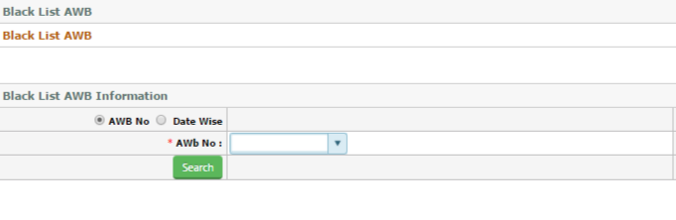

Select the AWB no from drop down list and click search

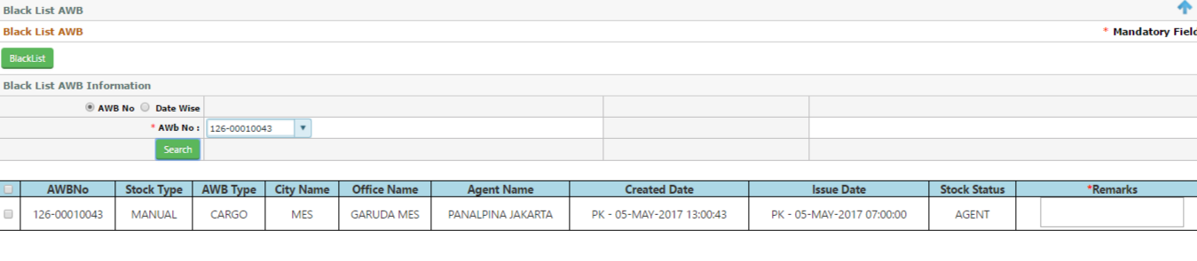

Tick the AWB and type the Remarks on free text field, and click the Blacklist Tab to make it as Black listed

Note – All Blacklisted AWB will be listed on Blacklist AWB report (Stock>Blacklist AWB Report)

#### Option 2-Date wise Black List

Click Date wise

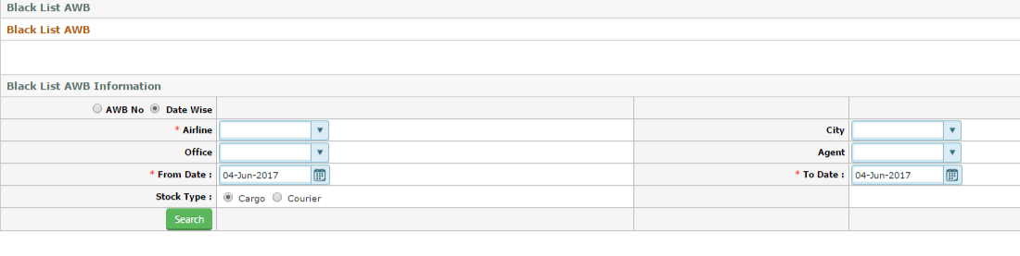

1. Select Airline
2. Select City as JKT
3. Select office as Garuda Office –Optional
4. Select agent –Optional
5. Select stock type as Cargo
6. Click search

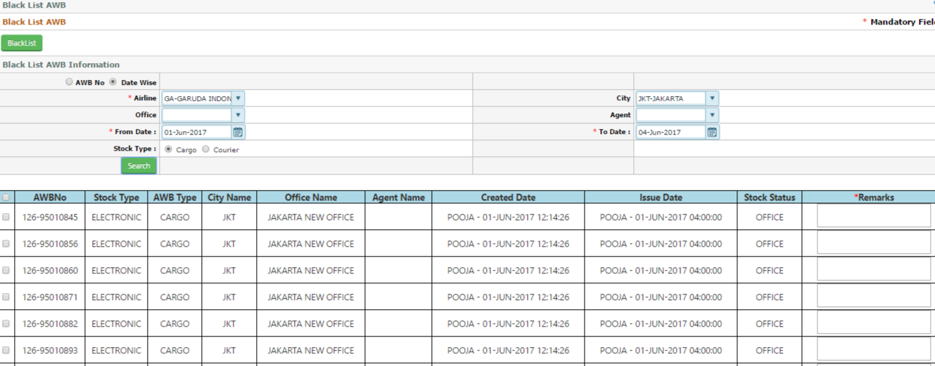

Select the AWB and put the remarks and click Black list –It will automatically blacklist all selected AWB

Note –All Blacklisted AWB will show in the Blacklist AWB report

### AWB stock Report

User able to see the stock report from this module

Navigation –Stock>AWB stock Report

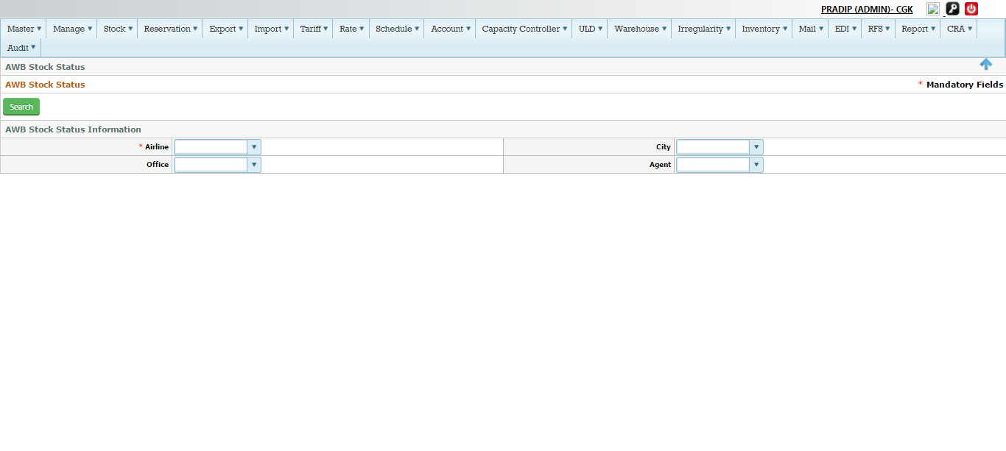

Figure AWB stock Report

Process –

1. Select Airline as GA
2. Select City as JKT
3. Select office –Optional
4. Select Agent –optional
5. Click search

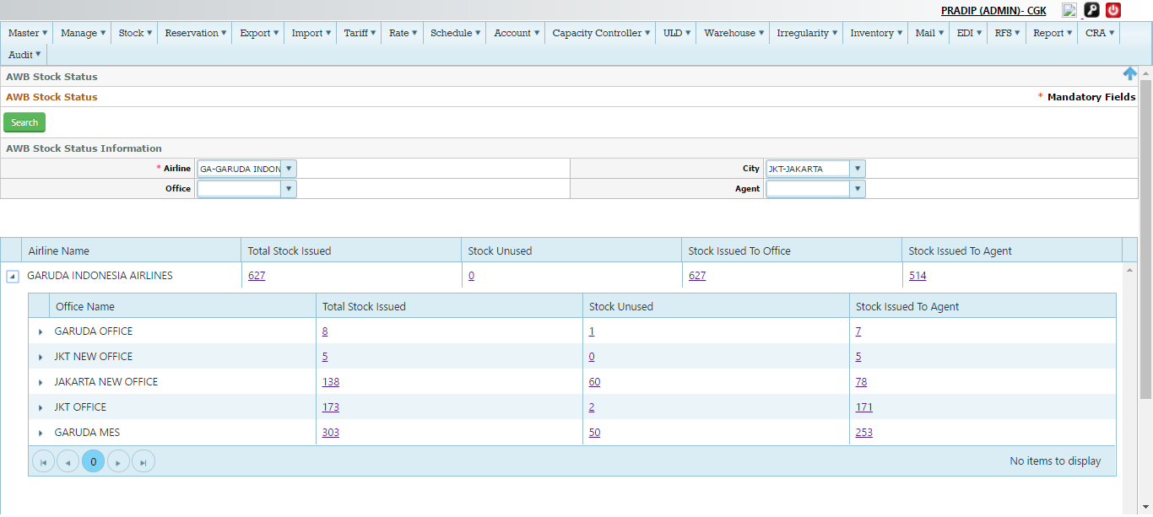

Figure Detail report

Click >(arrow ) to expand to see the details

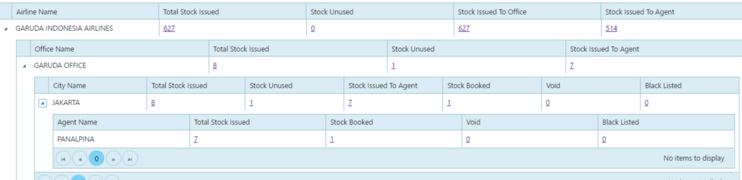

### Blacklist AWB Report

Navigation-Stock>Blacklist AWB Report

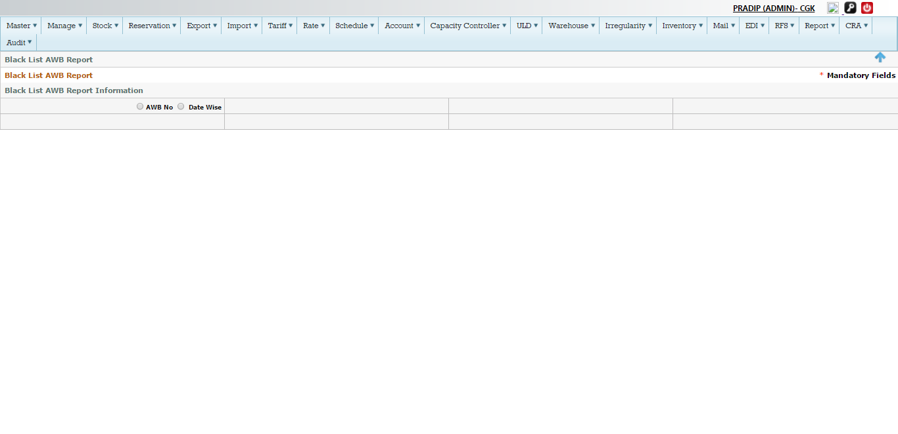

Figure Backlist Report

Click AWB no- and select the AWB and click search

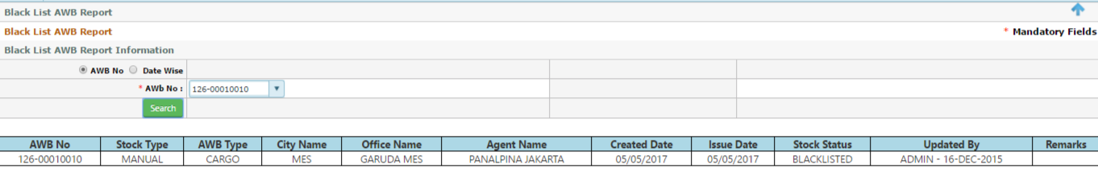

Click Date wise >select Airline >select city>select date range >click search

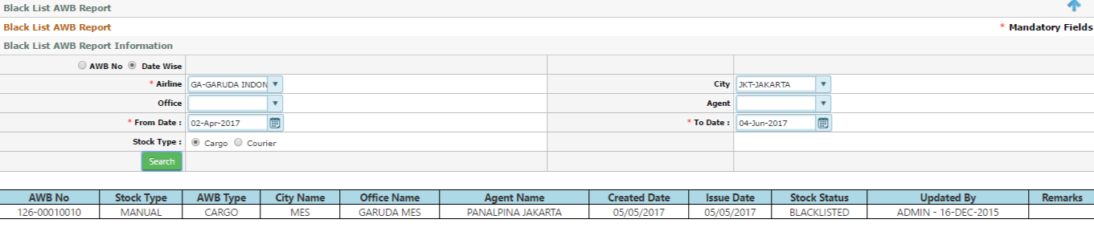

## Space control

Space control is the most important functions for HDQ capacity controller to manage the overall flight information across the Global network , As it is centralize platform and handle from Jakarta HO , some of the key functions for space control is managing the space confirmation and re plan of shipments

Navigation>Capacity control >Space control

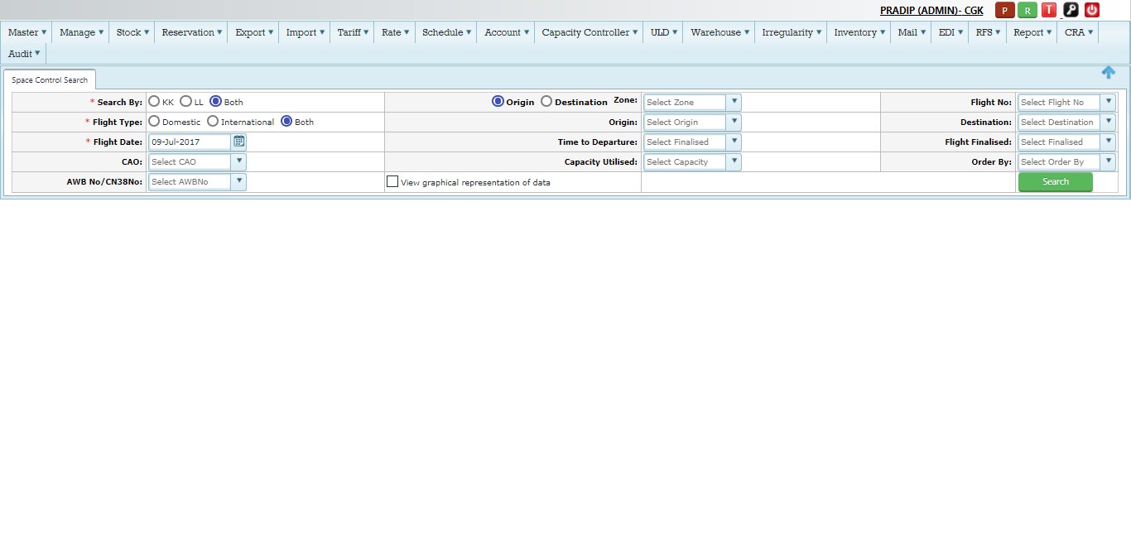

Figure Space control Search

Screen Details (Screen 110), This used to search by different parameter to get information about flight ,AWB , space etc.

|  |  |
| --- | --- |
| Search By | KK,LL or by Both , User can search by KK(all confirm shipments ) or LL(ALL wait listed shipments ) or by Both (both KK and LL shipments across the network )  User need to select the option and click the search button to get the data and information based on selection criteria  C:\Users\Pradip\Desktop\screen\screenshot-gauat.bookmycargo.net-2017-07-09-10-51-17.png  Click search C:\Users\Pradip\Desktop\screen\screenshot-gauat.bookmycargo.net-2017-07-09-10-52-05.png  Let’s search by KK , the bellow screen will open with details  C:\Users\Pradip\Desktop\screen\screenshot-gauat.bookmycargo.net-2017-07-09-10-52-57.png |
| Origin Zone | User can search the data based on Origin Zone by selecting the Origin Zone  C:\Users\Pradip\Desktop\screen\screenshot-gauat.bookmycargo.net-2017-07-09-10-56-09.png |
| Destination Zone | User can search the data based on Destination Zone by selecting the Destination Zone  C:\Users\Pradip\Desktop\screen\screenshot-gauat.bookmycargo.net-2017-07-09-10-57-07.png |
| Flight No | User can search by flight number , whereas date is mandatory , in this case data of a particular flight will open for action  C:\Users\Pradip\Desktop\screen\screenshot-gauat.bookmycargo.net-2017-07-09-10-58-54.png  Select the flight date , C:\Users\Pradip\Desktop\screen\screenshot-gauat.bookmycargo.net-2017-07-09-11-00-31.png  and click search C:\Users\Pradip\Desktop\screen\screenshot-gauat.bookmycargo.net-2017-07-09-10-52-05.png  It will open the new flight window screen for action  C:\Users\Pradip\Desktop\screen\screenshot-gauat.bookmycargo.net-2017-07-09-11-01-48.png |
| Flight Type | User can search the data based on Flight Type as –Domestic or International flight  C:\Users\Pradip\Desktop\screen\screenshot-gauat.bookmycargo.net-2017-07-09-11-05-04.png  If User select the Domestic , and click search it will open all domestic flights C:\Users\Pradip\Desktop\screen\screenshot-gauat.bookmycargo.net-2017-07-09-11-09-25.png  C:\Users\Pradip\Desktop\screen\screenshot-gauat.bookmycargo.net-2017-07-09-11-07-29.png  If user select the International and click search it will only open all International flights  C:\Users\Pradip\Desktop\screen\screenshot-gauat.bookmycargo.net-2017-07-09-11-10-03.png  C:\Users\Pradip\Desktop\screen\screenshot-gauat.bookmycargo.net-2017-07-09-11-08-29.png  If user select Both as option , it will open all Domestic and International flights  C:\Users\Pradip\Desktop\screen\screenshot-gauat.bookmycargo.net-2017-07-09-11-10-38.png  C:\Users\Pradip\Desktop\screen\screenshot-gauat.bookmycargo.net-2017-07-09-11-11-22.png |
| Origin (Airport) | User can search the information based on Origin Airport  C:\Users\Pradip\Desktop\screen\screenshot-gauat.bookmycargo.net-2017-07-09-11-17-52.png and click search |
| Destination(Airport) | User can search the information based on Destination Airport  C:\Users\Pradip\Desktop\screen\screenshot-gauat.bookmycargo.net-2017-07-09-11-20-26.png and click search |
| Flight Date | Flight Date are mandatory when user opted for Flight Number as search option or search by KK/LL or flight type like Domestic/International  C:\Users\Pradip\Desktop\screen\screenshot-gauat.bookmycargo.net-2017-07-09-11-26-00.png |
| Time to Departure | NA |
| Flight Finalized | NA |
| CAO | User can search based on CAO-Cargo aircraft only by selecting Yes from the drop down or No or Both  C:\Users\Pradip\Desktop\screen\screenshot-gauat.bookmycargo.net-2017-07-09-11-27-00.png |
| Capacity utilized | User can search the information based on Utilized capacity as such 50%- 70%,70-80% etc  C:\Users\Pradip\Desktop\screen\screenshot-gauat.bookmycargo.net-2017-07-09-11-31-30.png |
| Order By | User can filter it based on ETD or Queue ,  C:\Users\Pradip\Desktop\screen\screenshot-gauat.bookmycargo.net-2017-07-09-11-32-41.png |
| AWB /CN38 | User can search based on AWB /Cn38 , it will open the specific that AWB or Cn38 details for action  C:\Users\Pradip\Desktop\screen\screenshot-gauat.bookmycargo.net-2017-07-09-11-33-31.png and click search  C:\Users\Pradip\Desktop\screen\screenshot-gauat.bookmycargo.net-2017-07-09-11-34-32.png |
| Graph View | If user click into the Graph check box , it will open the graphical view information  C:\Users\Pradip\Desktop\screen\screenshot-gauat.bookmycargo.net-2017-07-09-11-36-17.png  And click search  C:\Users\Pradip\Desktop\screen\screenshot-gauat.bookmycargo.net-2017-07-09-11-37-08.png |
| Search | This is the search Button for all search criteria  C:\Users\Pradip\Desktop\screen\screenshot-gauat.bookmycargo.net-2017-07-09-10-52-05.png |

### Space control Action

Based on search criteria , space control user need to action for the flight or a specific AWB to make KK or LL or UU , space control need to analyze the all information to change the shipment status such as Revenue information, Yield,capacity,type of shipment ,agent details etc.

Example- We will how you here how space control will change the status of shipment from KK to LL or LL to KK or KK to UU , or LL to UU etc.

Lets search the flight GA-894/09Jul, CGK-PVG

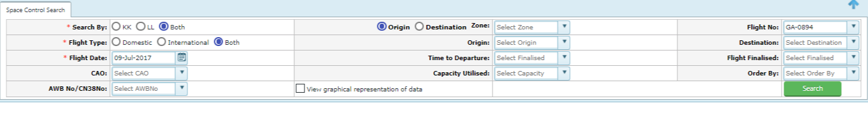

Click search, bellow screen will open for action

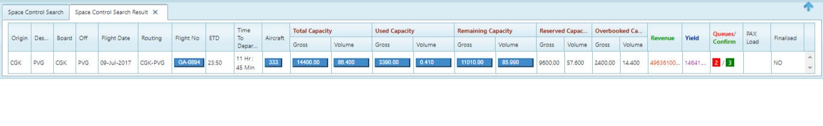

Figure Space control Flight Search Details

Screen Information (Fig 111)

It is Flight dashboards, where space control user can see all information of that flight like capacity, revenue, yield, confirm/queue information etc.

|  |  |
| --- | --- |
| Origin | Origin airport -It will auto display based on Flight search , |
| Destination | Destination airport-It will auto display based on flight search |
| Board Point | Boarding point –This is the boarding point of the flight |
| Off Point | Off point-This is the Off point of the flight |
| Flight date | Flight Date , Based on search criteria |
| Routing | Routing details of the flight , If flight is has multiple route , it will display over here |
| Flight No | Flight No –If user click this , it will open another new window where user need to action of the shipment  C:\Users\Pradip\Desktop\screen\screenshot-gauat.bookmycargo.net-2017-07-09-16-52-35.png  Will discussed more on next section |
| ETD | It will auto display based on flight |
| Time to Departure | It will auto display based on flight number searched |
| Aircraft | Aircraft –It will display the aircraft information on clicking  C:\Users\Pradip\Desktop\screen\screenshot-gauat.bookmycargo.net-2017-07-09-16-55-54.png  Click –  C:\Users\Pradip\Desktop\screen\screenshot-gauat.bookmycargo.net-2017-07-09-16-56-39.png |
| Total Capacity (Gross/Vol) | Total Capacity – This is the total cargo capacity of the flight  C:\Users\Pradip\Desktop\screen\screenshot-gauat.bookmycargo.net-2017-07-09-16-58-20.png  Click into the tab , it will open more detailed information for both gross and volume  C:\Users\Pradip\Desktop\screen\screenshot-gauat.bookmycargo.net-2017-07-09-16-59-29.png |
| Used Capacity (Gross/Vol) | This is the total used capacity of the flight , weight of Total booked shipments  C:\Users\Pradip\Desktop\screen\screenshot-gauat.bookmycargo.net-2017-07-09-17-01-08.png  Click to get more information  C:\Users\Pradip\Desktop\screen\screenshot-gauat.bookmycargo.net-2017-07-09-17-01-54.png |
| Remaining Capacity(Gross/Vol) | This is the total remaining capacity of the flight , Total actual capacity Over booking –total booked capacity  C:\Users\Pradip\Desktop\screen\screenshot-gauat.bookmycargo.net-2017-07-09-17-03-14.png  Click to get more information  C:\Users\Pradip\Desktop\screen\screenshot-gauat.bookmycargo.net-2017-07-09-17-03-59.png |
| Reserve Capacity(Gross/Vol) | This is the total reserve capacity of the flight  C:\Users\Pradip\Desktop\screen\screenshot-gauat.bookmycargo.net-2017-07-09-17-05-34.png |
| Over Booking Capacity(Gross/Vol) | This is the Total Over booking capacity of the flight  C:\Users\Pradip\Desktop\screen\screenshot-gauat.bookmycargo.net-2017-07-09-17-06-24.png |
| Revenue | This is the total revenue of the flight  C:\Users\Pradip\Desktop\screen\screenshot-gauat.bookmycargo.net-2017-07-09-17-14-15.png |
| Yield | This is the total yield of the flight  C:\Users\Pradip\Desktop\screen\screenshot-gauat.bookmycargo.net-2017-07-09-17-14-59.png |
| Queue/Confirm | This indicates total no of Queue(LL) shipment vs total no of confirm(KK) shipments  C:\Users\Pradip\Desktop\screen\screenshot-gauat.bookmycargo.net-2017-07-09-17-16-27.png |
| Pax Load | Total passenger of the flight |
| Finalized | Status of finalized flight info |

### Space control status –action

Continue from the searched screen – click into the flight Tab to get the flight information for taking action



Click into the flight Number –GA894, it will open another Tab flight tab (It is the more detailed about that flight )

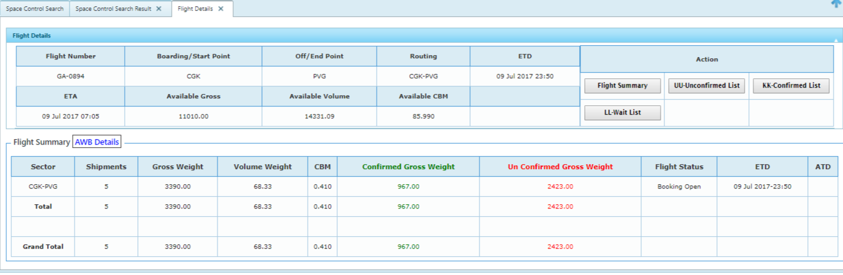

User then need to click into the AWB Details to take into the AWB tab where user need to take action of changing the status

Click AWB Details –

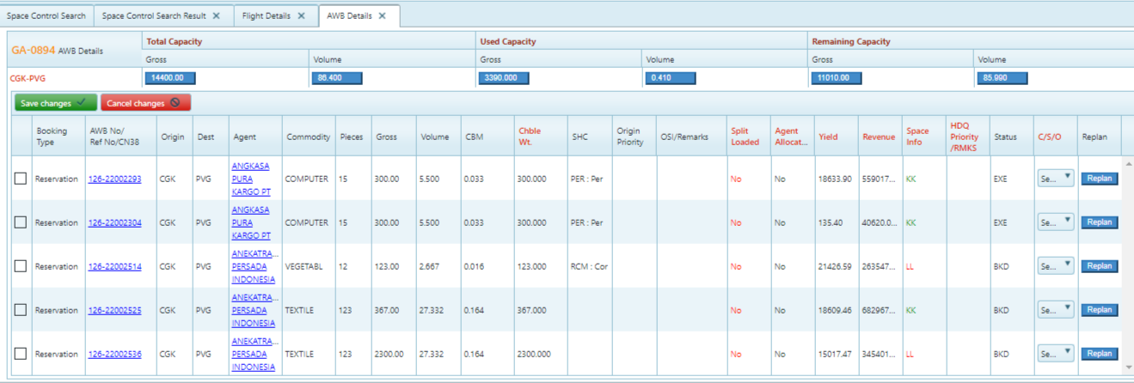

Process Details –

1. Tick the AWB/reference Number to take action
2. Select the status from the C/S/O column and select the advice code -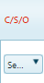
3. Save the information by clicking the Save changes button just left side of the screen 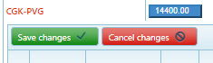
4. Once it is save , system will change the status of the AWB automatically as bellow

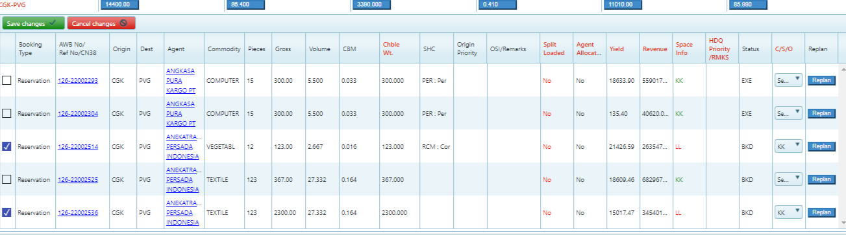

1. It will save as bellow with all status becomes as KK from LL

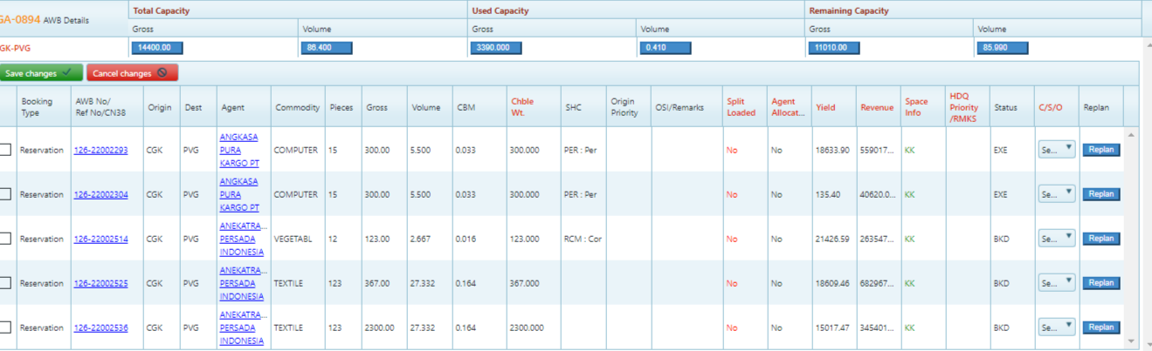

### Re plan –By space control

Under space control screen, user can re plan the shipment into another flight as well due to space or any other reason

To re plan – space control user need to select the AWB number and click re plan Tab just extreme right hand side of the screen

Navigation-capacity control>space control>search flight number/date>click flight Number >click AWB details



Figure Re plan

Re plan Process (step by step)-screen 112

1. Step 1 – click the AWB need to re plan
2. Step2- click the re plan tab , Once it is clicked it will open another window called re plan

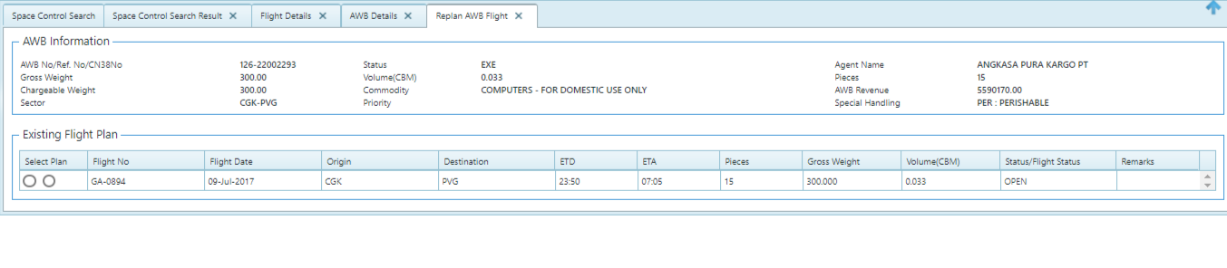

1. Step 3-ciick the select plan radio button , once it is clicked it will expand the same screen into more details information to re plan

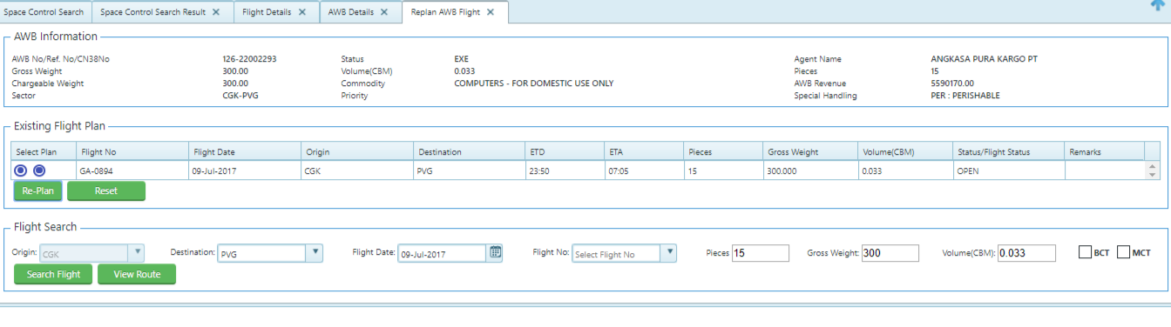

1. Step4-Click search button to get the flight itinerary , if user need o re plan as split also can selec the no of pieces button and just type manually

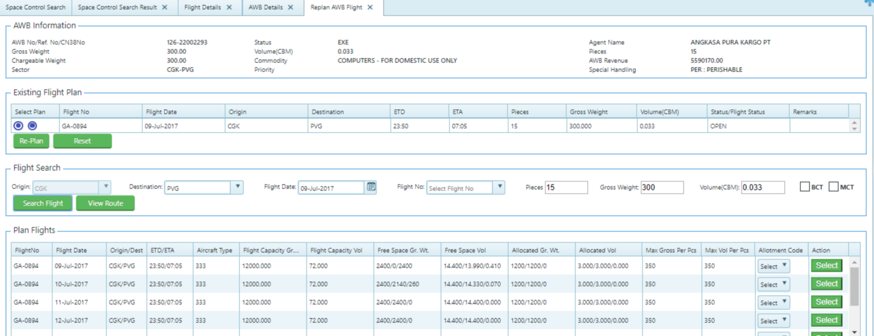

1. Step 5-select the flight number by clicking the select button

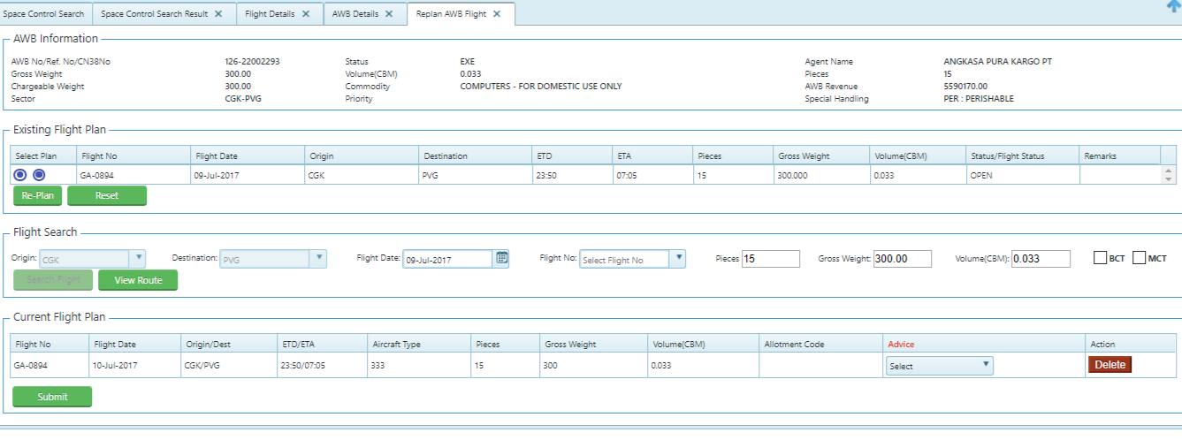

1. Step 6-clcik submit button to save the information

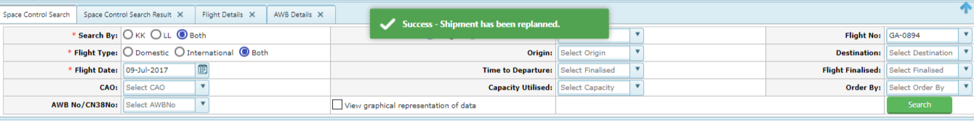

## Embargo

Space control user able to create/modify or delete embargos across networks and holds authority to do that

1. Space control user able to Search all embargos , which placed across networks for a flight or shipments level
2. Create/modify/delete a new embargo based on multiple parameters, including city-to-city, city-to-country, country-to-country, for a specific commodity, SHC, agent/GSSA, Airline Code/Prefix, allowed up to certain weight or pieces and define the period of validity.
3. Space control user able to activate or de activate the existing embargos which placed across networks
4. Soft/Hard embargo can be defined, Hard embargo does not allow the booking to take place at all, whereas, in soft embargo system will give a warning pop-up message
5. User able to override the soft embargo and continue the booking with warning message and such shipments will be booked as waitlist queue (LL status)

Navigation-capacity control>Embargo

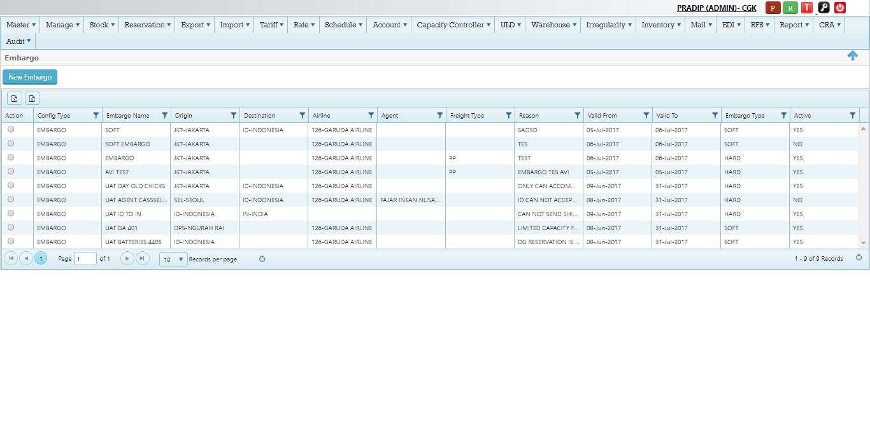

Figure Embargo

Embargo Screen details (Fig 113)

|  |  |
| --- | --- |
| Action | Action Tab used to view the Existing Embargo or edit the existing embargo information  C:\Users\Pradip\Desktop\screen\screenshot-gauat.bookmycargo.net-2017-07-09-18-17-18.png  Click Read to just view the information  Click Edit to modify the embargo information |
| Config Type | Embargo  C:\Users\Pradip\Desktop\screen\screenshot-gauat.bookmycargo.net-2017-07-09-18-18-50.png |
| Embargo name | This indicate the name of the embargo  C:\Users\Pradip\Desktop\screen\screenshot-gauat.bookmycargo.net-2017-07-09-18-19-36.png  Note – Hard embargo will not allow to proceed any transaction  Soft Embargo –will have pop and proceeds to make transaction and it will mark in the itinerary |
| Origin | Origin of the Embargo , Note –Origin can be city/Country  C:\Users\Pradip\Desktop\screen\screenshot-gauat.bookmycargo.net-2017-07-09-18-20-26.png |
| Destination | Destination city of the Embargo , Note –Destination can be city/Country  C:\Users\Pradip\Desktop\screen\screenshot-gauat.bookmycargo.net-2017-07-09-18-21-26.png |
| Airline | Name of the Airline –  C:\Users\Pradip\Desktop\screen\screenshot-gauat.bookmycargo.net-2017-07-09-18-22-57.png |
| Agent | Name of the Agent –for which Embargo has been placed  C:\Users\Pradip\Desktop\screen\screenshot-gauat.bookmycargo.net-2017-07-09-18-23-52.png |
| Freight Type | This Indicate the freight type like –PP or CC  C:\Users\Pradip\Desktop\screen\screenshot-gauat.bookmycargo.net-2017-07-09-18-25-41.png |
| Reason | This indicate the reason of the specific Embargo placed  C:\Users\Pradip\Desktop\screen\screenshot-gauat.bookmycargo.net-2017-07-09-18-30-32.png |
| Valid from | Valid From-It indicate the valid from date of the Embargo  C:\Users\Pradip\Desktop\screen\screenshot-gauat.bookmycargo.net-2017-07-09-18-31-38.png |
| Valid To | Valid to-It indicate the Valid to date of the embargo  C:\Users\Pradip\Desktop\screen\screenshot-gauat.bookmycargo.net-2017-07-09-18-32-34.png |
| Embargo Type | This indicate the Embargo type –soft or Hard embargo  C:\Users\Pradip\Desktop\screen\screenshot-gauat.bookmycargo.net-2017-07-09-18-33-28.png |
| Active | It indicate the Active yes or No of the embargo  C:\Users\Pradip\Desktop\screen\screenshot-gauat.bookmycargo.net-2017-07-09-18-34-24.png |

### Create New Embargo

Under this user able to create the new Embargo under different parameter

Navigation-Capacity control>Embargo>click New Embargo



Click New Embargo

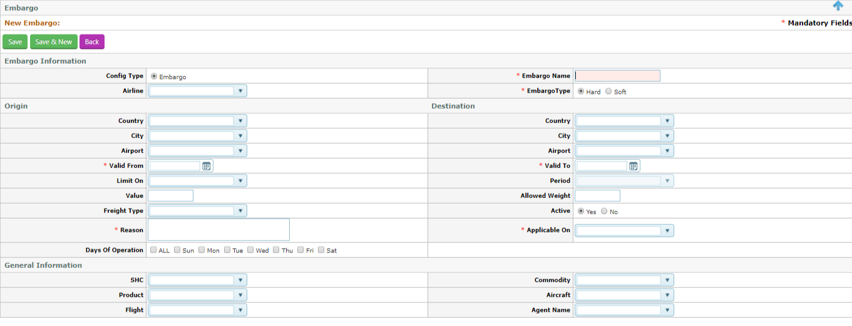

Figure New Embargo

New Embargo Process –

|  |  |
| --- | --- |
|  | Embargo Information |
| Config Type | By default it is Embargo |
| Embargo | Type the Name of the embargo to be given |
| Airline | Select the Airline name from the Drop down list , Example –GA |
| Embargo type | Select the radio button , soft or Hard embargo |
|  | Origin |
| Country | Select the country , Example- ID for Indonesia , Note If country selected city /airport will be disable |
| City | Select the city code from from drop down , Example-JKT ,Jakarta  Note – If city selected , country and Airport will be disable |
| Airport | Select the airport from the drop down list , |
|  | Destination |
| Country | Select the country , Example- ID for Indonesia , Note If country selected city /airport will be disable |
| City | Select the city code from from drop down , Example-JKT ,Jakarta  Note – If city selected , country and Airport will be disable |
| Airport | Select the airport from the drop down list , |
| Valid from | Mandatory-Select from date for which embargo need to get applied |
| Valid to | Mandatory -Select the to date for which embargo to be applicable |
| Limit On | Limit on(Optional)- select the some of the parameter from the drop down for which embargo need to get applied  C:\Users\Pradip\Desktop\screen\screenshot-gauat.bookmycargo.net-2017-07-09-19-31-47.png  Example-Max weight /pieces  -Max weight/shipment  -piece/shipment |
| Value | Optional – Based on Limit on , user need to type the value , Example If user selected as Max weight /pieces  Value to be given like 160kgs or 130 kgs etc. |
| Allowed weight | User need to type the allowed weight , this is applicable if user select as Piece/shipment |
| Freight type | Optional – select from the drop down like –PP or CC |
| Active | Yes or No , By default it will be Yes , If user select as No , then this embargo will not get applied |
| Reason | Mandatory – free text , type the reason |
| Applicable on | Mandatory – select the value from the drop down like Origin,Destinaion, or all  C:\Users\Pradip\Desktop\screen\screenshot-gauat.bookmycargo.net-2017-07-09-19-41-47.png  If selected as All , it will be applicable for origin/destination |
| Days on Operation | Select the all days , |
|  | General Information (specific Condition of the Embargo ) |
| SHC | If user need to apply the Embargo for a specific SHC , can select the SHC from the drop down m user select the multiple SHC |
| Commodity | If user need to apply the Embargo for a specific commodity , can select the commodity from the drop down user select the multiple commodity |
| Product | If user need to apply the Embargo for a specific product , can select the product from the drop down user select the multiple product |
| Aircraft | If user need to apply the Embargo for a specific Aircraft type , can select the Aircraft type from the drop down user select the multiple Aircraft type |
| Flight | If user need to apply the Embargo for a specific fight number , can select the flight number from the drop down user select the multiple Flight Number |
| Agent name | If user need to apply the Embargo for a specific Agent , can select the Agent name from the drop down user select the multiple Agent |
| Save | Click Save button to save the Embargo information into grid  C:\Users\Pradip\Desktop\screen\screenshot-gauat.bookmycargo.net-2017-07-09-19-50-19.png  Example – Booked the shipment from JKT to SOC on above Embargo condition  C:\Users\Pradip\Desktop\screen\screenshot-gauat.bookmycargo.net-2017-07-09-19-57-42.png  It becomes as LL due to soft embargo applied  C:\Users\Pradip\Desktop\screen\screenshot-gauat.bookmycargo.net-2017-07-09-19-58-59.png |